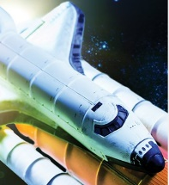
Moon Zoom!
These activities are for you to do at home with an adult. You can do all of them or choose the one that you find most interesting.
Please complete the home learning project this half term and bring it in during the last week of term. We will showcase our projects in class before the Christmas holidays!
Activities
1. Find out and write down the names of the planets in our Solar System. Place them in order, based on their distance from the Sun.
2. Choose your favourite planet from our Solar System. Find out and write six interesting facts about it. Tell an adult your interesting facts.
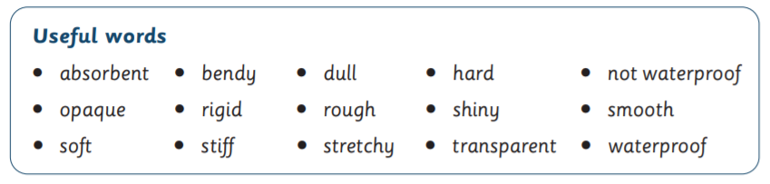
3. Wood, plastic, metal, glass, water, rock, paper, foil and fabric are all materials that are found on Earth. Find examples of each material and describe their properties using the useful words to help.

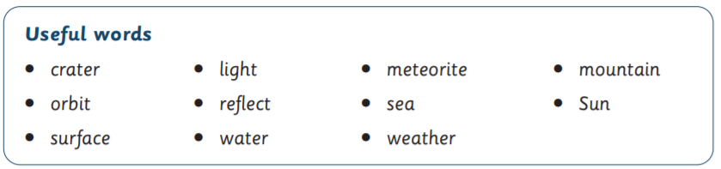
4. Visit BBC Bitesize KS1 – The Moon. Watch the video, then use the useful words to write some sentences to share what you have learned about the Moon.

Useful websites
BBC Bitesize – Earth and Space | BBC Bitesize – Materials
NASA – Space Place – Solar System | BBC Bitesize – The Moon

