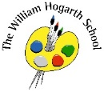

Maths

We will learn about mass, capacity and temperature as well as fractions. 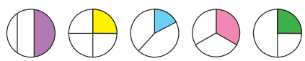

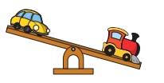 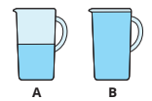

P.E.

This half-term we will improve our reaction times, jumping and throwing skills in a range of athletics sports.

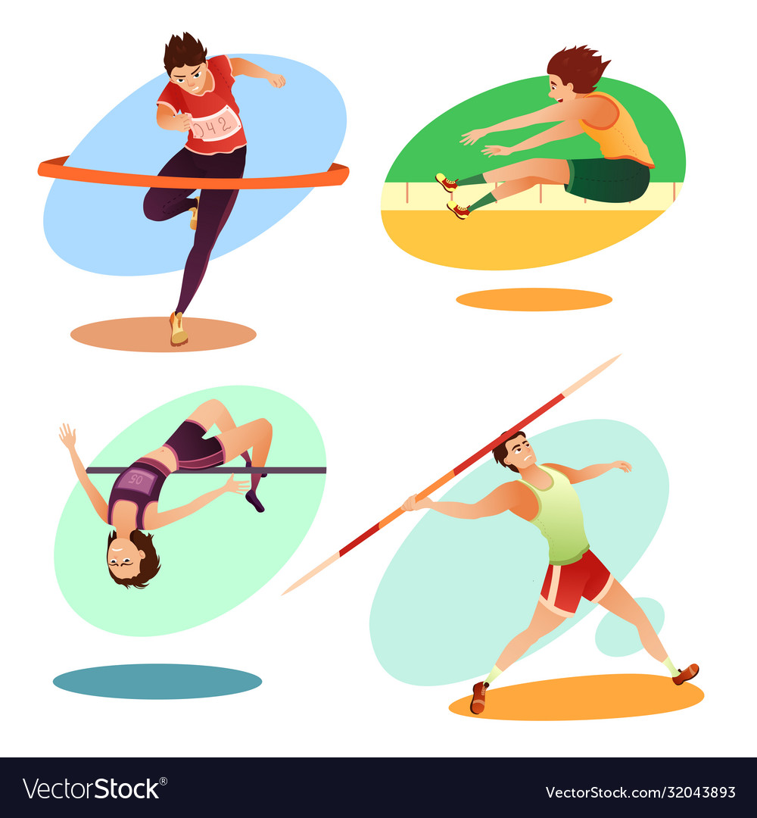

Science

In science we will learn all about Living Things and their Habitats

Plants! We will also find out about microhabitats and characteristics of living things.

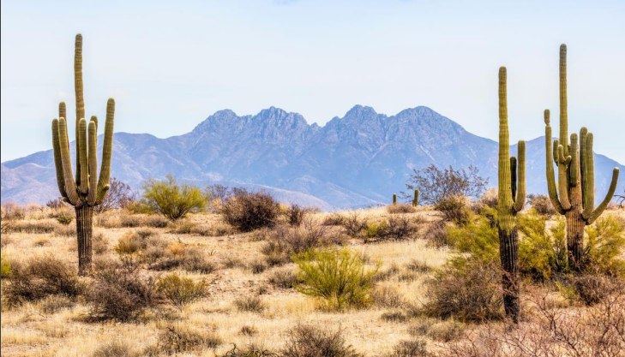

English

Our English book this half term is ‘The King Who Banned the Dark’. From this text we will write letters and a banning narrative.

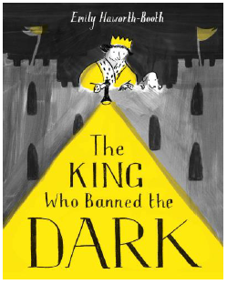

Computing

This half term we will have a focus on data handling through the use of pictograms. We will begin to understand what the term data means and how data can be collected in different forms

Humanities

Our History topic this half term will be ‘How should we remember Pocahontas’. We will learn about different types of evidence and how to create timelines. We will find out what life was like for Pocahontas and the Powhatan people.

Art and D&T

Our topic is Stick Transformation Project.

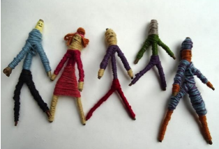

Music

Our music topic is ‘see and hear’. It is focused on discovering the music in the world around us. 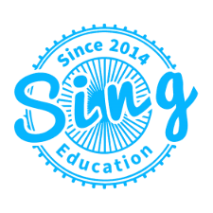

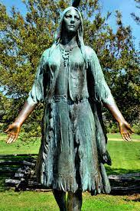

PSHE

We are learning about friendships and families. We will learn about conflict and how to make others feel part of a group. 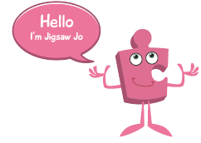

RE

Our focus this half term will be ‘How do some people talk to God?’ The children will investigate why some people pray; identifying similarities and differences between prayer practices in the Hindu, Jewish and Muslim worldviews.