What is it like to live by the coast?
Home Learning Project

Choose one activity from the list below to complete and bring in to school. You can choose more if you wish.
Make a 3D sea animal using materials of your choice. You could use papier mache, playdough, plastic bottles, fabric, lego or any recyclable materials you can find around your home and any natural materials. It’s up to you. | 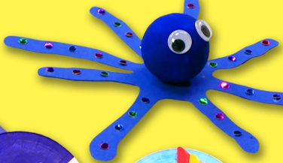  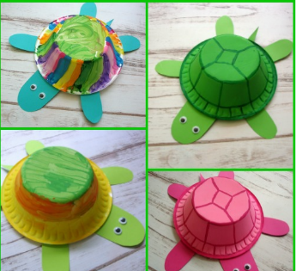  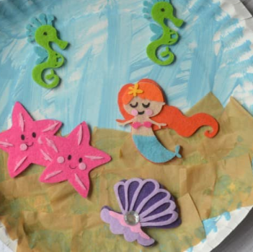  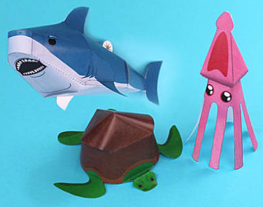
Create a collage showing the beach and seaside. | 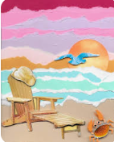  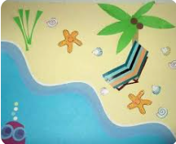  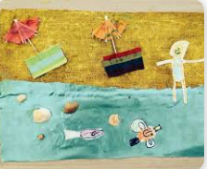
Make a miniature seashore garden using natural materials such as pebbles, twigs, sand and shells. | 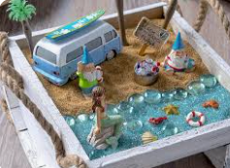  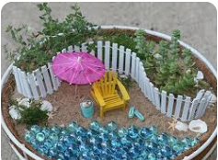
Learn some beach tongue twisters and riddles. Can you write some of your own? Can you use alliteration, eg Big, blue, beach balls bouncing on the beach. | Write a list of things that children and adults should do to stay safe at the coast. Examples include, taking notice of warning signs, and children being with an adult when near water. Once complete, use your list and what you have learned to design a poster to help people stay safe when visiting the coast. Include a title, bright colours, pictures and important information.

