Year 5 Creative Home Learning Project Spring 2
Please choose one of the following activities to work on WITH your parents.
It is your project, but we would love your parents to take this opportunity to make some time to help, guide and support you with it!
We will be celebrate your hard work at the end of term.
- Write a fact file on a biome.
- Draw a biome using pastels.
- Create a 3D model of a biome.
- Create a biome in a box or plastic container.
- Create a PowerPoint on a biome. Title: Living off the grid)
- Create an ECOSPY cards. (at least 5)
- Create a poem about a biome
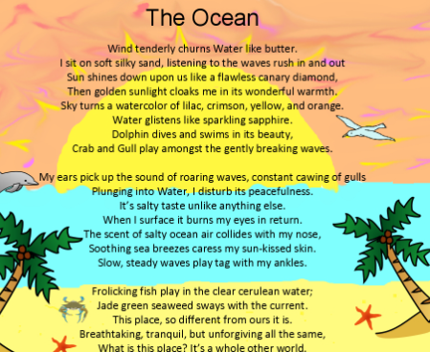
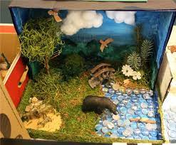
- A 3D replica of a plant of animal from a specific biome.
