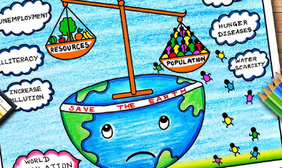Population

Home Learning Project.

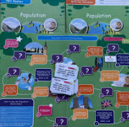

Research the data and trends of population of another country and compare this to the population of the UK.

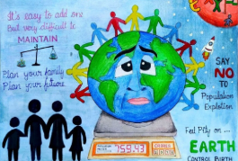Write a letter to the government with some advice on how to deal with an ageing population.

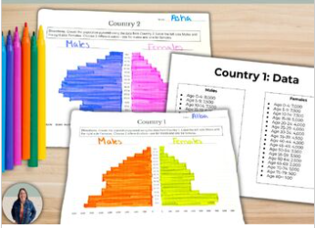Conduct a survey on the people of Chiswick to create your own population pyramids.

Create a piece of art that showcases the diverse population of the UK.

Create a leaflet explaining how we can best feed the planet.

**What can you see from your window?**

* + 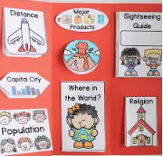Can you draw the view?
  + What is there all the time? What changes?
  + Which features are human features? Which are natural?
  + Can you see different things from different windows?
  + Can you do a survey of people, cars, bikes going past?



