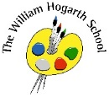**Spring 2 Term Newsletter Year 6**

**P.E.**

We will be taking part in Gymnastics this half term. Our topic will be ‘flight’ where the children will learn about different lifts and elevations from the ground. They will also try their hand at a number of rolls and creating sequences.

**Maths**

We will be focussing primarily on Algebra, Decimals, Fractions, Decimals and Percentages, Perimeter and Statistics this half term. This is a huge part of the year 6 curriculum and children will need to have a basic understanding when simplifying equations. They will also need to be able to understand the relationship between different units of measurement. The children will gain the opportunity to develop problem solving skills and reasoning skills as well as secure their fluency. We will also begin to tackle algebra and fine-tuning our understanding of BIDMAS.

**Science**

During science this half term we will be focussing on ‘forces’ we will be exploring and reinforcing children’s prior knowledge on ‘forces’ with an exciting curriculum topic of ‘rocket science!’ this will involve testing out different rockets and using different ‘fuels’ to make them fly.

**English**

This term we shall begin to explore the story of “Hansel and Gretel”. Neil Gaiman has written a retelling of the classic fairy tale. We will begin to tackle different points of view in our writing and this provides us with a great example of a dual narrative text. This book focuses on different relationships and how to reimagine a classic tale in a different way. The children will be creating a narrative and a persuasive letter using this book as stimulus.

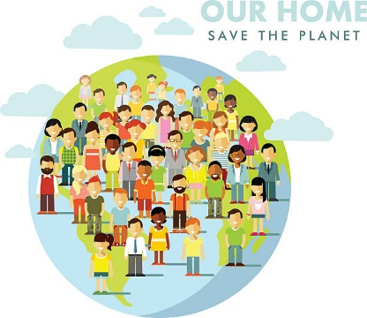

**PSHE**

Year 6 will be focusing on being healthy and making healthy choices. We will discuss health, fitness and nutrition. In addition to this, children will be coming up with their own exercise regimes and investigating how these routines help keep us fit and healthy.

**R.E.**

This term we will be learning about ‘why is there suffering’. Children will be interpreting and exploring different sources of wisdom and beliefs about why there is suffering in the world.

**Music**

Using the skills developed in Exploring Classical Music 2, children will learn about the composition process and will gain more experience of describing music and sounds. Children will study Rhapsody in Blue (Gershwin) and will use ideas from the piece to create their own piece of music based on a London skyline, using the glockenspiel, a range of untuned percussion, body percussion and their voices

**Computing**

We will be exploring computer science this half term. This is an incredibly important topic for all ages, especially after so much of our lives became digital during the pandemic. Children will be learning how to using coding software and becoming more confident in their use of digital programmes. We will be using SCRATCH primarily as our coding topic.

**Humanities**

Year 6 will be having an in-depth look at Geography. Our next topic to focus on is Population. During this, we will have a closer look at different trends in population data. Our key questions will be ‘why does population change?’ and ‘what challenges do an ageing population face?’ We will conduct our own research into these trends and data to write our own essay.