* 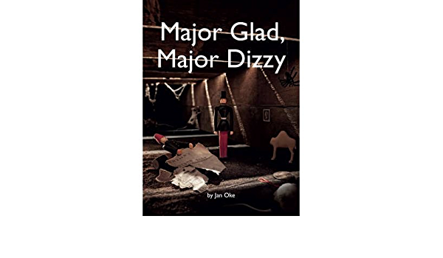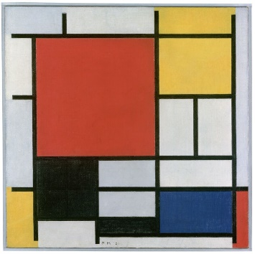 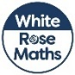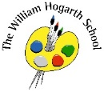

Topic  
Our topic this term is ‘Memory Box’. This is a history-based topic where children can examine aspects of the past. Children will be able to look back at their own memories of family and of when they were younger, as well as create new and exciting memories. For example, taking part in our very own Teddy bear’s picnic! We will also discuss and look at artefacts, such as old photographs and toys, to explore how things were different in the past.

Computing

The term will begin with a focus on E-safety. We will be learning how to use technology safely and respectfully, keeping personal information private. The children will learn where to go for help and support when they have concerns about content or contact on the internet or other online technologies.

Music

In music we will learn and experience what is meant by a PULSE or a steady beat. We will explore how to keep a pulse using actions whilst singing a song, and explore how to follow a changing tempo.

P.E.  
This term we will be making the most of what is left of the good weather and enjoying our outside space. We will take a multi-skills approach to learning through activities that are fundamentals of movement. This approach focuses on the development of movement, balance and coordination.

Art

This term we will spend time learning about our class artist, Piet Mondrian, and we will create pieces inspired by his work. These pieces will include the use of primary colours and straight lines. We will also create family portraits.

RE  
In RE this half term our focus religion is Christianity and we will learn about the Christian Creation story. We will explore how this story influences how Christians behave towards nature and the environment.

PSHE  
Our PSHE this term will have a strong focus on mental health and wellbeing. Our activities and discussions will focus on feeling safe and happy, reconnecting with friends, managing worries and fears and how to be positive and look forward to learning.

Maths  
In Maths we will begin the Autumn term by learning about number and place value. This will be followed by units on addition and subtraction. Towards the end of the term, we will explore geometry and shape and finally consolidate our knowledge in number and place value. Throughout our lessons, we have an element of problem solving and reasoning. Children will apply their mathematical knowledge and use manipulatives and resources to demonstrate their understanding, deepen thinking and develop mastery.

English  
We will be learning about a range of text types this term. These include:

* Recounts
* Instructions
* Letter writing
* Descriptions
* Information books

These text types will be used in a cross curricular manner across all subjects. We will also be following the **Read Write Inc. Scheme in Phonics.**

Science  
Our topic this term is ‘Building Things’ which will provide an exciting introduction to chemistry. It will allow us to explore the properties of materials, for example, which materials are waterproof, what materials to use when building a wall .We will learn important scientific skills such as questioning and observation and about how to use simple equipment to perform tests safely.

Memory Box