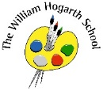

Communication

Our English book this half term is ‘A River’. From this story we will be writing a circular narrative and a reply letter.

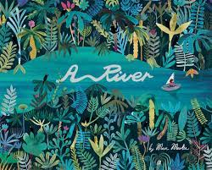

P.E.

Following primary passport PE we will learn fundamental movement skills. Each lesson will introduce a concept and skills will be applied through game-based sessions.

Science

Our topic is called ‘Building Things’. We will be conducting practical experiments involving water. We will learn about different materials and their properties.

RE

Christianity: We are learning to re-tell Bible stories that show kindness, and to explore how this makes Christians behave towards other people.

Computing

The first half term will focus on E-safety with children learning about how to stay safe online. We will look at how to be careful when using online games and apps.

Humanities

In our history topic ‘Chiswick’ we will develop our knowledge of our local area and its history. This will involve a scavenger hunt around Chiswick to find important landmarks and learn about William Hogarth,

Art and D&T

This term we will be creating elastic band sketchbooks and exploring colour.

Maths

Over the half-term we will learn about number and place value, then addition and subtraction. Lessons will include opportunities to develop fluency, reasoning and problem solving. We will secure our understanding of numbers up to 100 by using manipulatives alongside clear visual representations and revisiting our learning throughout. We will practice our fluency in the 2-, 5- and 10-times tables and division facts.

PSHE

Our topic is called ‘Being Me’ where we will celebrate differences, discuss dreams and goals and look at how we change over time.

Music

We will be having singing lessons where we will learn to join in at different times and keep up with the beat. We will find out what is meant by ‘tempo’, ‘pitch’, ‘rhythm’ and ‘duration’ in fun singing games.

