****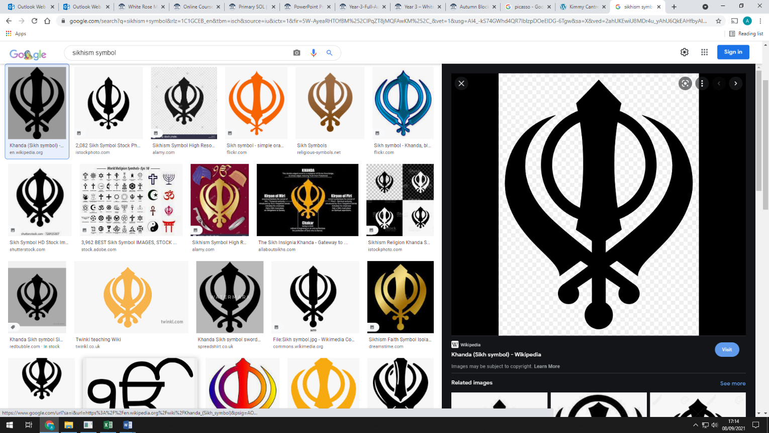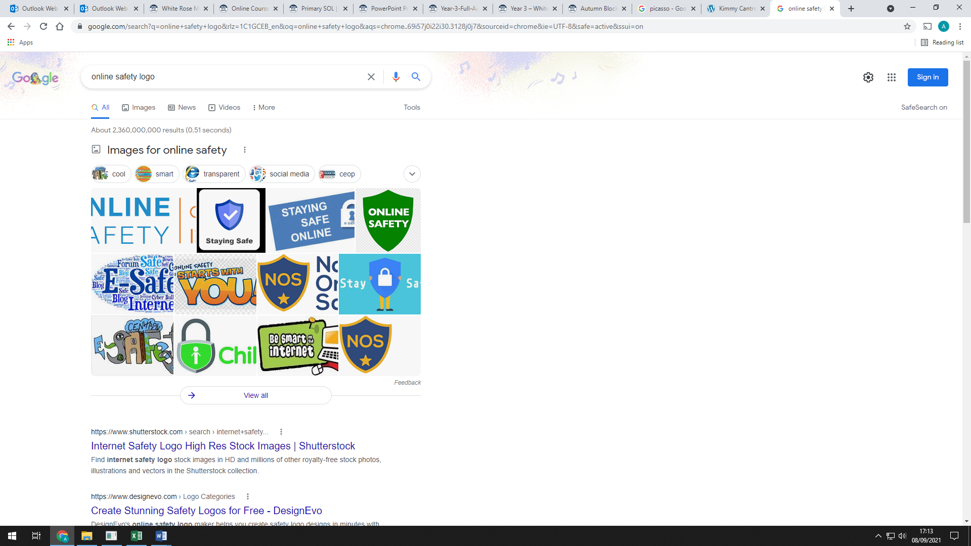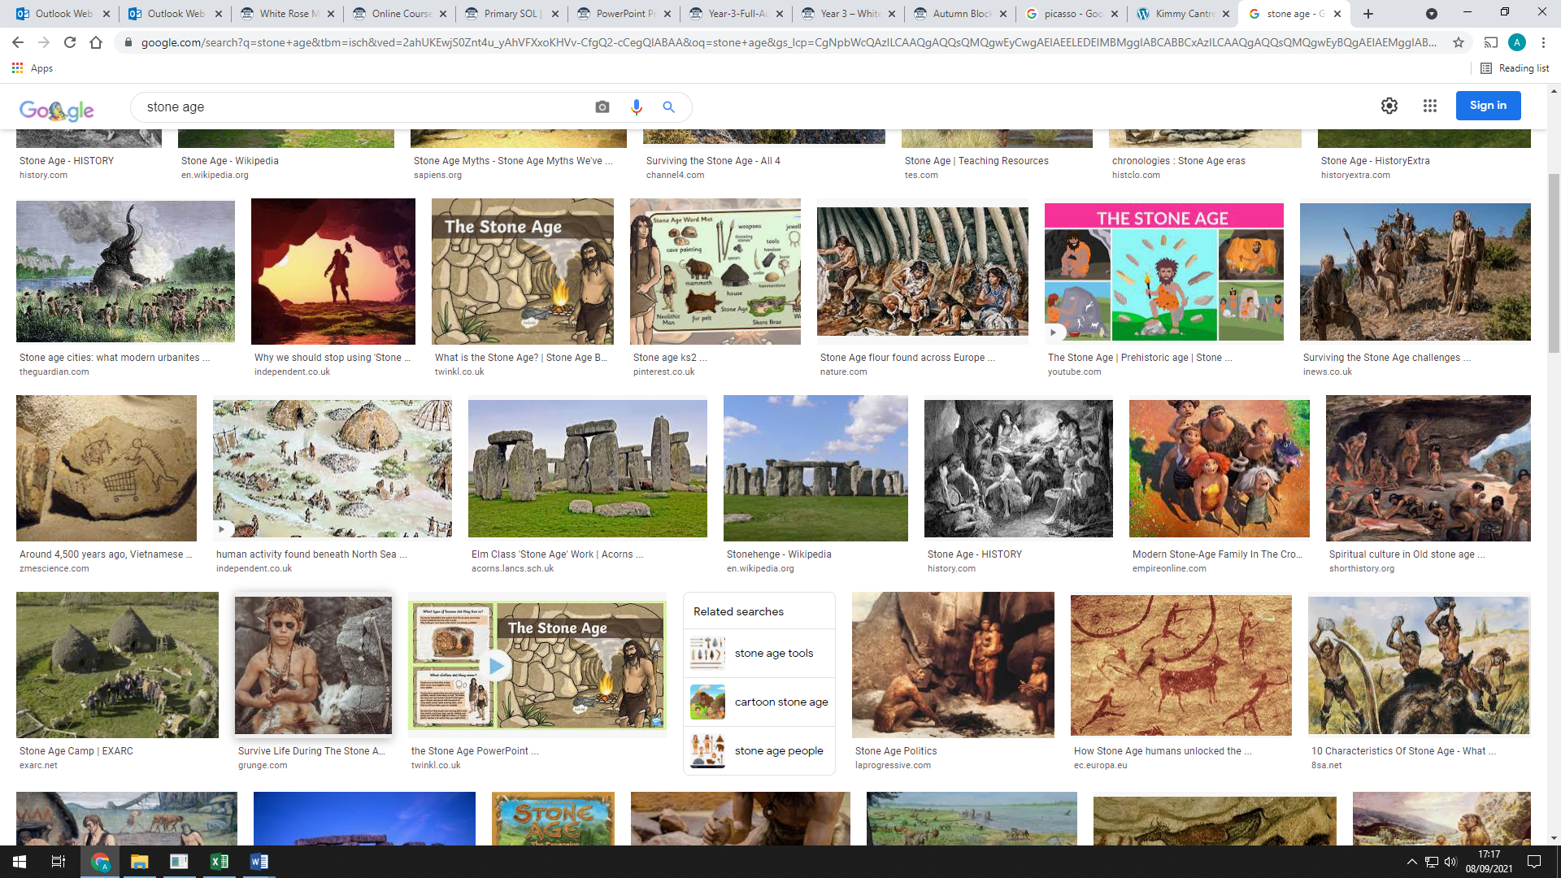**Autumn 1 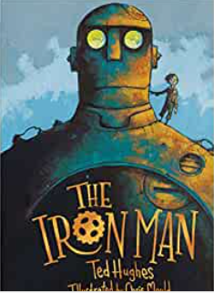 Newsletter Year 3**

**Music**

This unit builds upon previous learning on the glockenspiel and pupils’ knowledge of pitch, pulse and rhythm. They will apply the skills learned through songs and games, to playing the glockenspiel.

**Maths**

We will begin our maths learning with place value. We will learn to represent and partition 3-digit numbers. We will be comparing and ordering numbers as well as being able to find 1, 10 or 100 more or less than a given number. We will then move on to addition and subtraction where we will learn formal written methods.

**Story time book**

**The Boy Who Grew Dragons**

**PSHE**

In our ‘Being Me’ unit we will learn to recognise our worth and identify positive things about ourselves, and know how to make someone else feel welcome and valued.

**Computing**

We will be deepening our understanding of On-Line safety. We will focus on exploring aspects online safety, various communication devices and communicating online.

**R.E.**

This term we will be learning about Sikhism and understanding ‘Khalsa’.

**Humanities**

Year 3 will be learning about the Prehistoric Britain. The children will explore from the Stone Age until the arrival of the Celts in Britain. We will look at the creatures that were alive, the lifestyle of Stone Age people, and examine more closely, a case study of Bronze Age people.

**Art**

Drawing on Picasso and the work of Kimmy Cantrell, we will be creating abstract relief sculptures of our faces.

**Science**

We will learn all about space, such as solar and lunar eclipses, planets of the solar system and the universe.

**P.E.**

On Mondays we will be composing dance motifs and on Wednesdays we will be learning to play basketball.

**English**

Our stimulus book, The Iron Man by Ted Hughes and illustrated by Chris Mould. A well-known story about a little boy who realises the Iron Man is not here to destroy earth. He might even be here to save the planet! We will explore writing an Approaching Threat Narrative and Explanation text.