On the 22nd May, we have an exciting and inspirational visit from a professional basketball player called Pierre Henry-Fontaine.

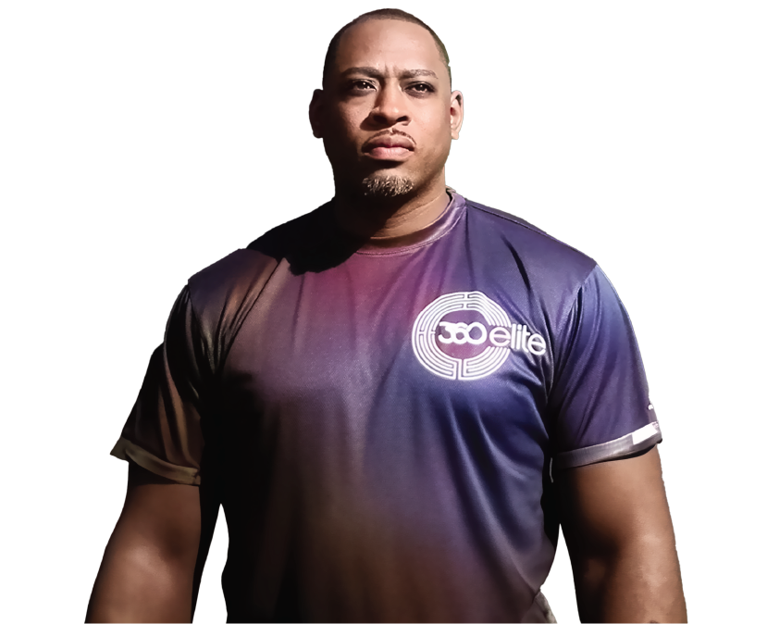

Children in all year groups (Nursery to Year 6) will complete a ‘Sponsored fitness circuit’ on the day. Please follow this link to access our co-fundraising page!
https://www.crowdfunder.co.uk/p/the-william-hogarth-primary-school-fundraiser
Let’s see how many sponsors we can get!
There will be prizes for the children that get the most sponsors!

