Nursery Newsletter
W/B 15th April 2024
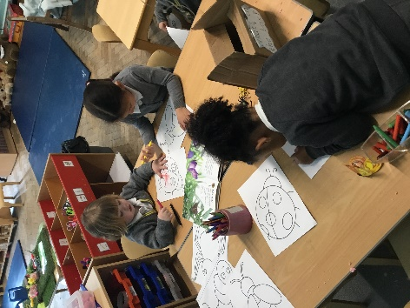
We have been:

• reading our focus story “What the ladybird heard”
• learning about different Mini beasts and what they are, particularly ladybirds
• learning about the life cycle of a ladybird
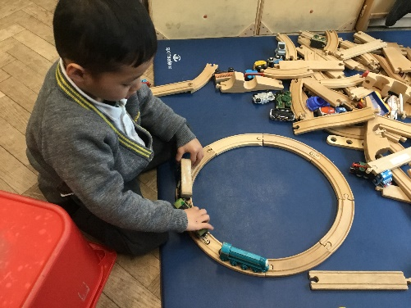
• creating our own ladybirds using paper plates and paint
• potato printing to create a ladybird pattern
• practicing our cutting and sticking skills
• hunting for mini beasts in our outdoor area
• practicing counting forwards to 20 and backwards f rom 10
• focussing on our 1 to 1 counting skills
• remembering to go to the toilet, flush the toilet and wash our hands

Important reminders:
- No nuts or nut-based food in packed lunches, please
- Your child will get a library book every Friday. Please ensure these are returned the following Thursday so that your child can receive their next book.
- Please ensure that your child is wearing the correct uniform and only has 1 piece of jewellery and no hoops/dangling earrings.

