Nursery Newsletter
W/B 22nd April 2024
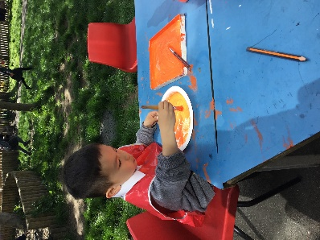
We have been:

• reading our focus story “The Bumble bear”
• learning about different Mini beasts, particularly bumble bees
• learning about the life cycle of a bee
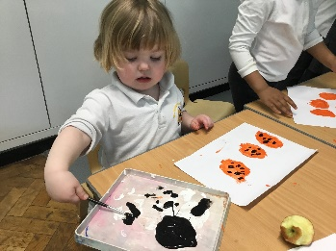
• drawing bees and doing a variety of arts and crafts
- creating repeated pattern with a variety of maths resources
- finding out how bees make honey
• practicing our cutting and sticking skills
• hunting for mini beasts in our outdoor area
• practicing counting forwards to 20 and backwards from 10
• focussing on our 1 to 1 counting skills
• remembering to go to the toilet, flush the toilet and wash our hands

Important reminders:
- No nuts or nut-based food in packed lunches, please
- Your child will get a library book every Friday. Please ensure these are returned the following Thursday so that your child can receive their next book.
- Please ensure that your child is wearing the correct uniform and only has 1 piece of jewellery and no hoops/dangling earrings.
- Please try to get as many sponsors as you can for the ‘sponsored fitness circuit’ (details were given out via parent mail)

