**Summer 2 Term Newsletter Year 6**

**English**

This term we shall be exploring the text ‘Shackleton’s Journey’ this will give us an insight into the heroic effort by Shackleton and his crew to reach and explore the Arctic region. This text will enable children to have a deeper understanding in factual writing. We will be writing newspaper reports and articles as nonfiction texts and writing our own adventure story as our nonfiction text.

**Maths**

We will be focussing primarily on investigative mathematics. This will enable children to develop their problem solving skills. These will focus on a variety of skills such as: trial and error and forming their own investigations. We will also be beginning to focus on transition and thinking heavily about what are the vital skills to take into secondary education. The children will gain the opportunity to develop problem solving skills and reasoning skills as well as secure their fluency.

**P.E.**

We will be taking advantage of warmer weather to introduce Cricket Cricket lessons will focus on developing the skills the children learnt in rounders last year. Children will have the opportunity to develop their bowling and batting as well as strategizing how best to order and organise their teams.

**Science**

During science this half term we will be focusing on Animals and Evolution – taking a closer look at different animals including humans. We will explore key questions such as ‘what type of organisms have lived over each era?’ and ‘how do fossils provide evidence for evolution?’ We are also taking a trip to the Science Museum and London Zoo to further explore our Science topic.

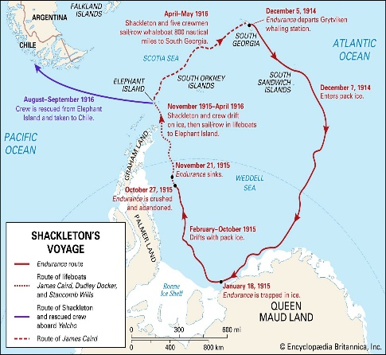

**PSHE**

Year 6 will be focusing on the topic ‘changing me’. This focuses on self-image, puberty and transition to secondary school. Children will begin to understand how to develop their own self- esteem and begin to be able to express how they feel about the changes to their bodies during puberty.

**Computing**

This half term we will be focussing on the topic of ‘search engines’. This will give children a more in depth understanding about how to effectively use a search engine. We will look at the computer science behind these devices and how we could try to create our own.

**Music**

This unit uses the musical skills children have developed this year and in previous years in listening activities, small group composition and improvisations. Children will learn to describe music, to recognise sounds and to create foley, background music and advertising jingles. Children will learn about how music can create an atmosphere or conjure up a certain emotion or experience from a viewer when used for film and television

**R.E.**

This term we will be learning about beliefs and morals. Our key question will be: Does belief in Akhirah help Muslims lead good lives?

**Humanities**

Year 6 will be continuing to have an in-depth look at Geography. Our topic for this half term is Globalisation, which allows the children to understand the relationship between product and consumer. It also allows us to explore the idea of transnational corporations and the monopoly they play in our global food markets.