Winmarleigh Church of England Primary School
Church Lane, Winmarleigh, Garstang, Preston. PR3 0LA
Telephone: 01995 603006
‘ENJOY- BELIEVE –ACHIEVE’
Our Christian Values for this half term are FRIENDSHIP and RESPECT

HEBREWS 13:16 We will show mercy to the poor and not miss an opportunity to do acts of kindness for others, for these are the true sacrifices that delight God’s heart.

Dear Parents and Carers,
Welcome back, we hope you enjoyed a lovely Easter break.
As we learn of the sad news that His Royal Highness, The Prince Philip, Duke of Edinburgh has passed away, the thoughts of all the governors, staff and the children of Winmarleigh Church of England Primary School, are with Her Majesty, The Queen and the rest of the Royal family at this sad time.

We give thanks for the unfailing dedication and commitment to the service of the United Kingdom, the Commonwealth and Her Majesty, The Queen, which The Duke of Edinburgh demonstrated throughout his life.

A Book of Condolence has been opened at school and we invite parents to contribute to this, if you should wish to. The book will be opened on Monday 19th April. It will be in the school entrance porch each morning from 8.40am – 9am for two weeks.
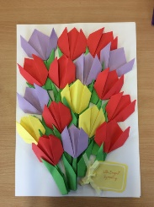

The children made this beautiful card to send to the Queen.
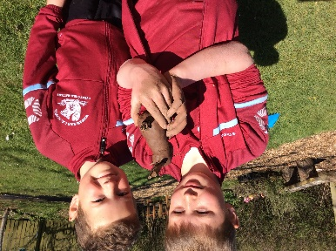
Family Zoom Bingo
Wednesday 28th April at 6pm
Please let Jane know if you would like to take part.

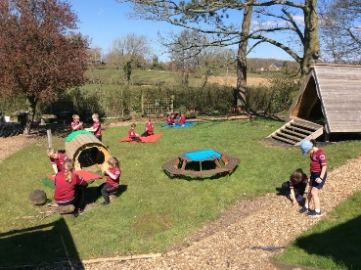

Please find the attached Curriculum Maps for Classes 1 and 2.
We have lots of lovely activities planned!

Could we ask you to please share the attached information on forthcoming Diddi Dance sessions for pre-school children – many thanks.
Kind regards,
Mrs. Alexander

