Policy statement:
The purpose of this policy is to provide clear guidance on the use of Restrictive Physical Intervention (RPI) within our setting, ensuring it aligns with the principles of Cambridgeshire’s Therapeutic Thinking approach and the guidance set out in the Cambridgeshire Restrictive Physical Intervention Policy (November 2022). Our primary aim is to promote safety, well-being, and positive outcomes for all individuals, while minimizing the use of restrictive practices and ensuring that any physical intervention is carried out in a safe, respectful, and appropriate manner.
Scope:
This policy applies to all staff, volunteers, and other individuals working or interacting with service users within our setting. It covers the use of physical intervention in situations where there is an imminent risk of harm to the individual or others, and all interventions must be used only as a last resort after other de-escalation techniques have been exhausted.
Principles:
Therapeutic Approach: We are committed to promoting a therapeutic environment where all individuals are treated with respect, dignity, and compassion. The use of restrictive physical intervention will always prioritize therapeutic goals, focusing on reducing the need for such practices over time.
Person-Centered Care: The individual’s needs, preferences, and rights are central to our approach. Interventions will be proportionate to the situation, tailored to the individual’s needs, and designed to minimize distress.
Last Resort: RPI will only be used when there is a real and immediate risk of harm and where no other means of de-escalation have been effective. The least restrictive option will always be chosen.
Proportionality: The use of restrictive interventions will be appropriate to the situation and based on a thorough assessment of the risk involved, ensuring that the minimum necessary force is applied.
Training and Competency: All staff members will receive regular, comprehensive training in Therapeutic Thinking, de-escalation techniques, and safe physical intervention strategies. They will be assessed for competency in these areas to ensure that physical interventions are carried out safely and effectively.
Accountability and Transparency: All instances of physical intervention will be carefully documented and monitored. Staff will reflect on their practice to identify opportunities for improvement and ensure that interventions are reviewed to ensure compliance with this policy and legal requirements.
Support for Individuals: Post-intervention support will be provided to both the individual subject to the intervention and the staff involved. This includes ensuring emotional and psychological support, as well as addressing any concerns or questions arising from the incident.

BEHAVIOUR EXPECTATIONS AT WISBECH ST MARY CofE ACADEMY
At WSM Academy, we believe that pupils need to be safe, know how to behave pro-socially and know that the adults around them are able to manage them safely and confidently. The use of restrictive physical intervention (RPI) will only be needed for a very small minority of pupils who demonstrate dangerous behaviour. On such occasions, acceptable, planned and agreed forms of intervention may be used.

The majority of pupils behave pro-socially and conform to the expectations of our school. We have a responsibility to operate an effective behaviour policy* that encompasses preventative strategies for tackling difficult and dangerous behaviour in relation to the whole school, each class and individual pupils.

All school staff will receive training to feel that they are able to manage difficult behaviour and have an understanding of what anti-social behaviours might be communicating. They need to know what options are available to them for managing dangerous behaviour.
Difficult behaviour
Behaviour that is anti-social, but not dangerous. It should be acknowledged in terms of context: ‘Daniel continually shouting out is difficult within a group teaching activity’.
Dangerous behaviour
Behaviour that is anti-social and will predictably result in imminent injury or harm (the level of injury and harm that constitutes the label dangerous should be defined within policy). This includes harm to self or others, damage to property or behaviour that would be considered criminal if the person was the age of criminal responsibility, such as racist abuse. Except within an unpredictable first manifestation, the behaviour described as dangerous will be supported by evidence of severity and frequency of outcomes such as ‘three children required first aid for minor bruising as a result of Jane’s kicking’.

* A therapeutically focused Behaviour Policy Guide is available from the Cambridgeshire
Therapeutic Thinking and Trauma Informed Lead.

ACCEPTABLE FORMS OF PHYSICAL INTERVENTION AT WISBECH ST MARY CofE ACADEMY
There are occasions when staff may have cause to have physical contact with pupils for a variety of reasons, such as:

  - Physically separating a child from their parent
  - Carrying, if necessary
  - Physically comforting a child
  - Steering, guiding or escorting a child
  - Comforting a pupil in distress (so long as this is appropriate to their age)
  - Averting danger to pupil/s or staff in an emergency
  - Praising a pupil
  - For curricular reasons (for example in PE, drama etc.)
  - In rare circumstances, restraining a child (RPI)

In all situations where physical contact between staff and pupils takes place, staff must consider:
  - The pupil’s age and level of understanding
  - The pupil’s individual characteristics and history
  - The location where the contact takes place

The pyramid below represents a graduated process of intervention for behaviour. The majority of pupils in our school and other education provision will have their needs catered for at the lower end of the pyramid.
Ethos and values
Language
A graduated response to SEND Managing and communicating expectations Adult behaviour and setting the daily mood
Modelling, mentoring, support
Differentiated measures for behaviour Roots and fruits
Anxiety mapping
Individual risk management plans
Predict and prevent plans
Regular review of plans
Training
Audit of need
Regular reviews RPI plan

RESTRICTIVE PHYSICAL INTERVENTION (RPI) DEFINITION
Restrictive physical intervention (RPI) is the term used to describe any method where the use of force to control a person’s behaviour is employed using bodily contact. It refers to any instance in which a teacher or other adult authorised by the Headteacher has to use ‘reasonable force’ to control or restrain pupils in circumstances that meet the following legally defined criteria:
  - To prevent a child from committing a criminal offence (this applies even if the child is below the age of criminal responsibility)
  - To prevent a child from injuring self or others
  - To prevent or stop a child from causing serious damage to property (including the child’s own property)

There is no legal definition of ‘reasonable force’, though, there are two relevant considerations:
  - The use of force can be regarded as reasonable only if the circumstances of an incident warrant it
  - The degree of force must be in proportion to the circumstances of the incident and the seriousness of the behaviour or consequences it is intended to prevent

Seclusion is an approach to RPI which may only be deemed acceptable in emergency situations, for example, if a student is wielding a knife and cannot be part of a planned approach to managing behaviour.

The definition of physical force also includes the use of mechanical devices (e.g., splints on the pupil prescribed by medical colleagues to prevent self-injury), forcible seclusion or use of locked doors. It is important for staff to note that, although no physical contact may be made in the latter situations, this is still regarded as RPI.

WHEN THE USE OF RPI MAY BE APPROPRIATE AT WISBECH ST MARY CofE ACADEMY
Restrictive physical intervention may be used when all other strategies have been considered and therefore only as a last resort. However, there are other situations when physical handling may be necessary, for example in a situation of clear danger or extreme urgency (see Section 3. above). Certain pupils may become distressed, agitated and out of control, and need calming with a brief RPI that is un-resisted after a few seconds.

The safety and well-being of all staff and pupils are important considerations. Under certain conditions, such as preventing serious injury this duty must be an over-riding factor.

WHO MAY USE RESTRICTIVE PHYSICAL INTERVENTION AT WISBECH ST MARY CofE ACADEMY
The named staff below (as well as the teachers employed at the school) are authorised by the Headteacher to have control of pupils and must be aware of this policy and its implications. However, non-inclusion on this list does not mean that an adult is necessarily barred from using physical intervention. If the Headteacher has lawfully placed an adult in charge of children, then that adult will be entitled to use RPI within the given circumstances.

We take the view that staff should not be expected to put themselves in danger and that removing other pupils and themselves from risky situations may be the right thing to do. We value staff efforts to manage what can be very difficult situations and in which they exercise their duty of care for the pupils.

At times there may be a requirement to use RPI without a plan – this would be considered to be an emergency situation for example:
  - preventing a child running into traffic/water
  - preventing immediate harm to self or others e.g., a fight or significant destruction

Staff will be aware of ‘reasonable force’ and ‘proportionate response’. After such an incident, a full debrief of student, staff and witnesses should occur. A plan must be made, or review of the risk management plan must take place, to mitigate against a recurrence of the situation which led to the RPI. Trained or untrained staff have a duty to act in an emergency with unforeseeable risk of imminent harm.
Names of authorised staff
All teachers are authorised to use RPI in school under the direction of a senior team leader.

DEVELOPING AN INDIVIDUAL RISK MANAGEMENT PLAN AT WISBECH ST MARY CofE ACADEMY
Our school behaviour policy plans for the majority of children. In addition, some children may require an individual risk management plan to formalise those strategies that differentiate from the whole-school policy.

When considering whether to complete a risk management plan for a pupil, we have completed a robust analysis of each pupil’s behaviour, using a graduated response encompassing early prognosis and identification of what needs are being met through the behaviour (what is the function of the behaviour?), risk calculation to determine the seriousness and probability of behaviour, protective and educational consequences, conscious and subconscious behaviour analysis, anxiety mapping, predict and prevent planning and roots and fruits.

When writing a risk management plan, we take into account our planned responses for all the areas below:


Dangerous
or Harmful

Escalation or Difficult
Emotional
Recovery

Reflect Repair Restore


Pro-social

We always ensure that the reflect, repair and restore stage:
- focuses on harm that has been done
- considers how the harm can be repaired
- looks at experiences, feelings and needs
- plans to ensure conflict is less likely to happen in the future.

The plan is regularly reviewed with staff, pupil (if appropriate) and parent/carers.

HOW RESTRICTIVE PHYSICAL INTERVENTION (RPI) IS RECORDED AT WISBECH ST MARY Cof E ACADEMY
The use of a restraint or restrictive intervention, whether planned or unplanned
(emergency), must always be recorded as quickly as practicable (and in any event within 24 hours of the incident) by the person(s) involved in the incident, in a book with numbered pages. The written record should include:
  - the names of the staff and child or young persons involved;
  - the type of restrictive intervention employed;
  - the reason for using a restrictive intervention (rather than non-restrictive strategies);
  - how the incident began and progressed, including details of the child 's behaviour, what was said by all those involved, and the steps taken to defuse or calm the situation;
  - the degree of force used, how that was applied, and for how long;
  - the date and the duration of the whole intervention;
  - whether the child or young person or anyone else experienced injury or distress and, if they did, what action was taken.

All records should be open and transparent and enable consideration to be given to the appropriateness of the use of restraint.

Governing bodies and proprietors must ensure that they comply with their duties under legislation. They must also have regard to this guidance to ensure that the policies, procedures and training in their schools or colleges are always effective and comply with the law.

Governing bodies and proprietors should have a senior board level (or equivalent) lead to take leadership responsibility for their schools or college’s restraint arrangement.

The nominated governor is:

Julie Coales

COMPLAINTS
It is intended that by adopting this policy and keeping parents and governors informed, we can avoid the need for complaints. All disputes which arise about the use of force by a member of staff will be dealt with according to Child Protection and Safeguarding policies.

The following guidance on complaints following a RPI is from page 7 of the DfE 2013 document ‘Use of reasonable force in schools’ (ref: DFE-00295-2013).
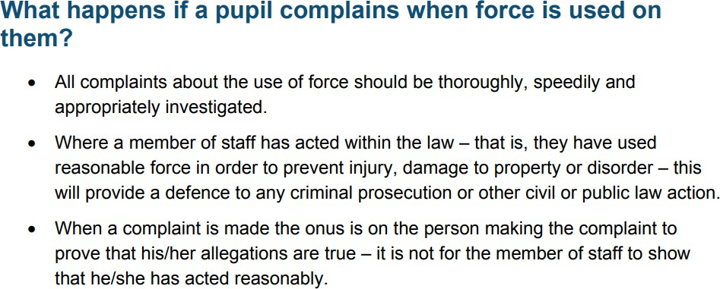
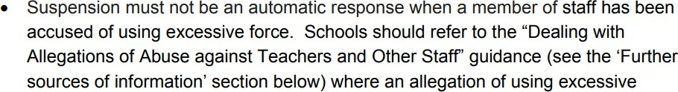
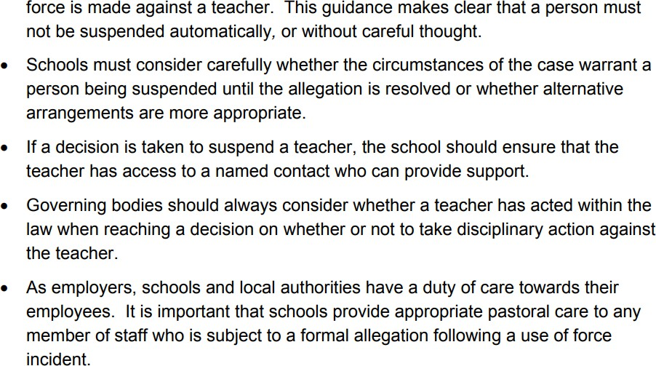

Staff need to be free of undue worries about the risks of legal action against them if they use appropriate physical intervention. Parents need to know that their children are safe with us, and they need to be properly informed if their child is the subject of an RPI, including the nature of the intervention, and the rationale for its use.

CAMBRIDGESHIRE THERAPEUTIC THINKING TRAINING
  - For further information about Cambridgeshire Therapeutic Thinking please click here.

DEFINITIONS
Antisocial (detrimental) behaviour: Behaviour that causes harm to an individual, a group, to the community or to the environment.
Behaviour: Everything a person says or does. The spectrum of behaviour goes from extreme pro-social to extreme anti-social behaviour. A behaviour policy should increase pro-social behaviour and reduce anti-social behaviours through planned responses.
Consequence: A logical, explainable response to a pro-social or anti-social behaviour. A consequence is a logical or natural outcome of something occurring earlier; a conclusion reached via reasoning. Consequences are designed to help children learn and develop pro- social behaviour transferable to all contexts.
Consequence (protective): Removal of a freedom to manage harm. They are necessary measures to manage the risk of harm that results from dangerous behaviours. Protective consequences limit freedoms
Consequence (educational): The learning, rehearsing or teaching so the freedom can be returned.
Dangerous behaviour: That which is anti-social and will predictably result in imminent injury or harm (the level of injury and harm that constitutes the label dangerous should be defined within policy). This includes harm to self or others, damage to property or behaviour that would be considered criminal if the person was the age of criminal responsibility, such as racist abuse. Except within an unpredictable first manifestation, the behaviour described as dangerous will be supported by evidence of severity and frequency of outcomes such as ‘three children required first aid for minor bruising as a result of Jane’s kicking’.
Difficult behaviour: That which is anti-social, but not dangerous. Difficult behaviour should be acknowledged in terms of context: ‘Daniel continually shouting out is difficult within a group teaching activity’.
Dynamic Risk Assessment :An assessment of risk based on all relevant factors available in the moment undertaken by a individual that needs to employ immediate and appropriate actions to manage the presented risk posed during an incident caused by dysregulation. This individual should trained to employ appropriate actions ( e.g. via CTT)
Pro-social (valued) behaviour: Relating to behaviour which is positive, helpful, and values social acceptance.
Punishment: The imposition of an undesirable or unpleasant experience upon a group or individual, meted out by an authority. Punishment is designed to suppress and control behaviour within a specific context.
Restrictive physical intervention (RPI): Any method which involves some degree of direct force to try and limit or restrict movement (Restraint Reduction Network 2019).
- Guidance and Compliance:
This policy is based on the Cambridgeshire Restrictive Physical Intervention Policy (November 2022) and will be reviewed every two years to ensure it reflects current best practices and legal obligations. Staff will be expected to comply with all guidelines provided by the policy, including ensuring that interventions are appropriate, documented, and subject to independent review.
- Monitoring and Review:
We are committed to continuous improvement and will regularly review incidents involving restrictive physical interventions. Feedback from staff, service users, and external agencies will be used to ensure that our practice is safe, ethical, and effective. The policy will be reviewed annually to ensure it remains in line with best practices, legislative changes, and therapeutic standards.
This policy it due to be reviewed in January 2027.
- Conclusion:
We believe that restrictive physical interventions should always be a last resort, used only in exceptional circumstances where safety is at risk. By adhering to the principles of Cambridgeshire’s Therapeutic Thinking approach, we aim to foster an environment of mutual respect, de-escalation, and the effective management of challenging situations, with the ultimate goal of minimising the need for physical intervention.

