**My Starting School Story**

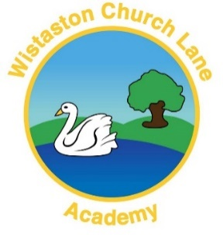

I am going to school on Monday, Tuesday, Wednesday, Thursday and Friday.

On a school day I need to get up at _______.

Before I go to school I need to

· Clean my teeth

· Get dressed

· Eat breakfast

· Brush my hair

· Put my shoes on

· Put my coat on

· Get my bag, my water bottle and ______________

I am going to go to school with Mummy/Daddy and we are going to walk/drive in the car.

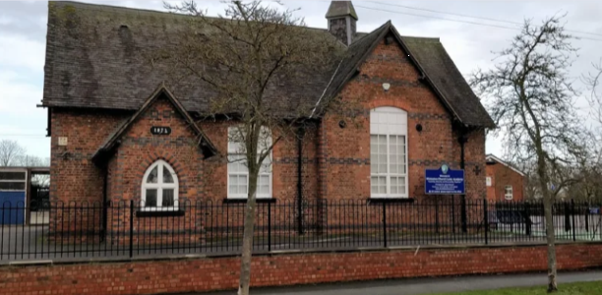

When I get to school I am going to walk through the gate and through the tunnel to the Reception Doors. Both Hungry Caterpillars class and Brown Bears class come in through these doors.

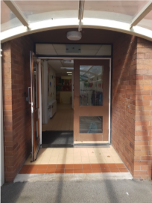

In the cloakroom I will hang up my coat and my bag on my peg. Then I will take my water bottle into the classroom. Sometimes my teacher might ask me to take something else into the classroom, like my reading book.

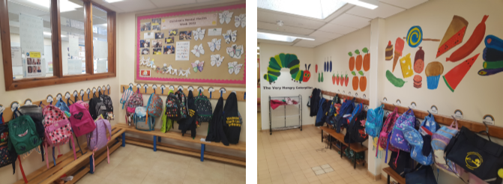

These are my teachers:

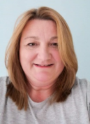 

Mrs Clyne - teacher Miss Longhorn - teacher

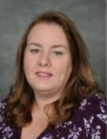 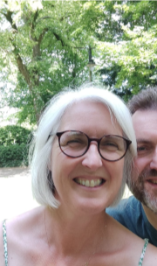

Mrs Earl – Acting Early Years Lead Mrs Palin – teaching assistant

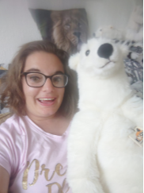

Miss Valente – teaching assistant

They help me learn lots of new things!

The toilets are in the cloakroom. I need to ask an adult if I need the toilet, so they know where I am.

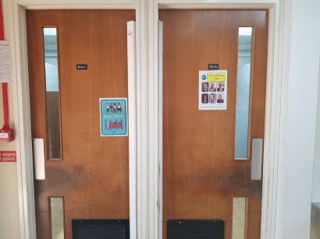

When I am in school, I will sit on the carpet and do the register, so the teacher knows who is in school. I will have a space to sit at. The teacher will ask me what I would like for my lunch from a choice of 3 things.

There will be a timetable on the wall to tell me what is happening during the day.

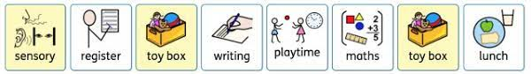

When we have Busy Bee learning time I can choose where to work.

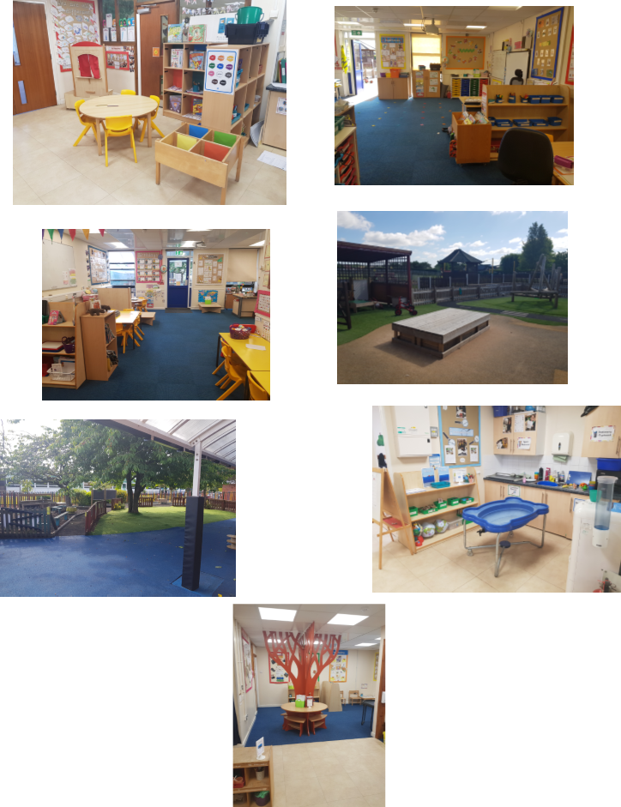

At lunch time I will wash my hands, then I go and eat lunch in the hall. After lunch I will go outside to play with my friends.

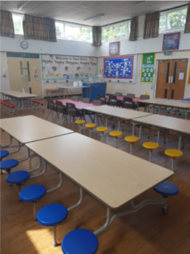

In the afternoon the teacher will do the register again.

At home time I will be collected by ______________.

They will wait outside my classroom door for me. I can go out when the teacher tells me to.

Sometimes I might go to an after-school club. My teacher will take me to the right place. After my club, I will be collected by ________________ from the Junior Playground/Swan Stars.