
Reading Fluency at Wordsworth

What is reading fluency?
Throughout their time at school, you will hear teachers talking about how fluent your child is at reading. But what does this mean? Fluency means reading without too many pauses and without making too many mistakes.
It can be split into these three areas:
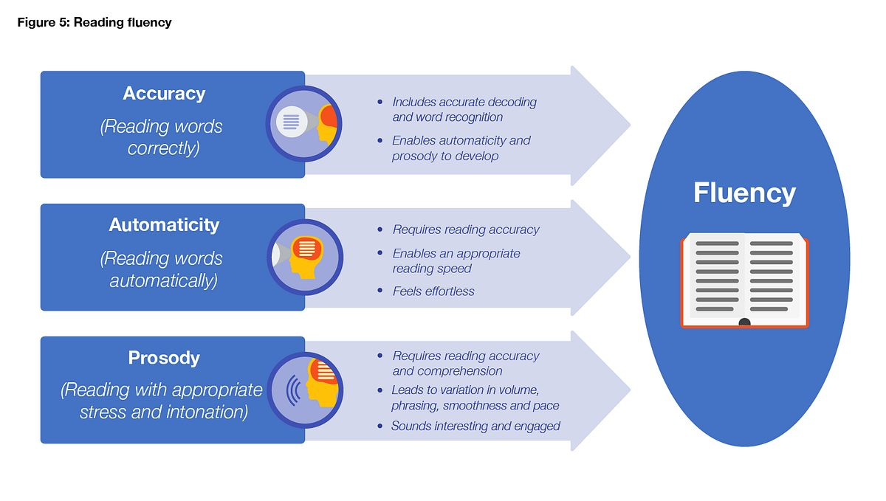
(‘Improving Literacy in KS2’ guidance report, EEF, 2021)

Why is it important?
When children are fluent readers, they are better able to understand what they are reading, as they no longer need to use brain space on decoding. This means they can focus on enjoying what they read and building their understanding (comprehension) which makes them stronger readers overall.

What do we do to help children become fluent readers at Wordsworth?
We teach children to be fluent readers first through the Little Wandle phonics program in year R and Year 1, where they are taught in phonics lessons then practice the sounds at their level in linked Little Wandle reading sessions.
Throughout the school, we teach children to be fluent readers by modelling how to read a range of different texts with accuracy, automaticity and prosody.
In Year 2 and Key Stage 2 children are taught using the Reader’s Theatre approach, where they listen to an adult model fluent reading of a text, echo that same prosody back, read the text multiple times themselves until they are fluent, then use their understanding of the text to choose their own prosody.
They then practice their accuracy, automaticity and prosody independently through their love of reading book and their Accelerated Reader text, which is closely matched to their reading level.

What can you do at home to support your child become a fluent reader?
- Read to your child regularly (short amounts every day)
- Listen to them read regularly – even after they have finished Little Wandle and appear to be fluent readers, children need to continue reading new and more challenging texts aloud.

