Wordsworth Primary and Nursery Safeguarding Newsletter Autumn Term 1 2026
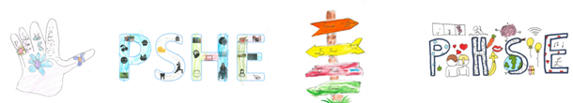
This half term our focus was Core Values and Community

YR – People who help us
Y1 – Core Values, Class Charters, Community
Y2 – Core Values, Class Charters, Community
Y3 – Core Vaues, Class Charters, Community
Differences & Relationships in the Community
Y4 – Relationships/Respect Ambassadors
Y5 – Rights, Respect & Responsibilities
Y6 – Peer Pressure


The National Crime Agency’s CEOP Education team have launched a suite of new resources to help, parents and carers, and young people understand and respond to the growing threat of online harm groups.

Online harm groups, often referred to as ‘Com Groups’, use tactics such as grooming, coercion, manipulation and blackmail to exploit young people online. Their activity can overlap with a range of harms, including child sexual abuse.

This is a link to it: Parents and Carers Guidance.

 Online Safety Hub
Trusted digital safety advice for caregivers
The Online Safety Hub offers advice and guidance to help you manage your child's safety online as a parent. It includes information on the latest hot topics when it comes to keeping children safe. Please take a further look. Online Safety Hub - Hamwic Education Trust
Are you experiencing Tech related Tantrums?
Please see the Parenting Advice by clicking on the link below



Taming the Tech Tantrum

Reminder please…..
 New Mobile Phone Policy and Code of Conduct

www.wordsworthprimary.co.uk
The DfE expect that all schools should be mobile-free environments for pupils. This is to ensure that interruptions to learning are minimised and that behaviour is not adversely affected by the access to a range of media and communication supported by mobile phones.
In line with DfE guidance, our expectations are that mobile phones should not be brought to school. If a staff member sees a pupil with a mobile phone or hears a mobile phone ringing in a child’s bag, it will be removed and taken to the main school office where it can be collected by a parent.
A phone will not be returned directly to the pupil. Any sanction will be issued to the pupil in line with the school behaviour policy.
We recognise that some older pupils travel to and from school alone, and parents require children to carry a mobile phone as part of keeping them safe. In our school we believe children up to age of 10 years old, should be travelling to school with an adult. Therefore, the exception below refers to pupils in years 5 & 6 after the child’s 10th birthday.

 Hamsphire & Isle of Wight Fire Rescue Service Safety Information

The best way to enjoy fireworks is by attending a professionally organised public display. Most firework-related injuries happen when fireworks are used at home, especially in gardens.
If you decide to use fireworks at home, make sure to follow our safety advice to protect yourself and those around you.

Using Fireworks Safely
We encourage anyone who does wish to host a private event to reduce the risk by following our fire safety guidance:

Things to Do
- Only buy fireworks with a CE mark.
- Keep fireworks in a closed box.
- Follow the instructions on each firework.
- Light them at arm’s length.
- Stand well back.
- Always supervise children around fireworks.
- Keep pets indoors.

Things Not to Do
- Don’t drink alcohol when handling fireworks.
- Don’t go near a firework that has been lit – even if it hasn’t gone off, it could still explode.
- Don’t put fireworks in your pocket or throw them.
- Don’t let off fireworks after 11pm.
- Don’t use fireworks near thatched properties or crops, especially during periods of dry weather.

Illegal Use of Fireworks – Know the Law
Using fireworks irresponsibly is against the law. You could face fines or prosecution if you:
- Set off or throw fireworks (including sparklers) in the street or any public place
- Carry fireworks in public if you are under 18
- Tamper with or attempt to modify fireworks in any way

Use fireworks outside the legal time limits:
- General rule: No fireworks before 7:00 AM or after 11:00 PM
- Exceptions: Bonfire Night: Until midnight. Diwali, New Year’s Eve, and Chinese New Year: Until 1:00 AM

Anti-Bullying Week 2026: Break the Silence
ABA are official organisers of Anti-Bullying Week and Odd Socks Day in England, Wales and Northern Ireland. Anti-Bullying Week 2026 will take place from Monday 16th to Friday 20th November with the theme: Break the Silence. The week will kick off with Odd Socks Day on Monday 16th, with adults and children being encouraged to wear odd socks to celebrate what makes us all unique.
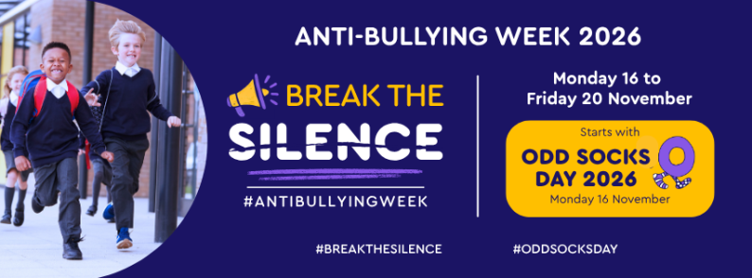


POLITE REMINDER

Our school site is a mobile phone free zone. Please greet your child with a smile not a mobile phone!

If you are in need of any support please do not hesitate in contacting us.

