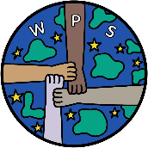Wordsworth Primary and Nursery Safeguarding Newsletter Autumn Term 2 2025
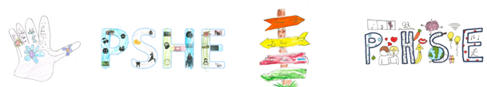
This half term our focus is #WWSafe

YR – Personal Safety
Y1 - How do we keep safe?
Y2 – Safe and unsafe play?
Y3 – What can we do about bullying?
Y4 – What are we responsible for?
Y5 – What does discrimination mean?
Y6 – Why and how laws are made?


Important Safeguarding Alerts
Roblox Roblox Roblox Roblox Roblox Roblox
Concerns are being raised about a new pop-up embedded into Roblox, where it asks a child to download an app called pollybuzz (or pollyfuzz in some spelling cases).
Onface value the app seems quite simple where children are asked questions, and it generates an Artificial Intelligence ‘friend’. This starts off quite innocently but then begins to show extreme content (including suicide, self-harm and pornography).
We strongly advise parents to
- check your child’s device if they play Roblox and remove the app, as soon as possible.
- remind your child about not clicking on pop-ups in games and not downloading new apps without your knowledge or agreement.
- remind your child about talking to them straight away (or another trusted adult, if appropriate) if they see anything online that is worrying or inappropriate.
Parents Reminders
- Parental controls do not stop all pop-ups, so you need to always keep a close eye on what your child is doing and seeing online.
- A link to the Parents Controls section of Roblox, containing instructions of how to put these on can be accessed via this link: Parental Controls Overview – Roblox Support

Online Safety Hub
Trusted digital safety advice for caregivers
The Online Safety Hub is a brand-new online resource with lots of expert advice and guidance to help you manage your child's safety online as a parent. It includes information on the latest hot topics when it comes to keeping children safe, such as how to manage your child's screen time, understand the latest gaming platforms, what they mean for your child’s safety and lots more. https://hamwic.onlinesafetyhub.uk/
We’re also offering you as a parent, a free Qustodio account facilitating parental controls on any individual device and free premium access for 30 days. Gain more visibility on what’s going on in your child’s online world. Block dangerous content, introduce screen-free schedules, receive alerts for inappropriate content, keep tabs on their location and more. Follow the link to create your free account
https://www.qustodio.com/en/30-days-school-special/?utm_source=internal&utm_medium=OSHub&utm_campaign=hamwic

Help shape our online safety session!

We know how important it is to keep children safe online, and we want to make sure our upcoming online Information Session answers the questions that matter the most to you.

In the New Year, experts in online safeguarding from the OSH will host a trust-wide event designed for parents and this is your chance to shape the content of the session.
Would you like information on Roblox, YouTube, social media safety, or cyberbullying? Or maybe something else? Tell us what you want to learn more about by completing this short survey:

Parent Survey Online Information Session on Pupil Online Safety – Fill in form

Don’t miss the chance to influence the content - please complete the survey by Wednesday 3rd December.

Together, we’re building a safer digital space for every child. Thank you for contributing.

School Rules
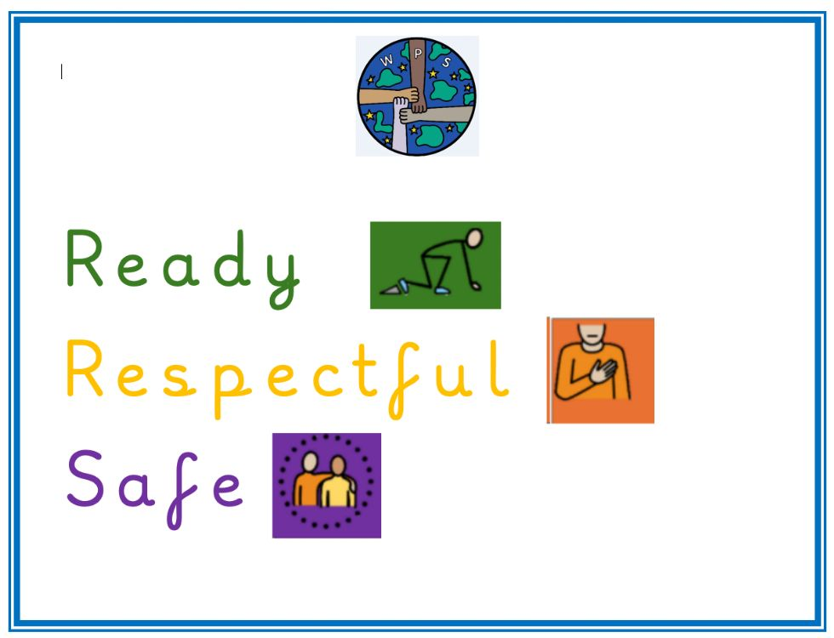
We have linked our school rules to our school values- Empowerment, Community, Trust, Nurture and Learning. The children and adults have broken each of the school rules down into 'what the children will do' and 'what the adults will do' to ensure all stakeholders know how to follow the school rules.
Please take time to chat about why School Rules are important and how we can all support each other in staying safe and having fun at Wordsworth.

If you in need of any support please do not hesitate in contacting us.

