Wordsworth Primary School Whole School Writing Map 2024/2025
Audiences are decided in consultation with the children and class teacher. As children move through the school and their understanding of purpose, form and audience deepens, there will be a greater element of choice allowed.
 | Autumn 1 (8 weeks) | Autumn 2 (7 weeks) | Spring 1 (6 weeks) | Spring 2 (6 weeks) | Summer 1 (5 weeks) | Summer 2 (7 weeks)
Year 6 | 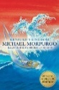  P: To inform  F: Non-chronological report  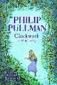  P: To entertain  F: Suspense story including dialogue |   P: To inform  F: Informal & formal letters  P: To persuade  F: Speech  F: Real life letter of persuasion related to world issues | 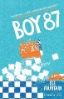  P: To persuade  F: Speech  P: To discuss    F: Balanced argument  P: To entertain  F: Diary extracts | 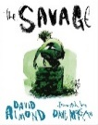  P: To entertain  F: Missing chapter including dialogue  P: To inform  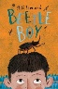  F: Informal & formal letters  P: To inform  F: Non-chronological report |   P: To inform  F: Diary extracts    P: To entertain  F: Twisted retelling including dialogue | 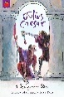  P: To persuade  F: Informal letter    F: Real life letter of persuasion related to world issues  P: To entertain  F: Poem
Year 5 |   P: To inform    F: Diary in role  P: To entertain  F: Adventure story |   P: To inform  F: Recount of EI workshop(Hist link)  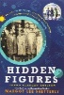  P: To persuade  F: Speech  F: Real life letter of persuasion related to world issues |   P: To entertain  F: Diary in role  F Letters in role formal vs informal |   P: To discuss  F: Balanced argument | 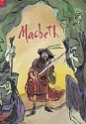  P: To persuade  F: Informal letter    P: To inform  F: Leaflet (Geog link) |   P: To inform  F: Leaflet  P: To entertain  F: Missing chapter
Year 4 | P: To entertain  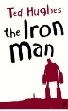  F: Mystery story    P: To inform  F: Non-chronological report about digestion (Sci link) | 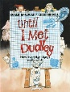  P: To inform    F: Explanation text  P: To persuade  F: Letter in role  F: Real life letter of persuasion related to community | 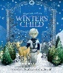  P: To entertain  F: Poem    P: To persuade  F: Leaflet advertising a coastal city (Geog link) | 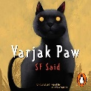  P: To inform  F: Non-chronological report  P: To entertain  F: Diary in role |   P: To inform  F: Recount  F: Non-chronological report (Hist link) | 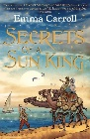  P: To entertain  F: Diary  F: Letter in role
Year 3 | 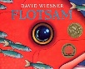  P: To entertain  F: Setting description  F: Sequel Story  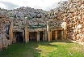  P: To inform  F: Instructional writing  F: Non-chronological report  (Hist link) | 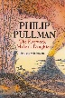  P: To entertain  F: Missing event narrative  F:    P: To entertain  F: Retelling | 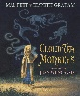  P: To persuade  F: Letter in role  F: Real life letter of persuasion related to school | 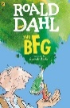  P: To entertain  F: Mystery story | 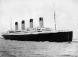  P: To inform  F: Non-chronological report/ leaflet  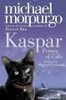  P: To entertain  F: Prediction story | 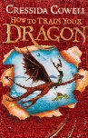  P: To persuade  F: Advertising poster  P: To entertain  F: Missing chapter  P: To inform  F: Non-chronological report
Year 2 | 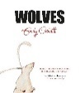  P: To inform  F: Non-chronological report/ Information Page  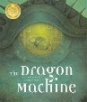  P: To entertain  F: Story | 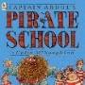  P: To entertain  F: Diary of own experience  P: To persuade  F: Danger poster    P: To inform  F: Recount of Zoo Lab workshop  F: Thank you Letter (Sci link) | P: To inform  F: Non-chronological report (Hist link)  P: To entertain  F: Retelling     |   P: To entertain  F: Story  P: To inform  F: Instructions    P: To inform  F: Recount of Minstead trip (Geog link) | 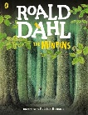  P: To persuade  F: Danger poster  P: To entertain  F: Character description  F: Retelling |   P: To entertain  F: Diary in role  P: To entertain  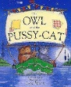  F: Poem
Year 1 | 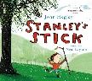  P: To entertain  F: Retelling  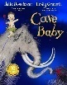  P: To entertain  F: Story | P: To entertain  F: Retelling  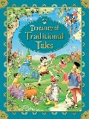  P: To inform  F: Letter  F: Instructions  P: To persuade  F: Danger poster |   P: To inform  F: Information page/Fact file  (Hist link)   | 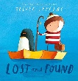  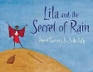  P: To entertain  F: Retelling  P: To entertain  F: Diary | P: To inform  F: Recount of Testwood Lakes Visit    F: Thank you letter (Sci link) | 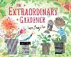  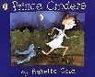  P: To entertain  F: Retelling  P: To entertain  F: Retelling

