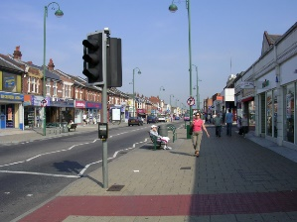
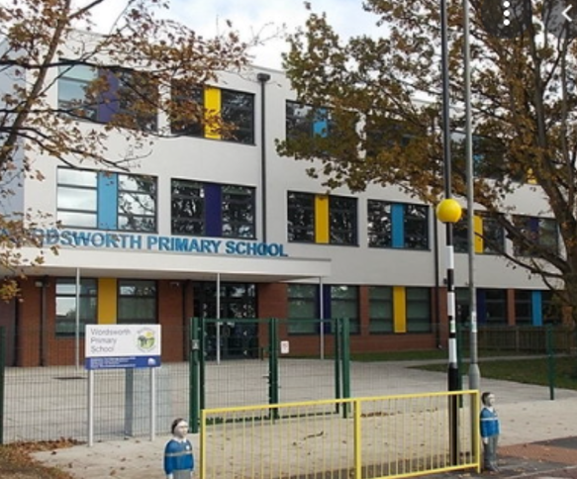


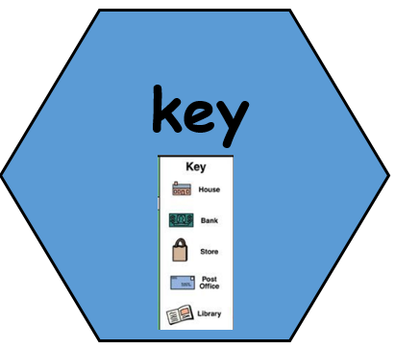
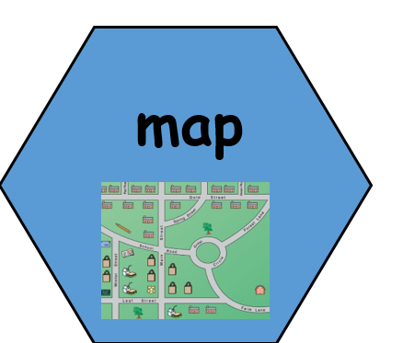


What is my local area like?
TWAL: To use maps to identify features of the local area.
We will talk about the local area we live in We will use digimaps, to look at the local area and describe the features they can see. We will use some symbols and keys on the map to help us.
A map shows us where places are. A key explains the symbols on the map

2. What is the weather like in Shirley?
TWAL: To describe the weather in Shirley across the year.
We will use our experiences and information to talk about what the weather is like in Shirley throughout the year.
A map can show us the weather. A key explains the symbols on the map (weather types).
A guide to explain the symbols on a map
A plan of a specific area.

6. What about further into Shirley?
TWAL: To describe features of our local area. To record features in a pictogram.
We will go on a virtual walk of Shirley high street
and record features in a pictogram.

5. Can you make your own map?
TWAL: To create my own map.
We will create our own map of the area around our school,
with our school at the heart of our map.

4. What does the area around the school look like?
TWAL: To describe the features of our local area. To use locational language to describe the location of features.
We will go on a walk around the surrounding school area and talk about the location of features. We will record the features we see in a simple table.

Words we will know!

3. What does Shirley look like from the rooftop?
TWAL: To talk about features from an aerial view.
We will look at an aerial view of the school and the surrounding area. Then we will visit the roof top and make observational drawings of what features we can see and where we can see them.
An aerial plan looks down from above.

Theme: My local area – What is Shirley like?
Concept: Location, Place, Settlement, Human and Physical Features, Weather and Climate, Mapping and Field Work.
We are learning about our local area, around our school and Shirley high street. We will learn about our weather, features of the area and all about maps. We will make our own maps, drawings and pictograms to record information.
Prior Learning:

