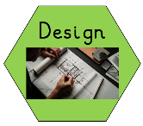
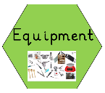
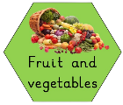
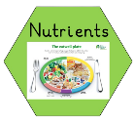
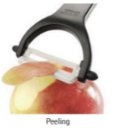
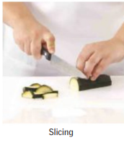
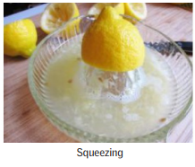
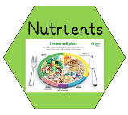
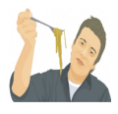
Glossary
Fruit – plant or tree’s edible seed with envelope.
Vegetable – plant used for food.
Nutrients – all the things in food that the body needs to remain healthy.
Pith – the soft white lining inside fruit such as oranges.
Sensory evaluation – subjective testing of foods where senses are used to evaluate qualities such as appearance, smell, taste, texture (mouth feel).
Words you will know:

Skills you will learn:
Prior Learning: In Year R children will have: pulled fruit, peeled fruit, spooned ingredients between containers, measured ingredients, cut soft foods with a butter knife.
- Designers and inventors- Biographical Knowledge
TWAL: We will learn about a famous chef and how they link to our design brief.
What do I know about Jamie Oliver?
We will find out facts about Jamie Oliver and create a class fact file.
We will find out how he helped to improve school dinners and introduce basic nutrition standards.
We will find out how he wants to help children by extending free school meals to more children.
We will be given our design brief- to make a healthy fruit smoothie.
Cross Curricular Links – PE – Keeping healthy PSED – Positive mental health Science – balanced diet
Meet a famous chef:

Jamie Oliver is a British chef who campaigned to make British schools serve healthier food. He has a number of cookbooks about healthy eating- some of which contain smoothies!
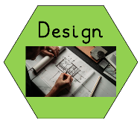
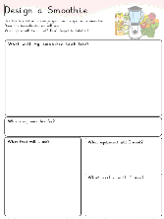
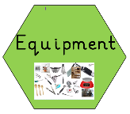
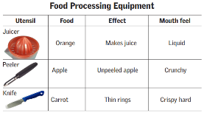
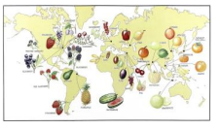
4. Generating Ideas- Making a proposal
What sort of fruit product shall I make?
Which fruit will I put into my smoothie?
Who will it be for?
Will my product appeal to my intended user?
What skills will I need?

5. Making Food: Materials and techniques
We will learn about hygiene and what we need to do before we prepare our fruit. We will learn how to cut soft fruits and vegetables using the claw and bridge grip. We will learn how to squeeze oranges to make juice for our smoothie.
What tools and food processing skills will I use?
What order will I work in?
What skills will I need to use?
6. Evaluating- We will carry out a sensory evaluation.
We will complete a sensory evaluation to evaluate qualities such as appearance, smell, taste, texture (mouth feel).Use of techniques
The product
Identify similarities and differences to others’ work
Reflecting
Do I need to adjust or change anything?
Will my fruit salad meet the needs of the user and achieve its purpose?
3. Generating Ideas: Experimenting
How will I process my fruit?

We will learn that chefs use peelers, knives and juicers to prepare fruit. We will be shown how to use the claw and bridge grip to cut fruit and vegetables. We will explore a variety of soft fruits and evaluate which ones we liked.
We will learn that chefs use blenders to make a smoothie. We will explore a variety of pre-prepared smoothies to identify the different fruits that have been used to create the flavour. We will complete a sensory evaluation to evaluate qualities such as appearance, smell, taste, texture (mouth feel).
2. Generating Ideas: Looking and talking
TWAL: to understand where fruit comes from and that some fruits are imported.
We will look at different fruits and learn where they come from.
We will learn that some fruits are imported.
We will find out the nutrients in fruit eg vitamins.
We will find out where fruit is in the healthy eating plate.

