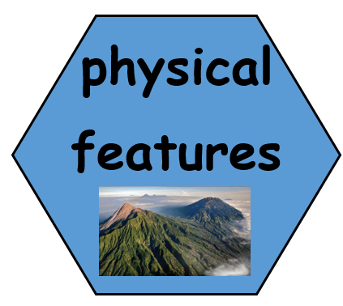
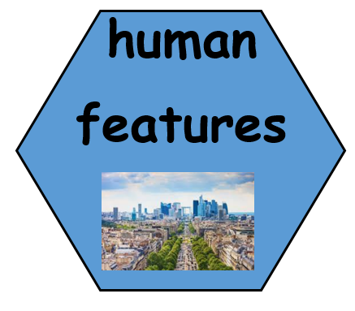
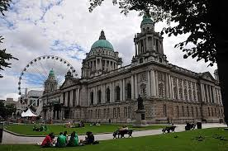


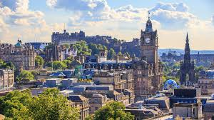
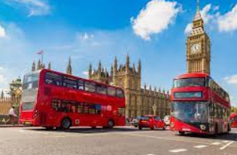
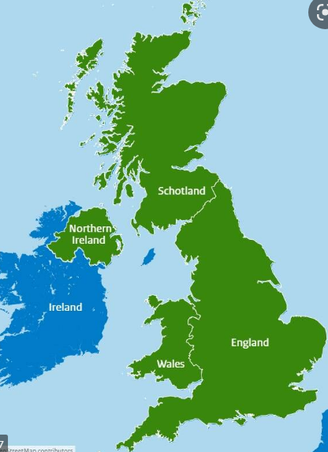

Features that are natural.
Features that are man-made.
The most important city in a country.

2. What is the capital of England? What is it like?
TWAL: To locate England, its capital city and describe what it is like.
We will learn what a capital city is and explore London using street view, learning about key landmarks. We will use maps to identify human and physical features and record them in a table.
London is the capital city of England

What countries are in the United Kingdom?
TWAL: To name and locate the four countries of the United Kingdom. To name and find seas surrounding the United Kingdom.
We will use maps to find and name the countries
and seas around the United Kingdom.
The United Kingdom is made up of the 4 nations Wales, Scotland, Northern Ireland and England. The seas around the UK are: The North Sea, The English Channel, The Celtic Sea, The Irish Sea and The Atlantic Ocean.

3. What is the capital of Scotland? What is it like?
TWAL: To locate Scotland, its capital city and describe what it is like.
We explore Edinburgh using street view, learning about key landmarks. We will use maps to identify human and physical features and record them
in a table.
Edinburgh is the capital city of Scotland.

Theme: Is everywhere like Southampton?
Concept: Location and Place, Human and Physical features and Settlement
We are learning about the location of the UK and its four countries. They will explore and discover facts about each capital city including famous landmarks.

6. Is everywhere like Southampton?
TWAL: To describe similarities and differences between Southampton and capital cities.
To use what we have learnt to about human and physical features that are the same and different.

5. What is the capital city of Northern Ireland? What is it like?
TWAL: To locate Northern Ireland, its capital city and describe what it is like.

We explore Cardiff using street view, learning about key

landmarks. We will use maps to identify human and physical features

and record them in a table.
Belfast is the capital of Northern Ireland.

4. What is the capital of Wales? What is it like?
TWAL: To locate Wales, its capital city and describe what it is like.
We explore Cardiff using street view, learning about key landmarks. We will use maps to identify human and physical features and record them in a table.
Cardiff is the capital of Wales. 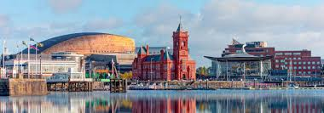

Words we will know!

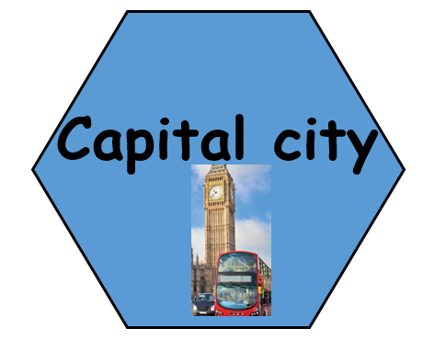
Prior Learning:

