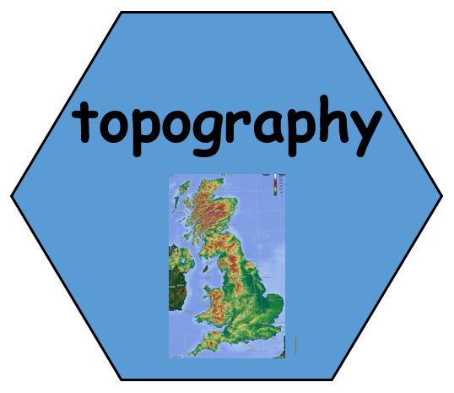

5. How and why has Southampton changed?

TWAL: To explain how land use in Southampton has changed throughout history.
We will use the information we have found, to compare the geography of Southampton in the past and now. We will identify the key ways Southampton has changed and how the lives of people here have changed over time.
The geography of Southampton is influenced by the sea and rivers. Land was reclaimed to form Southampton docks to cater for more ships. Southampton was located by the sea for transport links.

6. Weather and Climate: What is changing now? What does the future of Southampton look like?
TWAL: To talk about the impact humans can have on the environment.
We will use simple climate information from Southampton now and in the past. We will discuss some news headlines about climate and pollution in Southampton then talk about how the changes in the settlement of Southampton may have impacted our climate. We will talk about some recent new headlines and how Southampton is changing.

2. Location & Place What were the physical and human features of Southampton in the past?
TWAL: To use maps to observe, identify and describe changing human and physical features of Southampton in the past.
We will use digimaps and old maps of Southampton to identify human and physical features of Southampton in the past.
The port of Southampton was much smaller and had a few small quays.

Location & Place: What are the physical and human features of Southampton now?
TWAL: To use digital maps to name and locate topographical features of Southampton now.
We recap the location of Southampton in the UK and then use digimaps to investigate and identify the human and physical features of Southampton. We will learn what topography means and use topographic map to discuss the topography of Southampton.
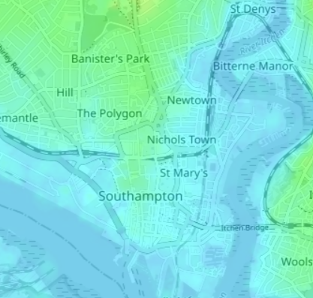

Theme: How has Southampton changed over time?
Concept: Location, Settlement, Mapping, Weather and Climate
We are learning about how the human and physical geography of Southampton has changed over time.
The arrangement of the physical features such as hills, rivers and mountains in an area.

4. Settlement: What does the settlement of Southampton look like in the past and how was land used?
TWAL: To understand what we mean by settlement. To identify how Southampton was used in the past.
We will use maps to identify features of settlement and land use in Southampton in the past. We will use photos to talk about the things that people did in Southampton in the past.

Words we will know!

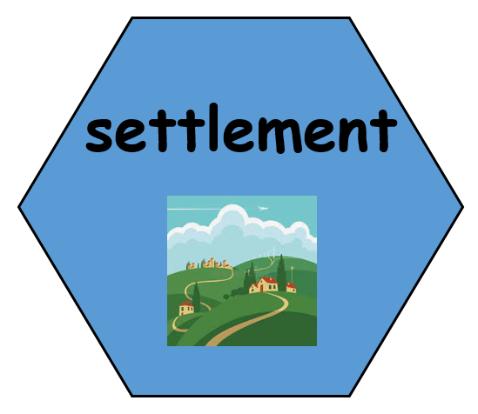

3. Settlement: What does the settlement of Southampton look like now and how is land used?
TWAL: To understand what we mean by settlement. To identify how Southampton is used now.
We will learn what a settlement is. We will use maps to identify features of settlement and land use in Southampton now. We will use photos to talk about the things that people do in Southampton now.

Prior Learning:

