



6. What is the coast of The Solent like?
TWAL: To present my findings to answer a question.
Children will use their work to write a short report about The Solent presenting the information they have found out.

3. How has the coastline changed?
TWAL: To recognise that our coastlines are changing.
Using digimaps and it’s key to compare the coastline between 1890 and current day. We will also identify the type of land that is eroding.
Marshland and single beaches have been eroding along some of the coastline of the Solent.

4 & 5: What is erosion?
TWAL: To investigate coastal erosion and record its effects.
We will conduct a simple experiment to investigate the cause and impact of coastal erosion. We will measure and record its impact.
Using photos, street view and aerial photos we will identify human features that link to erosion. Then we will build our own sea defences (jetties and seawalls) and repeat the experiment.
Coastal erosion is when water/waves moves or carries away rocks and soil. Sea defences can be found along the coast to protect against coastal erosion.

2. What is the coast on The Solent like?
TWAL: To find out the human and physical Geography of The Solent’s coast.
We will discover the human and physical geography of the Solent’s coast identifying features using maps and google earth and plot them on a map of The Solent. We will record the features we find in a bar chart.
There are a number of settlements along The Solent. There are many special areas of conservation (protected areas) along The Solent.

Where is The Solent?
TWAL: To locate The Solent using maps.
We will recap the names of the oceans using and locate The Solent, including where it is in relation to land and seas using maps. We find Southampton’s location in relation to The Solent and recap that Southampton was located by the sea for transport links.
The Solent is a strait between the Isle of Wight and mainland Great Britain. It is part of the English Channel.

Erosion is a process where natural forces like water, wind, ice, and gravity wear away rocks and soil.
Land next to or near the sea.

Words we will know!

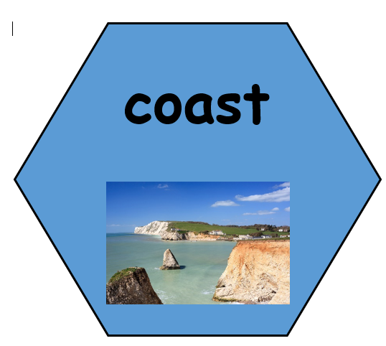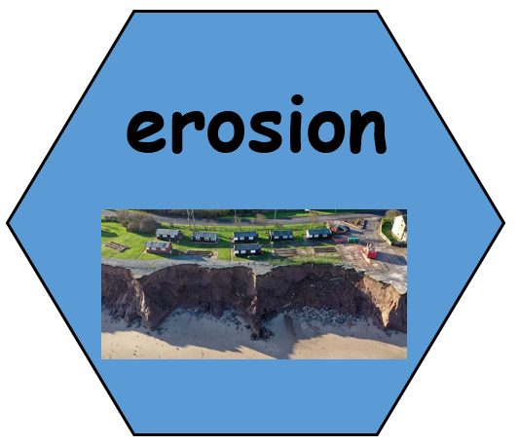
Theme: The Solent: What are our coasts like?
Concept: Location and Place, Human and Physical Features, Mapping, Environment and Sustainability, Weather and Climate
We are learning about the Solent, where it is located linked to settlements and oceans as well as its physical features. We will conduct an investigation, making observations, gather and record information to find out about coastal erosion.
Prior Learning: In Y2 children named the seas around the UK. In the Autumn term Y3 learnt that geography of Southampton is influenced by the sea and rivers.
- Land was reclaimed to form Southampton docks to cater for more ships.
Southampton was located by the sea for transport links.

