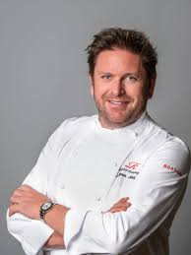
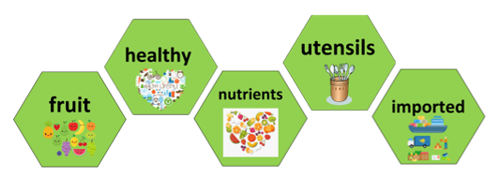
James Martin is a chef who has presented some of the most popular cooking shows on TV including James Martin's Saturday Morning, Saturday Kitchen, Home Comforts and James Martin's Great British Adventure. He has also published over 20 best-selling cook books.
4. Generating Ideas- Making a proposal
In small teams we will decide how we want to adapt the basic egg recipie.
What extra ingredients will we add? How can we adapt a recipe to meet cultural and dietary needs
What skills will I need?- press, peel, spoon, measure, grate, cut

- Designers and inventors- Biographical Knowledge
TWAL: We will learn about a famous chef and how they link to our design brief.
What do I know about James Martin?
We will find out facts about James Martin and create a fact sheet
We will find out about the Omelette Challenge on the BBC One Saturday morning show 'Saturday Kitchen'.
We will be given our design brief- to design and make an omelette.

Cross Curricular Links – PE – Keeping healthy PSED – Positive mental health Science – balanced diet
Meet a famous chef:

Words you will know:

Skills you will learn:
press, peel, spoon, measure, grate, snip, cut
Prior Learning: In Year 3 children will have learnt how to : press, peel, spoon, measure, grate, cut

6. Evaluating
Use of techniques
The product
Identify similarities and differences to others’ work
Reflecting
Do I need to adjust or change anything?

3. Generating Ideas: Experimenting
We will watch some clips of the omelette challenge on Saturday Kitchen.
We will sample some teacher made omelettes made with different ingredients.
We will explore adding different ingredients to change the flavour and nutritional content.
We will say what omelette we like the most and say why. We will say what omelette we liked the least and say why. We will learn about adding fresh herbs to add flavour.
2. Generating Ideas: Looking and talking
We will look at different recipes for omelettes and identify the key ingredients.
We will find out about the nutritional values in eggs and where they are in the healthy plate.
We will find out where eggs come from. We will learn about the difference between free range eggs and caged eggs. We will compare chicken eggs with duck eggs.
5. Making Food: Materials and techniques
TWAL: to create and follow a simple recipe.
What tools and food processing skills will I use?
What order will I work in?
What support will I need?

