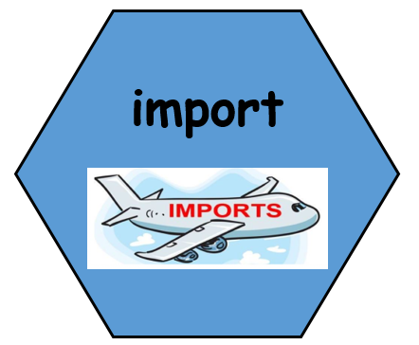
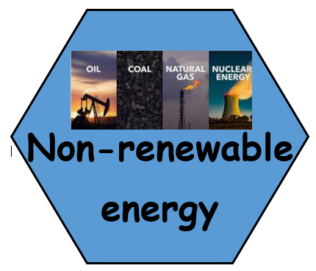
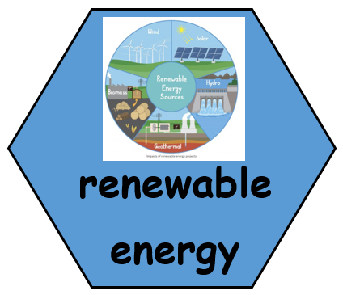
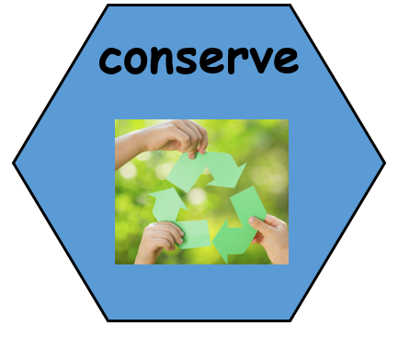

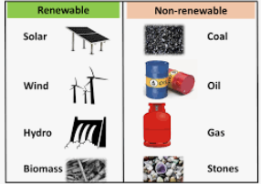


Prior Learning: Children will know where they live in relation to the immediate environment, the country and the continent. They will know the names and shapes of the continents and be able to name some countries in Europe. Children in Year 5 will know about the poles, the equator and some key lines of latitude and longitude.

Words we will know!

Buying goods from abroad
A source of energy that will run out.
Created by resources that nature can replace.
To use as few resources as possible.
Theme: How do we affect our world?
Concept: Settlement and Land Use, Mapping, Environment and Sustainability, Weather and Climate
We are going to learn about the distribution of natural resources including energy and food. We will also look at how these can have an impact on people and the environment and changes over time.

What do settlers need?
TWAL: To explain what settlers need.
We will think about the location of different settlements and why early people chose to settle there. Children will identify which resources are key to survival, and why it is helpful to be located in certain places.
Settlers need shelter and resources to survive.

2. Where does our power come from?
TWAL: To find out land use for power and energy around Southampton.
Children will think about how electricity gets to the classroom. We will also look at different ways in which power is produced in the Southampton/Hampshire, thinking about the positives and negatives of each source. Using atlases/Digimaps, we can locate some power stations/sources.

4. Is all our food local?
TWAL: To learn about origins and distribution of food and the impact on the environment.
We will use using atlases/Digimaps, to locate places of food production in Southampton/Hampshire. We will look at other food available in the supermarkets calculate some food miles. We will think why food may come from these places and about whether it is good or bad to be importing food a long distance.

5. What is the impact on our world?

TWAL: To know about changes to the world environment over time.

We will use Digimaps to explore and discuss the changes in world climate. We will look and talk about changes to pollution and air quality using using maps and data.

6. How can we make a positive impact on our world?
TWAL: To know some reasons why people seek, manage and sustain the environment.
Children will look at conservation of resources and think about how this will affect the world long term. We will play a simple climate change game to help us make links between our choices and the environment.
People need to control their use of resources to safeguard them for the future.

3. Renewable or non-renewable?
TWAL: To about recognise the difference between renewable energy sources
Children will investigate different types of renewable power. They
will think about the advantages and disadvantages of each type of
power.

Renewable energy sources are much better for the environment.

