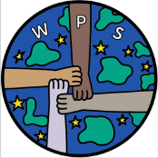
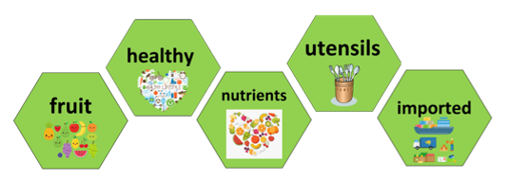
During your Wordsworth journey you have learnt about different famous chefs and looked at their skills and techniques. You have practices lots of skills to become chefs.
Words you will know:

Skills you will learn:
press, peel, spoon, measure, grate, snip, cut
- Designers and inventors- Biographical Knowledge
TWAL: We will showcase our food and nutrition skills and how they link to our design brief.
What skills do I know?
We will reflect on the skills we have been taught to design, prepare and make different foods.
We will reflect on the skills that we used to follow and adapt recipes.
We will be given our design brief- to create a year 6 recipe book for sweet and savoury kebabs. We will make our recipes and sell the kebabs to raise money for our end of year celebrations. Our adults can also buy copies of our recipe book.

Cross Curricular Links – PE – Keeping healthy PSED – Positive mental health Science – balanced diet
I am the chef!

Prior Learning: Children have learned how to peel, cut, press, spoon, cut, trim, snip, spoon, grate, measure,

2. Generating Ideas: Looking and talking
We will look at different types of kebab- sweet and savoury and talk about the ingredients used to make them.
We will share our own experiences of kebabs and say what we liked/disliked about them.
We will research different flavour combinations and suggest ones that we want to try.
3. Generating Ideas: Experimenting
We will think about different flavour combinations for kebabs. We will explore if we can combine sweet and savoury ingredients to create a new and exciting kebab.
We will think about if any of the ingredients need marinating to improve the flavour.
We will think about if our kebabs need a dipping sauce and how we will make it.

6. Evaluating
Use of techniques
The product
Identify similarities and differences to others’ work
Reflecting
Do I need to adjust or change anything?

5. Making Food: Materials and techniques
TWAL: to create and follow a simple recipe.
What tools and food processing skills will I use?
What order will I work in?
What support will I need?

4. Generating Ideas- Making a proposal
We will create our own recipe to make kebabs. We will use instructional writing to create a recipe that could be followed by someone else.

