




6.
TWAL: To
We will explore the physical geography of the Tijuca National Park and its land use. We will identify and talk about similarities and differences between the Tijuca National Park , Wye Valley and Southampton Common.
There are different Biomes across the globe. Their ecosystems provide different goods for people.

5.

TWAL: To
We will locate the Tijuca National Park in Brazil and discuss its location on a world map. We will find out and talk about its weather using climate maps and simple data.

Tijuca National Park in Brazil has a warm climate all year-round. It has a tropical climate. Tropical rainforests are found near the equator.

A large area with similar ecosystems.

3.
TWAL: To
We will locate the Wye Valley in Wales and discuss it’s location. We will find out and talk about its weather using climate maps and simple data.
The Wye Valley is a temperate rainforest. It has high rainfall and low change in temperature across a year. Temperate rainforests are found in North America and Europe.

2.
TWAL: To find out
We will visit Southampton common and explore its physical geography and discover its land use. We will recap the weather and climate and look at what flora and fauna lives here and talk about why.
The climate effects what grows at Southampton common. It is a site of special scientific interest.

TWAL: To
Using the book ‘The Incredible Ecosystems of Planet Earth’ we will discover what a biome is and talk about ecosystems and how flora, fauna all interact with each other. We will talk about the weather and climate of Southampton common using climate maps and simple data.
Southampton has a climate with mild winters and warm summers.

Theme: What are Biomes?
Concept: Location and place, settlement, human and physical features, climate and weather.
We are learning about different biomes, their locations, unique climates, physical geography and land use.
A bubble of life: flora, fauna, weather and landscape.
Animal life
Plants and vegetation.

4.
TWAL:
We will explore the physical geography of the Wye Valley and its land use. We will identify and talk about similarities and differences between the Wye Valley and Southampton Common.
Ecosystems provide goods that are essential for people’s needs and survival.

Words we will know!

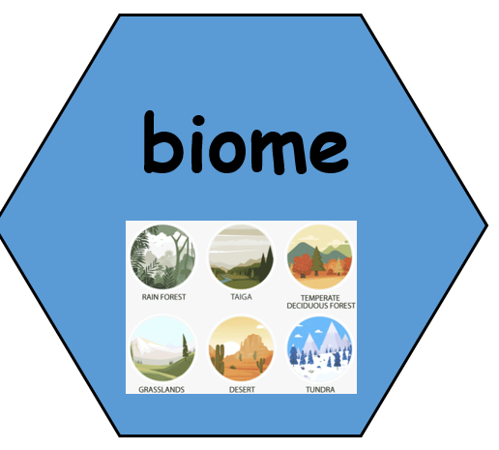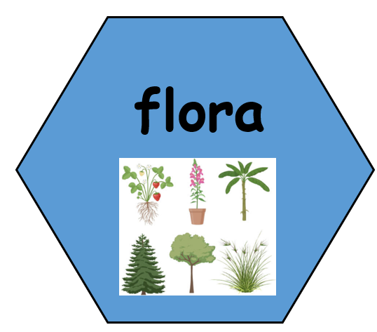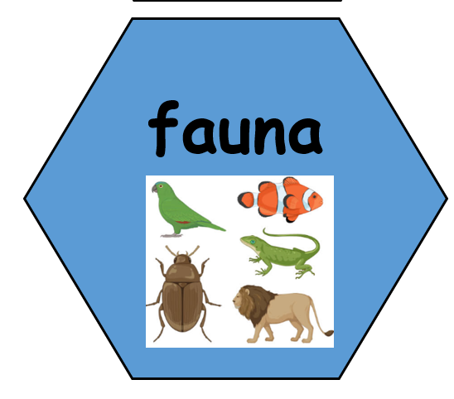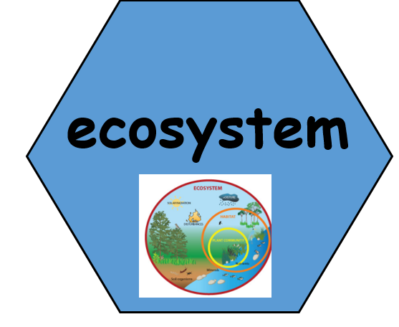
Prior Learning:

