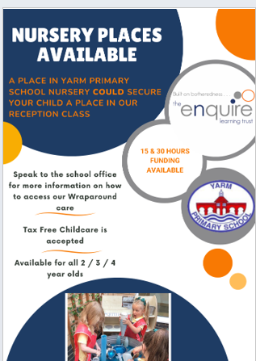

We are now offering provision for 2-year-olds. you may be eligible for 15 hours free funding. Visit www.childcarechoices.gov.uk to find out if you are eligible. We offer 5 morning sessions, or 5 afternoon sessions. There is also the option to pay to have your child to come to our 2-year-olds Nursery all day – with wrap around care this could include breakfast, lunch and after school care.
At Yarm Primary our 2-Year-Old provision will be integrated into the Early Years part of the school. There are intended to be 10 places available (on a 30- or 15-hour basis) and the setting will be overseen by our Early Years Lead/Vice Principal. There will be staff dedicated to the setting, and we will also benefit from the expertise of the Nursery and Reception staff, who will be in close proximity. We have access to members of the central team (Enquire Learning Trust) and colleagues from academies within our trust family, who are a source of information and advice. We are excited to be broadening our commitment to early education, and in providing an excellent service to our school community. Once you have registered your firm interest, we will be in touch to offer a place with a start date. Because of the summer break we will offer some pre-visits before the start date (from beginning of September).

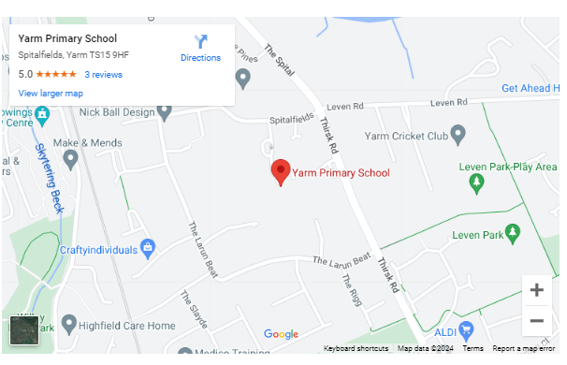
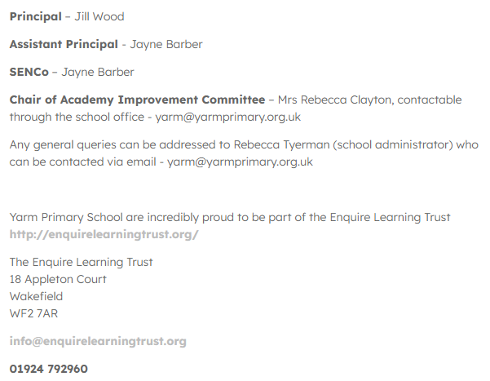




T

Terms and Conditions
We believe that there needs to be a formal agreement between the Academy and Parents. The contract will outline the obligations and commitment, of both the Academy and the Parent(s).
This is a contract between Yarm Primary School (referred to as ‘the academy’) and the Parent(s) or legal Guardian (referred to as ‘the Parent) of a child (or children) that is enrolled at the academy.
The Contract: -
a) The minimum contract period is for one academic term (Autumn, Spring and Summer).
b) Notice Period: Due to the long-term commitment we make when reserving a child’s place, we must ask you to make a similar commitment to us. We therefore, require a minimum of one terms written notice, commencing from the first day of the term, to reduce or cancel your child’s normal booking.
c) Increasing your booking is subject to availability.
HOURS OF OPERATION
Monday to Friday 8.45am to 3.30pm
We operate term time only in line with the rest of the academy’s holidays.
A full day place would be from 8.45am – 3.30pm
A morning session is from 8.45 – 11.45 (there is an option to stay for lunch and for you to collect your child at 1.00pm).
An afternoon session is from 12.30pm – 3.30pm (there is an option to come for a school lunch – please ask for details).
Children will be allocated either the morning or afternoon group – we will consider parental preference wherever we can but cannot make guarantees about which group your child will be in.
MONTHLY FEES
Monthly fees are at the prevailing fee schedule***. The setting reserves the right to increase said fees at any time giving one calendar months’ notice of the proposed increase to parents / guardians. Monthly fees include all sick days and holidays taken as these are paid days. Any statutory holidays will be deducted from your monthly bill. Fees are based on booked days not attendance. Refunds and credits will not be given for days where your child does not attend due to sickness or holiday. We do not allow swapping of days unless it is permanent and there is availability, we will try to accommodate swapping of days in cases of emergency or under special circumstances.
GOVERNMENT FUNDING
Eligible working parents and carers of children aged 3 - 4 can get an additional 15 hours of childcare support, bringing the total support they can get up to 30 hours a week. Eligible working parents of 2-year-olds can also access 15 hours of childcare support.
Some parents of 2-year-old children may also be entitled to 15 hours childcare support, if they receive some additional forms of government support. Please note, if you’re eligible for both the working entitlement and the 15 hours for families receiving support, you cannot take up both offers, and should apply for the 15 hours for families receiving support. You can do this by contacting your local authority.
Your hours can be used per week for 38 weeks of the year (during school term time).
You can use Tax-Free Childcare or Universal Credit Childcare whilst claiming your 15 or 30 hours of childcare support.
Find out if you are eligible at www.childcarechoices.gov.uk
PAYMENT POLICY
Parents agree that all monthly fees (full time and part time attendance) will be paid on the first of each month in advance.
Additional sessions will be invoiced at the end of each month and will be due for payment immediately. Unpaid fees are subject to a £20 late payment fee if fees not received by the 7th day of the month. Unpaid fees may result in immediate suspension or termination of care unless reasonable arrangements are made and accepted by both parties. Extra hours are billed at the session rate.
Full time and part time fees are based on booked days, not attendance, therefore parents are responsible for fees whether child attends or not. (This includes sick days and holidays booked.)
Costs will be added through MCAS (our parents finance and communication portal),and will reflect your use of the service. This will be set up once you have a confirmed place.
ILLNESS POLICY
Please advise the Academy prior to 8:30 am if a child will not be attending due to illness. Parents agree that a child who is ill (e.g. Fever, infection, diarrhoea, communicable disease, or any other type of illness that may be passed on to others, with the exception of the common cold) will be kept at home to protect the well-being of the staff and other children in our care. The parents further agree should a child become ill while in our care that immediate arrangement will be made to remove the child from the Academy. Children will not be allowed to return to Academy until they have been symptom free for at least 24 hours for a fever and 48 hours for sickness or diarrhoea. In some cases, a note from a doctor may be necessary. By signing this contract, you are agreeing to staff seeking any necessary emergency medical advice or treatment during their time at Yarm Primary School.
LATE ARRIVAL/PICKUP POLICY
Please advise the Academy immediately if you will be arriving later than the pre-arranged time to pick up your child. It is the parents’ responsibility to ensure that children are picked up no later than 3.30pm. If you are not able to pick up your child by 3.30pm alternate arrangements must be made.
Please notify the Academy if an unauthorised person will be picking up your child. Verbal or written permission must be received before we will release a child to anyone who is not authorised on the registration form. Our typical process is that we will call you to confirm the arrangement at the point of collection, and therefore expect you to make yourself available for a brief conversation.
TERMINATION
Yarm Primary School reserves the right to suspend or terminate care of any child without notice, should it be deemed necessary for the overall safety and well-being of staff and/or other children in my care.
WITHDRAWAL
Notice Period: Due to the long-term commitment, we make when reserving a child’s place, we must ask you to make a similar commitment to us. We, therefore, require a minimum of one terms written notice, commencing from the first day of the term, to reduce or cancel your child’s normal booking.
HEALTH & SAFETY
The name of the designated Health & Safety Officer is on the main notice board. Any health & safety queries please arrange to meet with the Academy Business Manager. We would ask all parents to make sure doors are closed when entering or leaving the building and that they are mindful of little fingers. If the Academy must close due to any health and health & safety and illness reasons including bad weather, fees will still be due to be paid during the period closed.
REGISTRATION
A non-refundable registration fee of £40 (per child) is required upon completion of registration to secure your child's placement in care. The registration fee is non-refundable. Spaces will not be held unless the registration fee is paid in full.
POTTY TRAINING
We will work in conjunction with parents during potty training. If you have a method that has been working for you, please let us know and we will adopt it for your child. Should you discontinue potty training at home, please let us know. If a child shows no interest in potty training, we will discuss this with you and probably choose to discontinue and try again at a later date.
BEHAVIOUR MANAGEMENT
If a child’s behaviour is seen to endanger others and all routes according to our Behaviour policy have been adhered to Yarm Primary will take advice from the Trust and arrange a meeting with the parents to discuss the options available. If a parent does not support the academy in gaining help and advice from outside agencies, then Yarm Primary reserves the right to terminate the parent’s contract and will no longer provide care for that child.
WHAT TO WEAR
In order to feel free to explore and experiment with all kinds of materials, including messy ones, it is advisable to send children dressed in clothes that are easily washable and preferably not new. It is good for children to practice the skills, which will make them independent. Simple clothing which they can handle themselves will enable them to go to the toilet unaided and to put on and take off their outdoor clothes without being too dependent on other people for help. The Academy also requests that each child is provided with a pair of Wellington boots and slippers, which are clearly labelled, to be kept at the Academy.
DATA PROTECTION
I agree and understand that my personal information will be held and used in our accordance with The Enquire Learning Trusts Privacy Policy, a copy can be found at https://enquirelearningtrust.org/key-information/gdpr and

- In compliance with the General Data Protection Regulations
- To contact me about my funding claim, if required
- For analysis and statistical purposes including government returns
- To support my children’s learning and development.

ACCEPTANCES
a. The above terms and conditions are considered to be fair and reasonable. In the event of any term found by a Court of Law to be unreasonable then the clause shall be removed but the agreement shall remain in full force and effect.
b. The parent/guardian has read and understands the Terms and Conditions contained and undertakes to be bound by the same. This agreement must be signed by all persons with Parental Responsibility and/or those who are accepting responsibility for paying fees. Your childcare may only commence once payment of the first invoice, or a minimum of one month’s fees has been made.
I have read and understood the Parental Agreement and I agree to be bound by it and any other relevant booking terms and conditions that are issued from time to time.

SIGNED:_________________________________PRINT NAME:____________________________________DATE: ___________________
(Parent/Legal Guardian)

SIGNED:_________________________________PRINT NAME:____________________________________DATE: ___________________
(Parent/Legal Guardian)

SIGNED:__________________________________PRINT NAME:____________________________________DATE:___________________

Sunflower Charges
Numbers of hours | Description | Charge
15 | Fully funded - no lunch | 0.00
15 | Fully funded - stay for lunch | PL-2.00  SM-4.25
15 | 15 hours paid – no lunch | £85 per week
15 | 15 hours paid – stay for lunch | £85 per week  PL – 2.00  SM – 4.25
30 | 15 hours funded, 15 hours paid | £85 per week  PL-2.00  SM-4.25
30 | 30 hours paid | £170  PL-2.00  SM-4.25



