
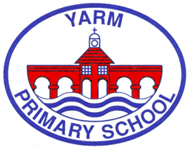


The children have made a super start to the school year and are getting accustomed to the routines and changes of adults, classrooms/playgrounds etc. You can hear about some of these ‘changes’ during a presentation by class teachers for each year group. These sessions are in addition to parents’ evenings and Open-Door Fridays and will take place at drop off – 9.05am – entry through the main entrance. It is anticipated that they will last approximately 30 minutes and we hope that you find them useful.

Monday 15th September |  | Monday 22nd
Tuesday 16th | Y3 | Tuesday 23rd | Y1
Wednesday 17th | Y4 | Wednesday 24th | Nursery
Thursday 18th | Y5 | Thursday 25th | Y2
Friday 19th | Y6 | Friday 26th | SEND unit
*Parents of children in Reception have a separate induction programme.

Other dates for your diary:
Open door Friday | Parents evenings
17th October – linked to the eco work across school  14th November – showcasing our anti-bullying & Empathy work  6th February – linked to Storytelling week  20th March - a celebration of our whole school British Science week learning  26th June – a showcase of our whole school Butterfly initiative | 20th October  16th & 17th February  6th July
EY Christmas performance – 9th December am
KS1 & KS2 Christmas performance – 10th December pm
Christmas Jumper & Christmas dinner day – 19th December
Sports Day EY am – 17th June
Sports Day KS1 & KS2 pm – 18th June
Week beginning 29th June – Annual reports to parents are published
As we know good attendance at school is vital to children’s learning and progress. The DfE’s Statutory Guidance Working together to improve school attendance supports improvements and sets out he national expectations for attendance. At Yarm Primary we value the partnership between home and school in continuing to secure attendance rates above national.
It is also crucial that children are in school during statutory assessment periods – these are:
Y6 Statutory assessments | 11th – 14th June 2026 (inclusive)
Y4 Multiplication tables check | 1st – 12th June 2026 (inclusive)
Y1 Phonics screening test | 8th – 12th June 2026 (inclusive)
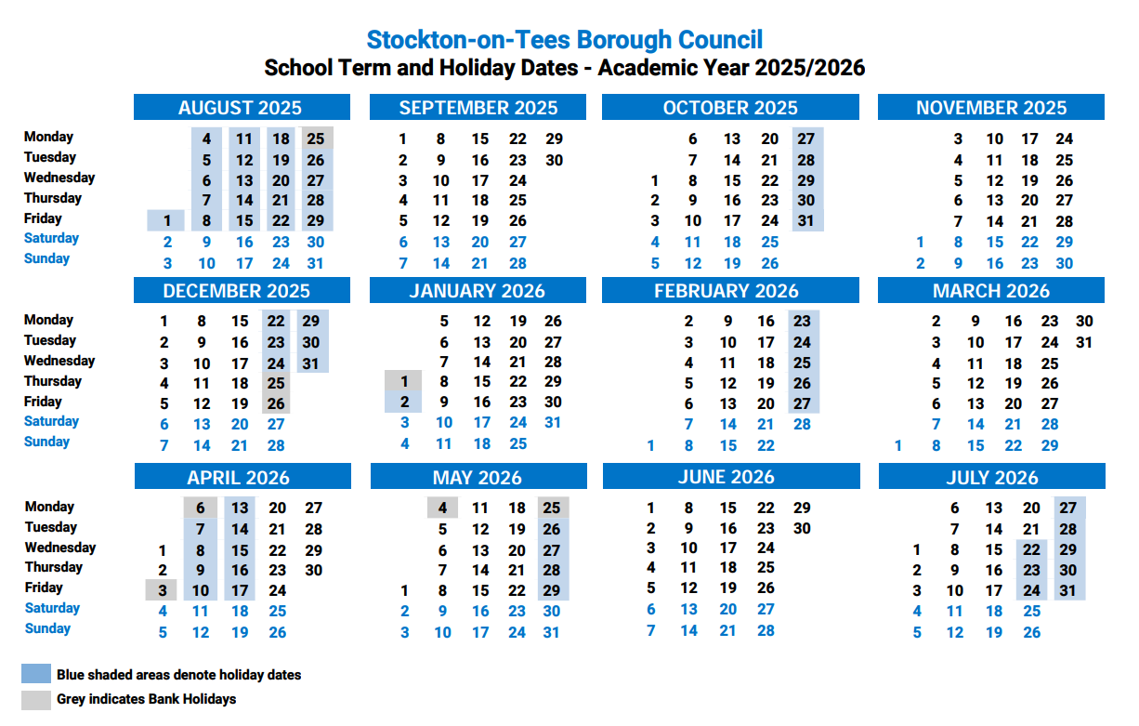
School term dates :

In addition schools have 5 PDDays:
*PDDays for academic year 25/26 are:
1st & 2nd September 2025
1st December 2025
20th & 21st July 2026
* School is not open to pupils on these days.

We hope this is useful.
I am always available to meet with you – please contact me directly ‘on the gate’ or via the school office – our goal as a staff is to respond to any parental communication the same day, or certainly within 24 hours.

We are really looking forward to sharing a brilliant year with you and your children.

Yours
Mrs Wood

