
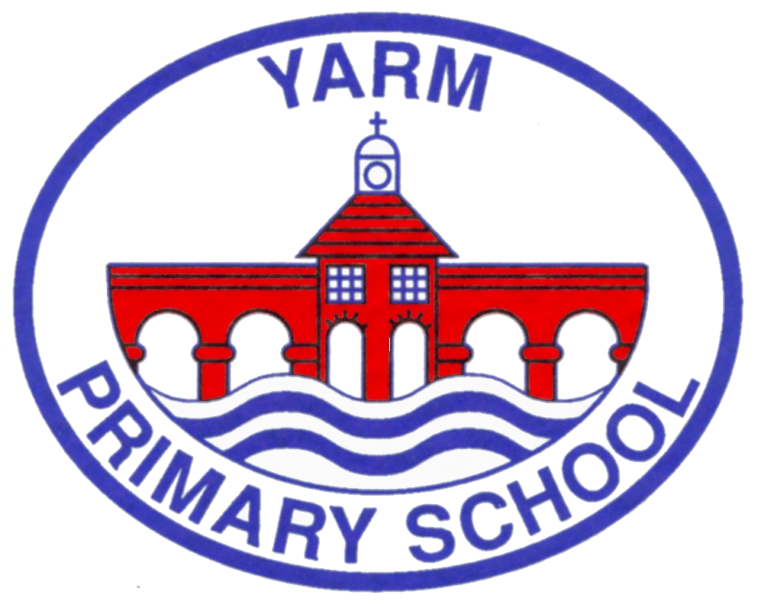

Newsletter 1

Summer Fayre – we really hope that you are planning to come along next Monday – 14th – for our first Y6 led Summer Fayre. There will be a Bake Sale during the day, if children would like to bring 50p for a cake they will have time to visit the sale – there will be an opportunity to buy cake at the Summer Fayre too. AND from 3.20pm parents/grandparents/friends are welcome to join us to view the sculpture event (all year groups will be displaying their unique work around the school site) AND come to the Summer Fayre - Come along to play hook a ducky, hit the target, pick a lucky Lolly stick, guess the name of the Sloth (!), take the staking chairs challenge, guess how many buttons in the jar? Take home a treat from the last Tuck Shop of the year. Take part in crafts, make a purchase at the plant stall or try your luck at the tombola, get a great new book from the book trade area… We are hoping that the ice cream and drinks vans that were so popular at sports day will be making a return. And along the way pick up some uniform which is currently unloved and needs a new home. So, if you would like to send in any contributions – cakes, books, uniform – we will be very grateful – please drop them off on Friday 11th OR Monday 14th July – THANK YOU. All profits will go to school fund.
Our residentials programme picked up a pace this term and we have successfully completed experiences for Y2/Y3 & Y6 (with the Y4 & Y5 visits taking place earlier in the year) – Thank you to the staff who make these possible – it shows our commitment to the enrichment that these opportunities provide. It is noteworthy to share that during the Y6 ‘tour of’ Northumberland that each day was punctuated by members of the public stopping the adults with the group to praise behaviour – lovely!
We are already provisionally ‘booked up’ for next year and will be contacting year groups early in the academic year to share plans.
This week, Y6 are holding their movie premiere of a series of short films they made with Mr Newton over the last few months. The team are excited to see the fruits of this labour and know that it will be a unique and creative evening.
THANK YOU – as you continue to show your kindness when you are ‘having a tidy out’ and think of us – we regularly receive books and toys from parents, and these are always appreciated. THANK YOU again!
CONGRATULATIONS and GREAT EFFORT to all the children who have been involved in statutory assessments this year – Reception Class and the Good Level of development measure/Y1 with the PSC (Phonics screening check)/Y4 and MTC (Multiplication test check) and Y6 SATs – we have a great set of outcomes for all these cohorts – well done to the children for their hard work and to the staff who have shown skill and dedication in guiding them – we will publish the data on the website in due course.
As we hurtle towards the end of the academic year, we inevitably say Goodbye to some of our tribe. Mrs Smith (Liz) our school Cook will not be returning to us in the new academic year, and while we look to recruit a replacement, we are aware that she is indeed irreplaceable, after so many years of devoted service (during Covid she did not miss a shift). We wish her well and offer a HUGE THANK YOU for everything she has brought to YPS.
Miss Breckon has completed her training with us and has secured a post at a local school – Congratulations!
Miss Yule will also not be returning in September; we wish her well and hope she is able to move forward doing the things she wants to do – Good Luck!
We will be welcoming Miss Sinclair, Miss Fingland & Miss Dodgson, who will be joining the school to work primarily in the new SEND unit – we look forward to working with them and in welcoming our new pupils into the provision.
Last weeks – Run to Uganda - raised £210 towards this Trust initiative. Thank you to everyone who contributed towards this potentially life changing project.
REMINDER - Another Trust initiative – collecting milk bottle tops – to sell for recycling, continues – please send the washed tops into school – the collection point is in front of the main office – Thank you.
We hope you find the following useful -
Helping young people stay safe on smartphones and online
In light of the recent series shown on Netflix - Adolescence and the need to educate young people about the pressures and the content they can view online, Kooth are offering parents and carers a 30 minute webinar covering how they can encourage them to think about how they spend their time on social media platforms and how they can get help to deal with similar situations that they may find themselves in.
The webinar will cover:
•Young people online
•Social media, the law, the pros and cons
•Smartphone safety
•What parents can do to support their children
•How our platforms can help
https://connect.kooth.com/events/event/23-jul-helping-young-people-stay-safe-on-smartphones-and-online
We have been made aware of an art competition at Lucy Pittaway where children from 4 - 16 can enter a piece of artwork using any medium they like to win prizes (one prize for the categories of 4 - 6-year-olds, 7 - 9-year-olds, 10 - 12-year-olds and 13 - 16-year-olds - so siblings can get involved too!) The focus is around 'The day in the life of you'. The overall winner will receive three mounted Artist Proofs unique to them and a framed print of their final artwork. It is free to enter - competition begins from 1st July and closes on the 31st August. Children can hand their artwork into any Lucy Pittaway store or digitally scan it in and send via the email on their website. https://www.lucypittaway.co.uk/art-competition-2025
We hope your creative and talented children will want to enter – Good Luck!
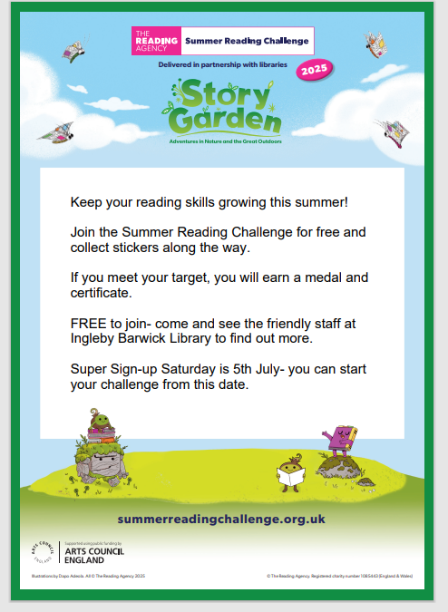

In 2024, nearly 600,000 children took part in a summer reading challenge across the UK. Let’s make 2025 even bigger!
Sarah Drury the Branch Librarian at Yarm Library will be able to tell you more…

Some more local initiatives which you may find useful for over the summer break:



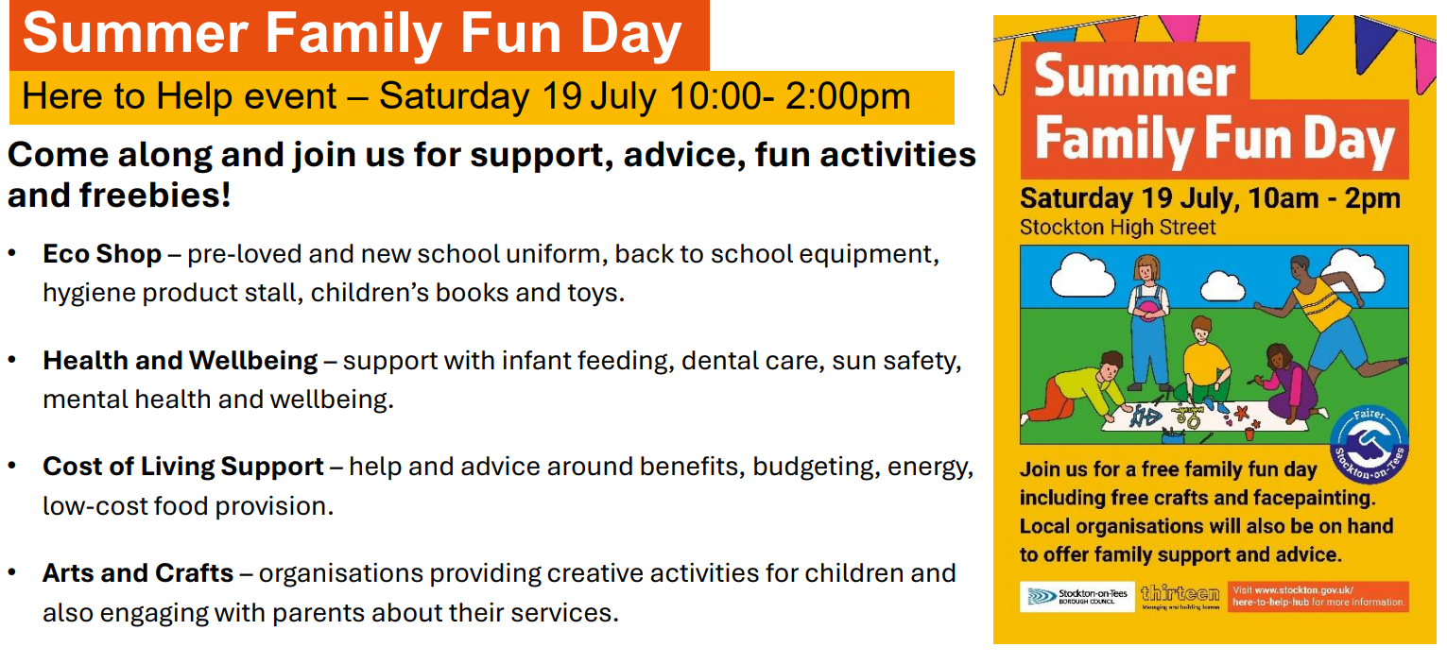

The end of the academic year is an important time – with children having the chance to end a year positively and prepare for the next year through transition. Please support us in ensuing your children are in school – Thank you.
REMINDER:
School dates:
School closes – last day in school FRIDAY
School reopens – WEDNESDAY 3rd SEPTEMBER 2025
*PDDays are:
1st & 2nd September 2025
1st December 2025
20th & 21st July 2026
* School is not open to pupils on these days.

Mrs Wood

