


Newsletter 2
Happy holidays!

Almost the end of another super busy and successful academic year.
It has been a year of challenges and successes and although I think we are collectively ready for a summer break, there are lots of plans from staff and children for the coming year - Every day really is a school day!

I hope you all received your child’s school report and managed to come to parents evening – it was the best attended summer parents evening for several years – I am delighted that the children had the opportunity to celebrate their successes with their parents.

Thank you so much for supporting the Y6 led Summer Fayre – Congratulations to Oliver (Y4) for guessing the grizzly bear was called Chocolate and to Penny (Y4) who was nearest in guessing the number of buttons in the jar (she was only 5 away from the total). Despite the rainy weather you helped us to make a profit for school fund of £587.11 a brilliant effort – many thanks.

I know many of you braved the rain to see the sculptures – thank you to everyone for their creativity and I will make a gallery for the website to share the sculptures (pre lashing with rain!) for everyone to enjoy.
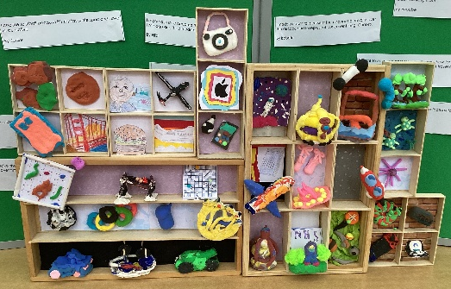
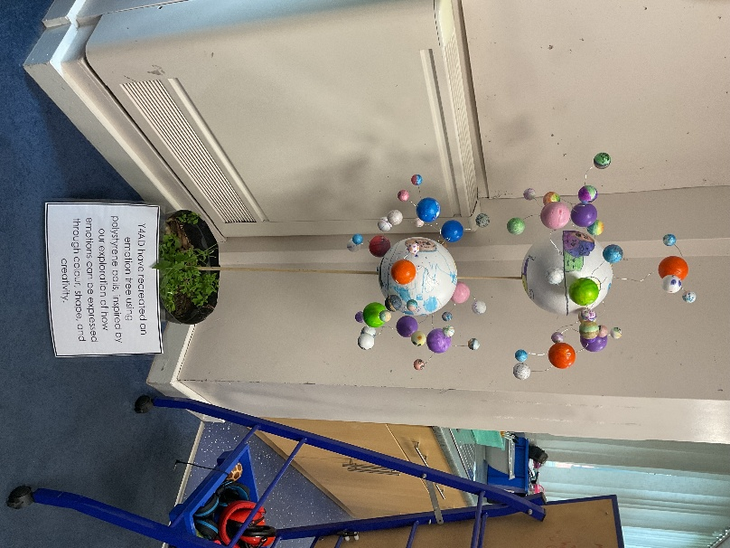
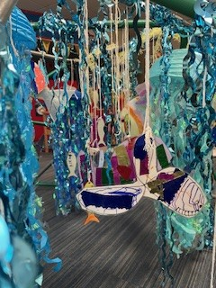

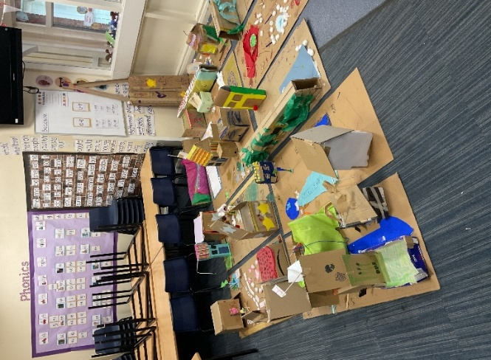

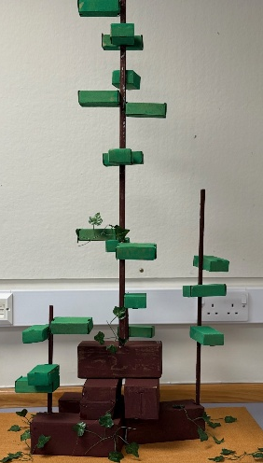

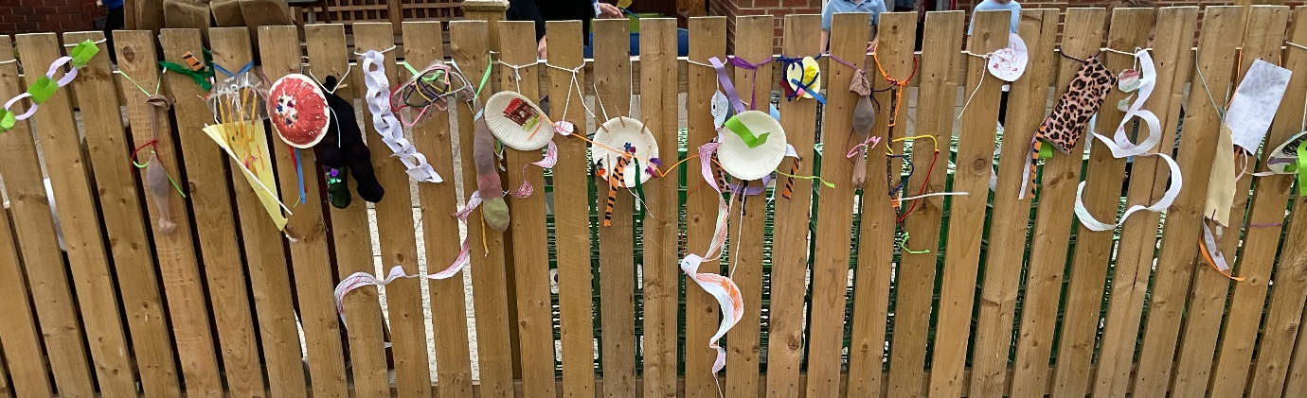

Y6 showcased their talents, determination and courage in their leavers performance. It was a privilege to see children pushing themselves out of their comfort zone to dance, sing, narrate, play instruments and generally be brilliant! We had a wonderful Wednesday evening sharing the theme of growing up in the North East, with family and friends – creating so many wonderful memories… A BIG THANK YOU to Mr Newton for his musical skill and Joanna for her wonderful choreography, which involved every child and tapped into some previously hidden talent! They then performed on Thursday morning to KS1 & KS2 – great role models. I am so very proud of these young people –– we will miss them and wish them only wonderful things for their futures. Y6 ‘you are full of wonder’.
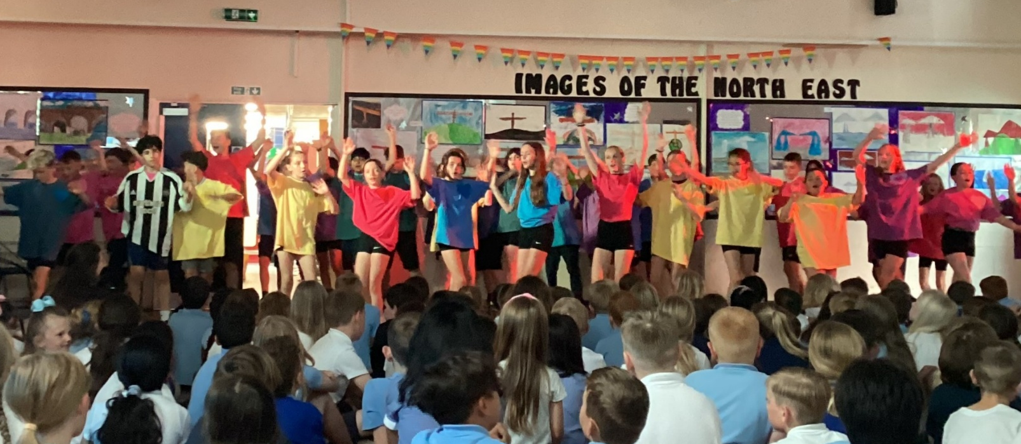

There are other families who are ending their journeys with us and we also wish them only great things for the future.

And once more to the staff who are leaving us – you will be missed, and we say THANK YOU and GOOD LUCK!

As you may be aware, we are a community of lifelong learners, and staff take part in professional development throughout the year. Some of this training is beyond the school or trust and I would like to congratulate Mr Parry on successfully completing his leadership apprenticeship (with distinction) – well done!

As we all know great attendance supports great learning – congratulations to the children who have 100% attendance and to those who almost got there – school should be unmissable, and we really appreciate your efforts in supporting children in accessing every opportunity. Let’s make next year an even more impressive high attendance year – both individually and collectively!

From Mr Painter (STEM Lead). Year 5 have been working hard all year on their STEM car project. During the year, they've built their car, designed its chassis and had lots of practice driving it. This month, Year 5 all had the chance to drive their car in our 'Yarm Speedway' event. There was lots of STEM-based activities and some future F1 stars may have been born. All of this wouldn't have been possible without the amazing support of Cummins, Teesside Karting and our fantastic parent community.
We're looking forward to this project continuing for our new Year 5's next year!
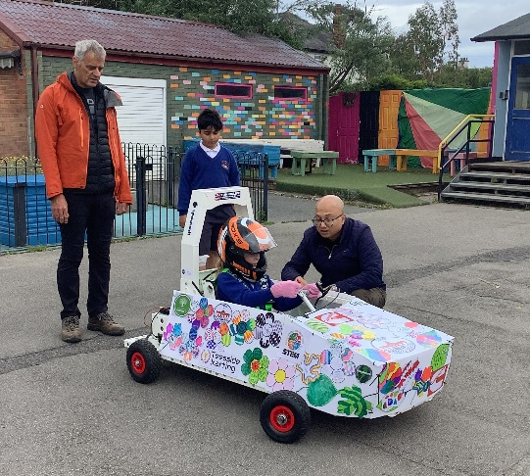
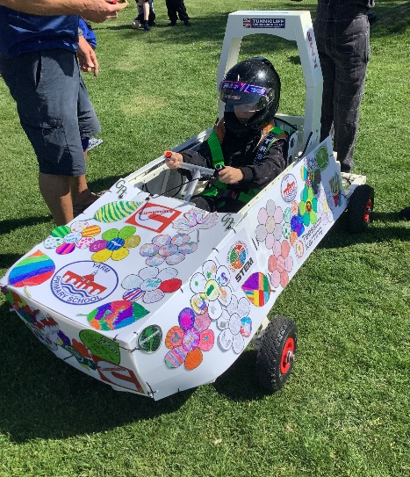
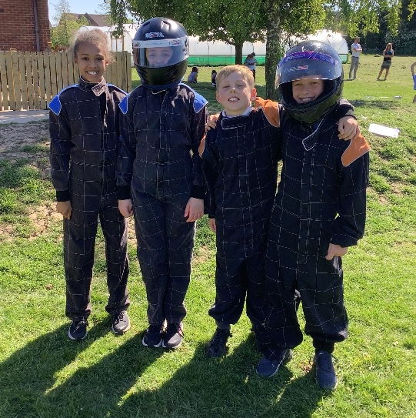

As we ‘round up’ our finances for the year we would appreciate any outstanding monies to be settled asap. THANKYOU.
As parents know, Y3 pupils will need to pay for their school meal from September (unless eligible for a free meal) – we were able to use some of the produce from the polytunnel this week in the school kitchen – the children involved were very proud – well done you champion growers!
Please ensure the children are bringing home their belongings on Friday, we are making several internal changes to school over the summer and corridors and cloakrooms need to be clear - thank you.

We are very appreciative for the kind gifts, words and wishes you have been sharing with us over the last few days.
I have been talking with children over the transition period and whilst anticipated change can be a challenge I have been told many things that the children are looking forward to.
Whatever you plans for the coming weeks, I hope you are able to have some carefree times as a family and that you keep safe and well, so that we can welcome you back ready for a great time in September.
The new school year begins for the children on Wednesday 3rd September – we will be excited to hear all their news!

Yours as ever
Mrs Wood
*PDDays for academic year 25/26 are:
1st & 2nd September 2025
1st December 2025
20th & 21st July 2026
* School is not open to pupils on these days.

You may have heard of the National Trust ‘50 things to do before you’re 11¾’.
50 things to do before you're 11¾ | Kids | National Trust

Their summer recommendations are:
Explore a rock pool
Camp outdoors
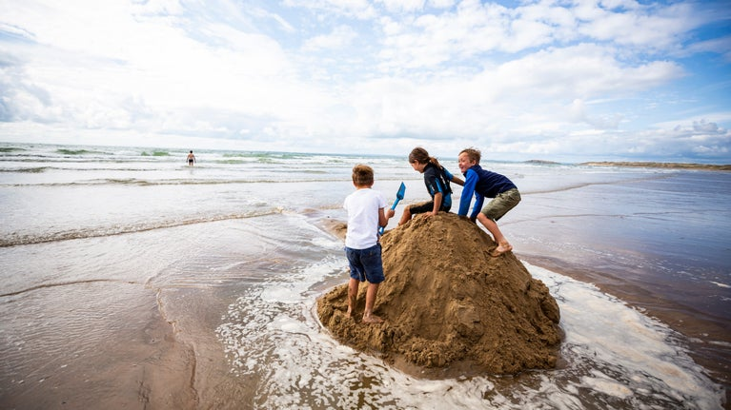
Discover wild animal clues
Hunt for fossils and bones
Go swimming in the sea
Grow a butterfly
Catch a crab
Float in a boat
Make a wild crown
Eat a picnic in the wild
Go paddling
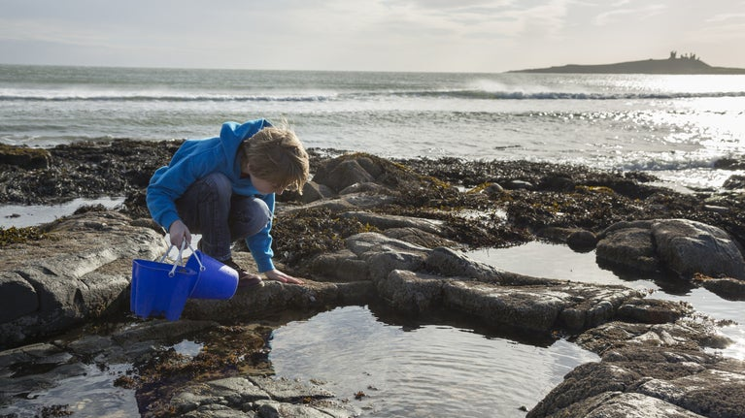

Think it might be a great idea for all of us over 11 ¾ too!

