[](https://www.google.com/url?sa=i&url=https%3A%2F%2Fwww.dreamstime.com%2Fillustration%2Ffirst-place-rosette.html&psig=AOvVaw3IgOo27MjB7uge9RVEy4Vy&ust=1611330889322000&source=images&cd=vfe&ved=0CAIQjRxqFwoTCNDNp7yxre4CFQAAAAAdAAAAABAE)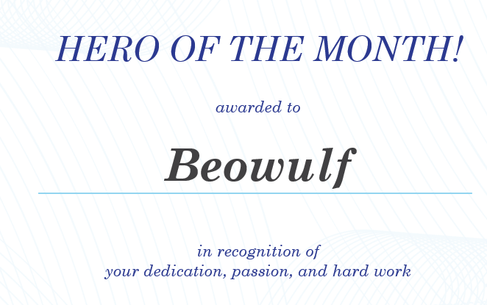

King Hrothgar