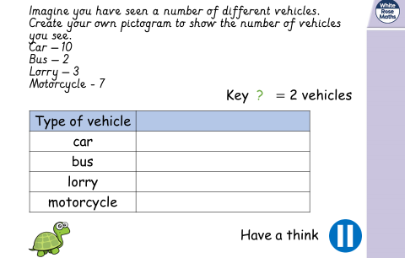

Draw your own pictogram for the number of vehicles you might see. Give it to a friend to interpret. Can they work out how many of each vehicle you saw?

