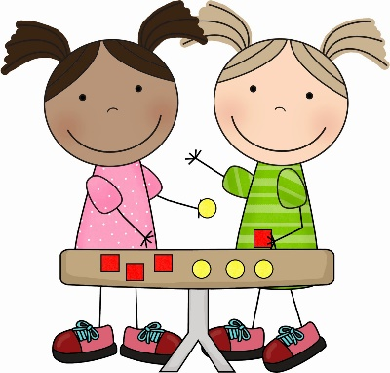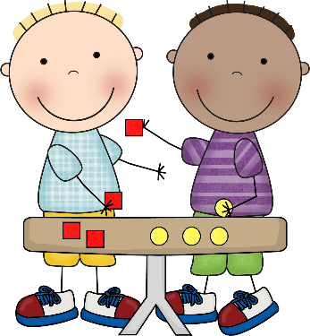**Maths in Reception**

What are children expected to learn?

Children at the expected level of development will:

- Have a deep understanding of number to 10, including the composition of each number;

- Subitise (recognise quantities without counting) up to 5;

**Find out about subitise** - <https://youtu.be/Lwt7NgfeZRY>

- Automatically recall (without reference to rhymes, counting or other aids) number bonds up to 5 (including subtraction facts) and some number bonds to 10, including double facts.

- Verbally count beyond 20, recognising the pattern of the counting system;

- Compare quantities up to 10 in different contexts, recognising when one quantity is greater than, less than or the same as the other quantity;

- Explore and represent patterns within numbers up to 10, including evens and odds, double facts and how quantities can be distributed equally.

What can I do to help?

* Sing counting songs and rhymes and encourage your child to join in.

If you don’t want to sing (!) there are lots of rhymes online to share:

<https://www.bing.com/search?q=counting+rhymes&cvid=55e9d0e2052e47358c8f9afd6ab7de1e&aqs=edge.0.0l9.3779j0j1&pglt=43&FORM=ANNTA1&PC=U531>

Share songs that count forward like *One, Two, Three, Four, Five, Once I Caught a Fish Alive*…

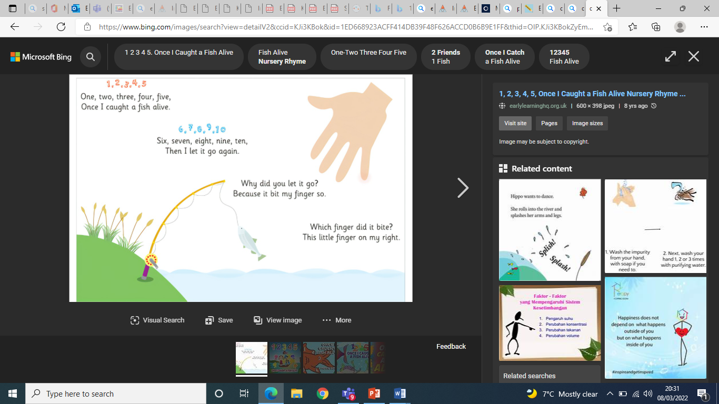

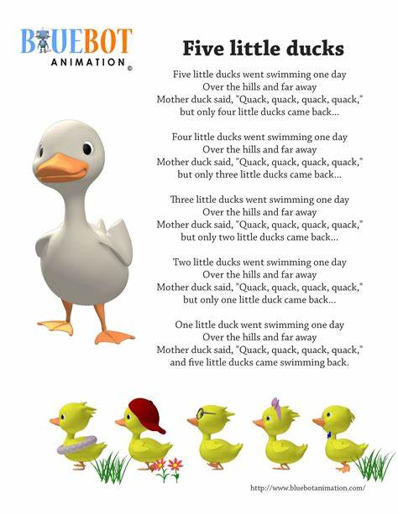…and backwards, like *Five Little Ducks went Swimming one Day.*

* Reinforce early counting skills with physical objects your child can touch, move and count, these are sometimes called **manipulatives**. A manipulative is an object that children can interact with and move to represent mathematical ideas. Manipulatives could include everyday objects such as pine cones, buttons, and small toys as well as resources like interlocking cubes, numicon and building blocks. They can help children make sense of mathematical concepts, develop visual images, increase engagement and enjoyment and provide a bridge to abstract thinking.
* Look for ways to encourage them to count in everyday life, for example, ‘Can you lay the table for three people?’ or ‘Shall we see how far we can count before the traffic light goes green?’
* Encourage your child to spot how many objects are in a group without counting – dominoes and dice games are great for this.

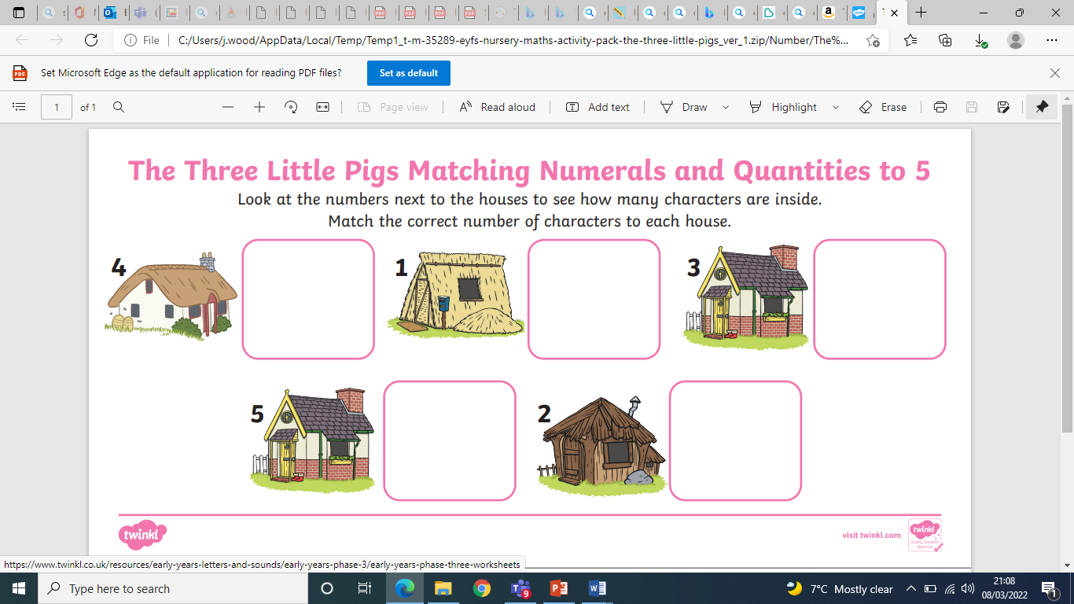

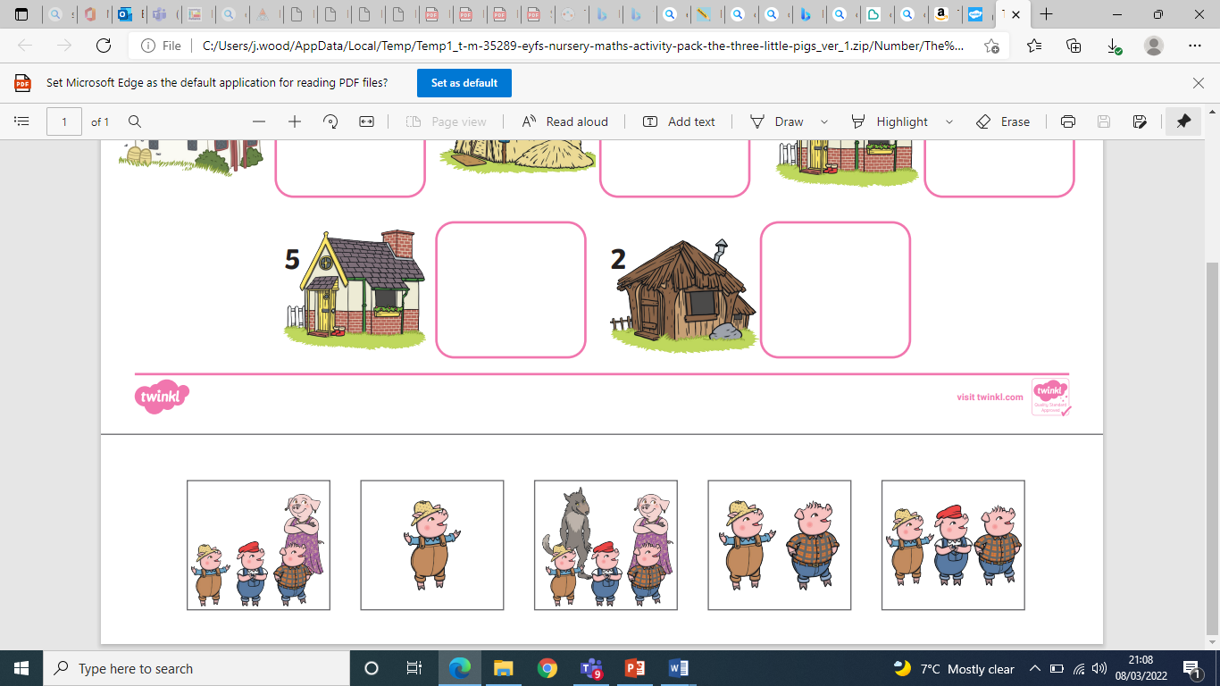

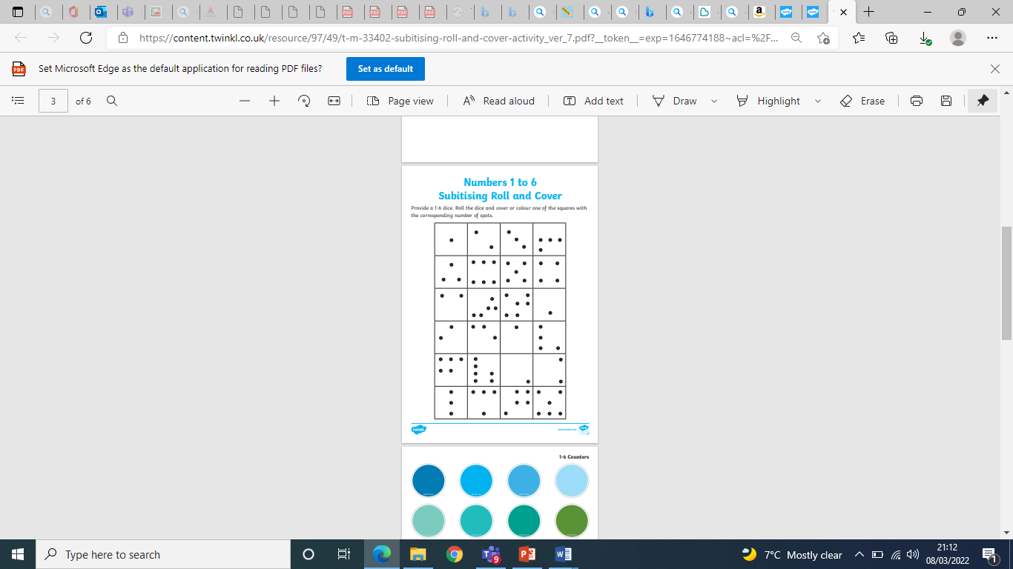

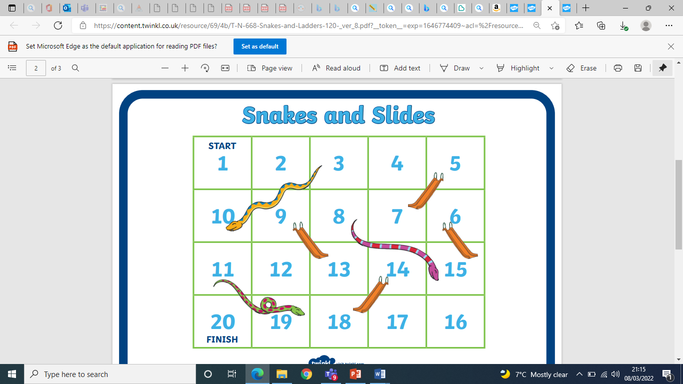

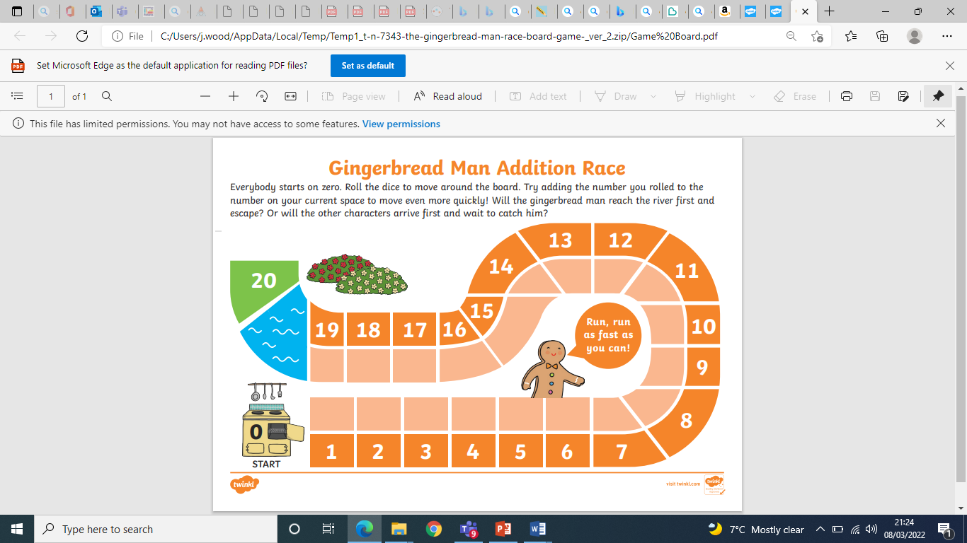

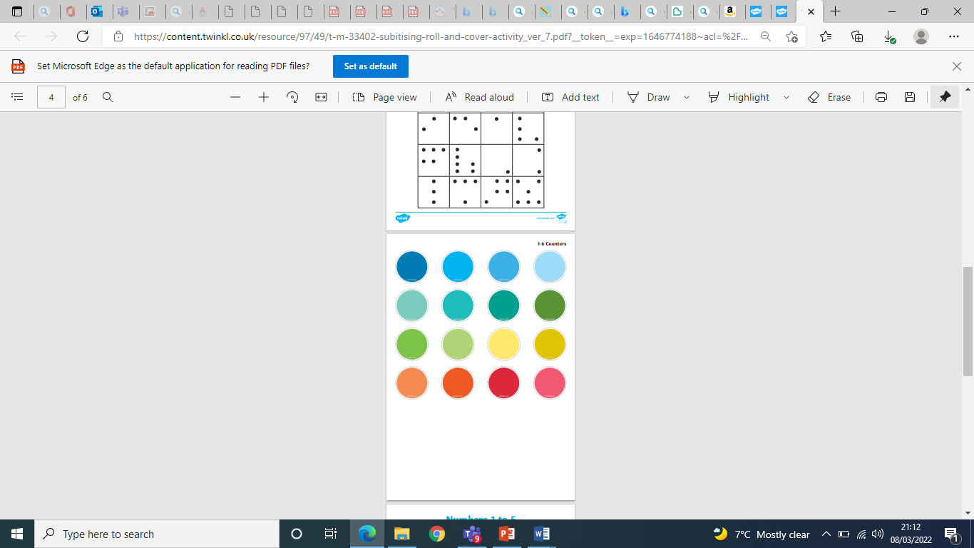

* Share some great counting books – you may already have your favourites

<https://www.booktrust.org.uk/booklists/c/counting-books/#:~:text=1%2C%202%2C%203,and%20some%20frogs.%C2%A0>

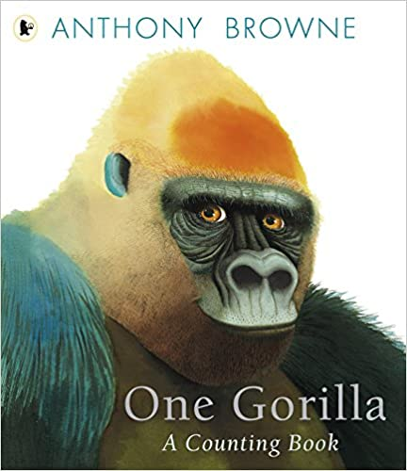These are some of mine!

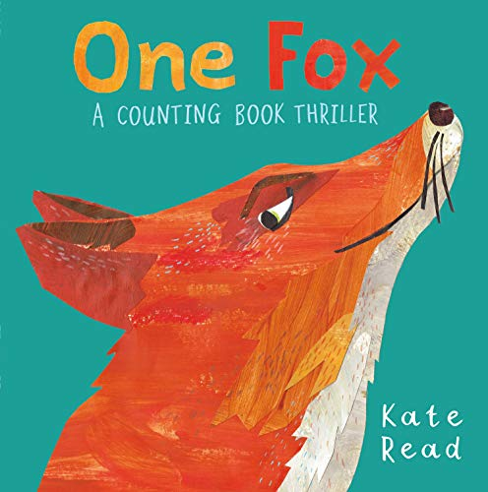

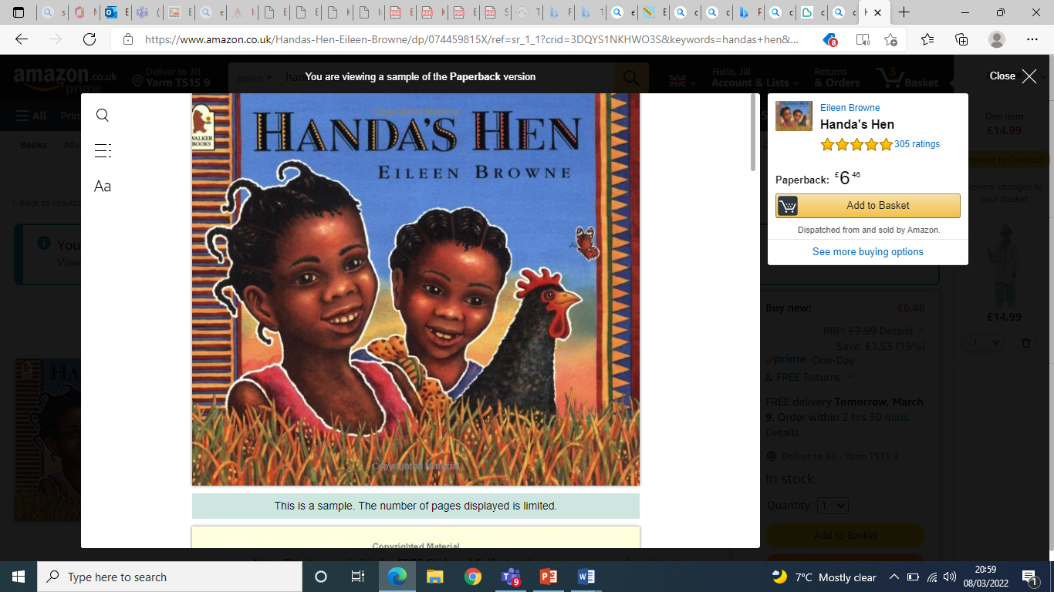

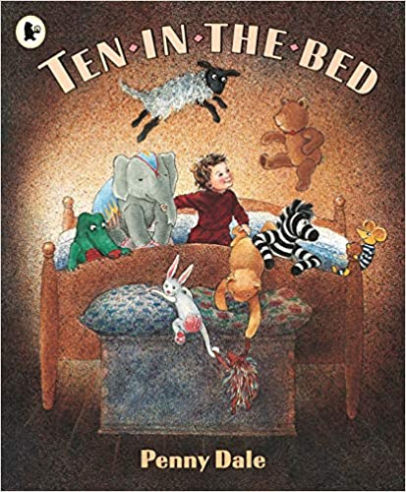

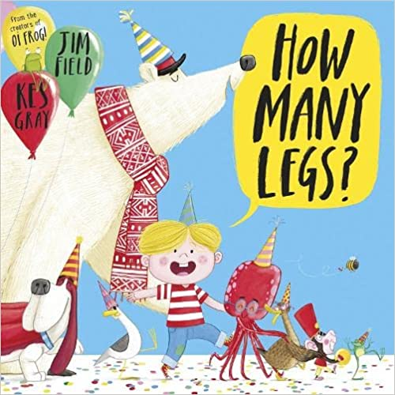

* Learn together

The children gain so much more from sharing their maths online experiences with another person than if they watch solo. The opportunity to share and reinforce mathematical language and refer back to these shared experiences really do enhance learning.

A classic kids' television character, the Count from **Sesame Street** was obsessed with numbers. [**Watch the Count's videos and play his number games on the Sesame Street site**](https://www.sesamestreet.org/)**.** <https://youtu.be/ZIniljT5lJI>

**BBC Bitesize** has a range of activities and visuals which support early number.

Try:

**Buds number garden** - Join Bud the bee to explore his magical garden and practise recognising numbers, counting, sequencing and much more. This game is great for children in their first year of school or for pre-school children who want a taste of what they'll be learning when they start. <https://www.bbc.co.uk/bitesize/topics/zjkphbk/articles/zd4b382>

**Counting** - A collection of musical films on counting one to 10, 10 to 20, sets and ordinal numbers. <https://www.bbc.co.uk/bitesize/topics/zhsspg8>

Go to the **Cbeebies go explore app** <https://www.bbc.co.uk/cbeebies/watch/cbeebies-go-explore-app>

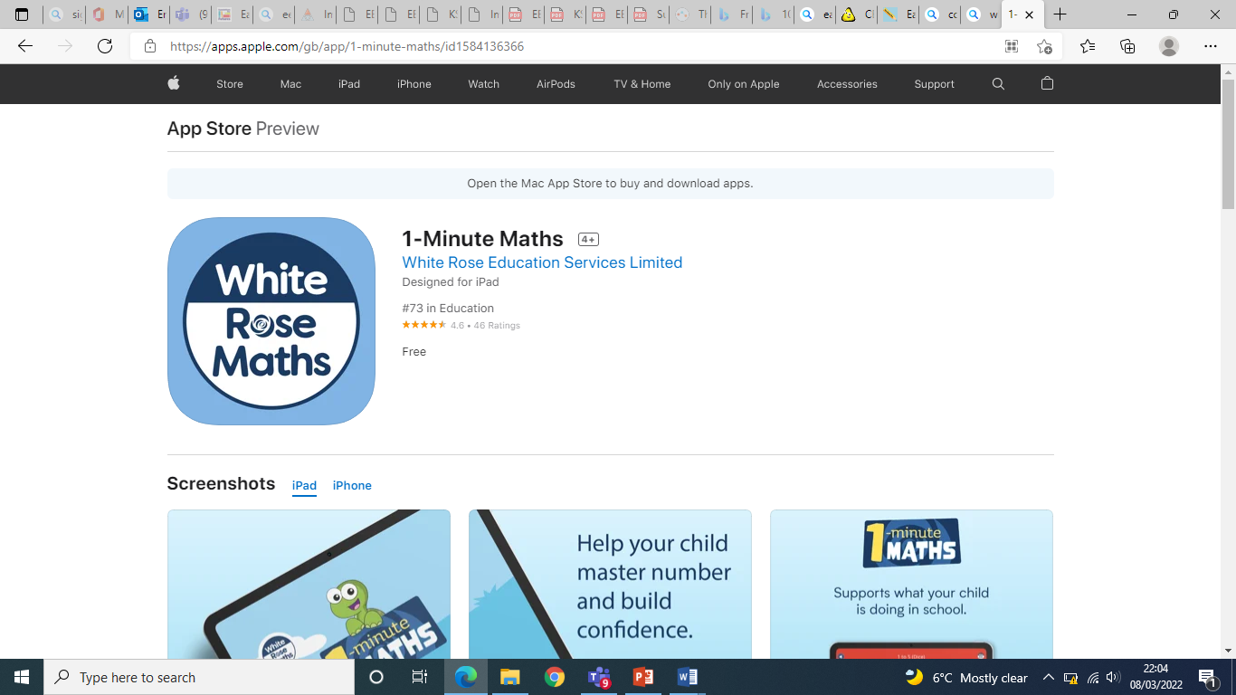For Numberblocks ‘Number Magic Run’ – to help your child to practise simple maths and learn number counting

Go to the App store for **1-Minute Maths** from White Rose

Education Services Limited. 1-Minute Maths is a free app

that helps children build number confidence & fluency

through engaging, 1-minute tasks.

Let us know about any other sites/activities you

enjoy sharing with your child …

JW

