Dear Children, week beginning 29th June 2020
We have put together a range of learning challenges for you to do at home. We would really like you to complete a maths, reading and writing each day as you would in school. We would also like you to complete the work as best you can, remembering that we expect ‘beautiful work’.
Please remember we are working a week behind on the White Rose Maths videos.
We have started to include a daily warm up activity for maths. It is designed to recap topics taught previously. You can complete all three sections in one day, or spread them across the week.
MATHS GAMES – we are sending home some fun maths games to play this week. We hope you enjoy playing them.
Use the grid below to track the work you are expected to do and what you have already achieved.
 | Maths | Reading | Writing | Extra
Monday | Go online and watch summer term, week 9, lesson 1 – measuring length and height  https://whiterosemaths.com/homelearning/year-2/  Complete activity relating to online lesson  Extra challenges can be found at https://www.bbc.co.uk/bitesize/articles/zcbwr2p | Complete the Electricity comprehension activity.  Daily Reading (15 minutes) | Spot Mr Whoops’ mistakes – activity 5 | Draw and label an underwater food chain.  Cosmic kids yoga  https://www.youtube.com/watch?v=YR1OxBk8BF4
Tuesday | Go online and watch summer term, week 9, lesson 2 – comparing length and height  https://whiterosemaths.com/homelearning/year-2/  Complete activity relating to online lesson.  Extra challenges can be found at https://www.bbc.co.uk/bitesize/articles/z9dp7yc | Play Small Town Superheroes – Tricky word endings  https://www.bbc.co.uk/bitesize/articles/zxpx8hv  Complete activity 1  Daily Reading (15 minutes) | Read the newspaper article provided. Use colour pencils to underline the different features. | Create an underwater scene.  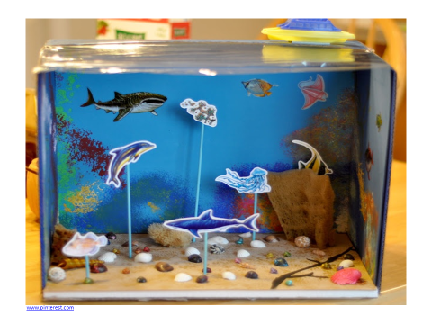  Please upload this to Class Dojo portfolio  PE: This is PE Lesson 13  https://www.youtube.com/watch?v=_pWus22nTVI&list=PLYGRaluWWTojV3An2WEgsQ4qGFy_91jDL&index=14
Wednesday | Go online and watch summer term 1, week 9, lesson 3 –  https://whiterosemaths.com/homelearning/year-2/  Complete activity relating to online lesson  Extra challenges can be found at https://www.bbc.co.uk/bitesize/articles/zdfq4xs | Exclamation marks – activity 2  https://www.bbc.co.uk/bitesize/articles/zmng9mn  Daily Reading (15 minutes) | Plan a newspaper article using the planning format. It can be based on anything interesting that has happened or you could make something up. | Watch the clip on food chains:  https://www.bbc.co.uk/bitesize/clips/z8hxpv4  PE – 10 minute shake ups  https://www.nhs.uk/10-minute-shake-up/shake-ups/dashs-ball-skills
Thursday | Go online and watch summer term, week 9, lesson 4 – comparing mass  https://whiterosemaths.com/homelearning/year-2/  Complete activity relating to online lesson.  Extra challenges can be found at https://www.bbc.co.uk/bitesize/articles/zpgtjsg | Read the shark comprehension. Discuss the answers to the questions. | Write your newspaper article. Remember to use capital letters and full stops accurately. Try to make it interesting! You could include exclamation marks.  Check your work.  Please upload this to Class Dojo portfolio | Write an explanation or draw a diagram explaining how the sun's energy is transferred in a food chain.  PE: Supermovers  https://www.bbc.co.uk/teach/supermovers/ks1-maths-the-5-times-table/zhbm47h
Friday | Have a go at the maths challenges – remember to explain your thinking and show how you got to your answers.  Don’t forget we like to see errors too!  Please upload this to Class Dojo portfolio | 10 minute test – On top of the world  Answer questions 1-5  Daily reading (15 minutes) | Write silly sentences using your spellings for this week.  E.g.  The knight was afraid of night time because he was scared of the dark. | PE: Supermovers  https://www.bbc.co.uk/teach/supermovers/ks1-english-grammar-rules-with-braydon-bent-and-moonbeam/zr8sqp3
Spellings – we will be sending a set of spellings each week to practise.
Homophones and near homophones & conjunctions
Night Whole
Knight Because
Blue So
Blew That
Hole Or

Any ‘extra’ work can be completed in the back of the book provided, as children would in the classroom.
Please also be aware that Joe Wicks will be taking part in a daily online workout at 9am each day if you are your child wanted to access this.
PE with Joe https://www.youtube.com/watch?v=Rz0go1pTda8

