
Yarm Primary School

Year 4 | PSHCE |  | Theme: Healthy and Happy Friendships  What are the qualities of a happy and healthy friendship?
Key Vocabulary |  |  |  | Golden Rules
friend | A person who you know well and who you like a lot, but who is usually not a member of your family. | For this half term, our PSHCE topic will be focused on being a good friend.  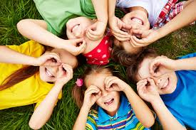  Children will explore friendships, their importance, what being a good friend means and how to keep friendships positive and healthy.  They will investigate their own values and develop skills to resolve difficulties within friendships, including maintaining and respecting personal boundaries and safe touch.  Children will be introduced to the concept of resilience, identify ways in which they can develop it themselves, as well as helping others to do so. |  | - We are kind and gentle.  - We are kind and helpful.  - We listen.  - We are honest.  - We work hard.  - We look after property.  
permission | The action of officially allowing someone to do a particular thing.
boundaries | Boundaries are guidelines for acceptable behaviours, expectations and personal limits.
value | If you value something or someone, you think that they are important and you appreciate them.
compromise | Settle a dispute by mutual concession
resilience | The ability to recover quickly, to be happy and successful again after something difficult or bad has happened.
Respect | A feeling of admiring somebody or something that is good or important.
Can you think of any other important words linked to ‘friend’ or ‘friendship’?

