 |  |  | Yarm Primary School
Year 5 |  | History: Romans | Enquiry question: What impact did the Romans have on Britain?
Subject Specific Vocabulary |  |  |  |  |  | Sticky Knowledge
amphitheatre | A round, open building surrounded by seats to view sports, entertainment or dramatics. |  |  | This Half term, we will be learning about the  Romans. On the reverse, you will find some suggestions that you could carry out to enhance  learning around this theme should you wish. These are just suggestions and you are more than welcome to add your own.  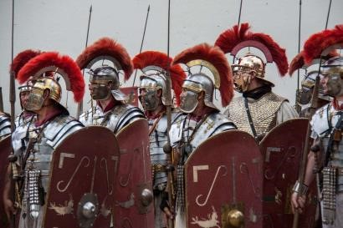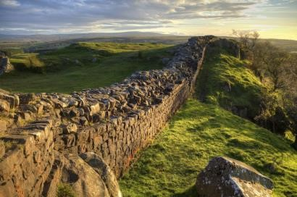 |  | - The Romans were famous for  building long, straight roads to transport legions, supplies, trading goods and messages from the emperor.  - Early in Roman times, the Roman people believed in many different gods and goddesses whom they believed controlled different aspects of their lives.  - The Romans built elaborately designed Roman baths where people would go to relax and socialise. Some of these impressive buildings still remain today.  Key Dates and Events  753BC – The city of Rome is founded.  55BC – Julius Caesar leads two Roman legions to invade Britain for the first time. He is unsuccessful.  43AD – Emperor Claudius successfully invades the southern part of Britain. 60AD – The Iceni tribe under Queen Boudicca rebel against the Roman. 122AD – Hadrian’s Wall is built to protect Roman land from the Caledonian tribes.  410AD – The Romans leave Britain to defend their homeland in Italy.
aqueduct | A manmade channel used for delivering water to Roman towns.
Celts | The tribes of people living in Britain during the Iron Age.
chariot | A vehicle with two wheels pulled by horses or ponies. Often used in battle.
invade/ invasion | To take over a country or region with an armed force.
legion | A large section of the Roman army, made up of 5000 soldiers.
mosaic | A picture made by arranging together small pieces of tile or glass. |  |  | Significant | t Individuals
numeral | Any letters representing numbers in the Roman number system. |  |  | 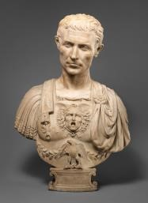  Emperor Julius Caesar  Famous Roman general who invaded Britain twice. | 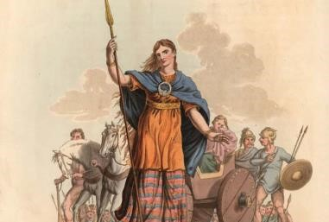  Queen Boudicca  Queen of the Iceni tribe of Celts  Led a rebellion against the Romans.
Roman empire | The name used for the land that was controlled by the Romans, including parts of Europe, Middle East and North Africa.
standard | A pennant, flag or banner suspended or attached to a long pole. The symbol of a Roman legion.

Create a section of Hadrian’s Wall. Be imaginative with your materials.
Design a poster showing what the Romans brought to Britain and how it is useful today.
The largest Roman amphitheatre in Britain was in Chester. Can you find out what happens in an amphitheatre?
Find out about a Roman god or goddess. Draw a labelled diagram of them.
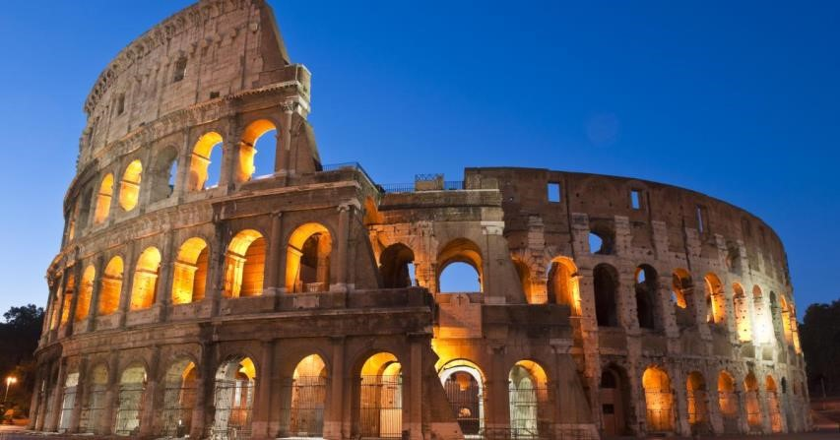
Many Roman towns end in –cester. Use a map of the UK to locate as many as possible.
Research various Celtic or Roman shield designs before making your own.
Compare the lives of Roman children with children today. Record your findings in two columns.
Create your own Roman mosaic using media of your choice.

