

•

•

•

•

MM.

**Behaviour Statement of Procedure Policy**

**Key Document Details**

|  |  |  |  |
| --- | --- | --- | --- |
| School: | Zouch Academy |  |  |
| Version no: | 1 | Ratified date: | Sept 2024 |
| Author: | Simon Cowley | Interim review date | n/a |
| Owner: | Nina Johnson | Next review date: | Sept 2025 |
| Approved by. | Governing Body |  |  |

**The White Horse Federation** [twhf.org.uk](http://twhf.org.uk/)

Values, culture and character through excellence in standards THE WHITE HOP SE FEDERATION



*This policy should be read and understood with reference to the following:*

*Anti-Bullying Policy*

*Safeguarding Policy*

*Physical Intervention Policy*

*Code of Conduct to staff and visitors*

*TWHF behaviour policy.*

**Key principles**

Here at Zouch we aim to achieve a learning environment that develops our children as independent learners equipped to play a full role in the life of the school and one that raises pupils' self-esteem, rewarding their achievements in their learning. Effective behaviour management is essential for the smooth running of a school and in the creation of a learning environment where everyone's rights and responsibilities are addressed.

1. We are a values school and as such we role model day in and day out our   
   embedded values in all interactions with pupils, parents and our colleagues.

Respect, Friendship, Honesty, Responsibility,   
Happiness Trust, Courage, Caring,   
Understanding, Thoughtfulness, Appreciation



1. We are unrelentingly positive in all areas of school life focusing on celebration and what is going well with our pupils whilst reinforcing expected behaviours. A key feature of our thinking reflects Carol Dweck's work on ***GROWTH MINDSET.***

|  |  |
| --- | --- |
| **Growth Mindset** | **Fixed  Mindset** |
| * Believe that effort create success | * Believe you either have the ability or |
| * Believe that skill and ability can | you don't |
| be increased over time | * Are reluctant to take on challenges |
| * Views mistakes as an | * Are worried about making mistakes |
| opportunity to develop | * Prefer to stay in their comfort zone |
| * Are resilient | * Think it's important to seem |
| * Think about how they learn | intelligent in front of others |

3. We understand the expectations of all as laid out in the Teachers' Standards in particular those highlighted below:

**1. Set high expectations which inspire, motivate and challenge**

* establish a safe and stimulating environment for pupils, rooted in mutual respect
* demonstrate consistently the positive attitudes, values and behaviour which are expected of pupils.

**2. Promote good progress and outcomes by pupils**

* encourage pupils to take a responsible and conscientious attitude to their own work and study

**3. Manage behaviour effectively to ensure a good and safe learning environment**

* have clear rules and routines for behaviour in classrooms, and take

responsibility for promoting good and courteous behaviour both in

classrooms and around the school, in accordance with the school's behaviour policy

* have high expectations of behaviour, and establish a framework for discipline with a range of strategies, using praise, sanctions and rewards consistently and fairly
* manage classes effectively, using approaches which are appropriate to pupils' needs in order to involve and motivate them
* maintain good relationships with pupils, exercise appropriate authority, and act decisively when necessary.

**Expectations of all staff at Zouch**

1. **Unrelenting positivity and culture of celebration in classroom.**

Each classroom needs to have a range of rewards that are consistently used and applied. It's vital though that those children who do the right thing day in day out are continuously recognised.

1. **Use language of choice in managing behaviour that matches expectations**

This enables us to provide opportunities for pupils to become refocused and leads into a

greater independence and taking responsibility for own actions.

1. **Our procedures recognise the importance of minimising conflict and positive resolution**
2. **Role model positive behaviours** -acknowledge pupils when they are behaving appropriately (remember the assertive discipline movement). Ensure there is a positive working environment (maximum use of seating plans, leadership roles, classroom layout etc.), positive feedback should be on going. Transitions/movements between activities should be clearly modelled and practiced regularly.
3. **Use positive corrective non-verbal signals/language for example**

* *Non verbally -* cueing by raising hand
* *Descriptive reminders -* teacher describes the behaviour to raise awareness ‘(always use child's name) you're calling out'
* *Directional language* raises the awareness of the child as well as focusing on positive expectation so `listen when I'm talking' becomes 'Tricia, pen down and eyes on the learning’. `Four on the floor Vanessa' when asking a child to stop swinging on the chair.

1. Avoid open interrogative `why' when dealing with pupils as it just opens up conflict.
2. Use least-to-most intrusive' approach/repertoire ranging from nonverbal, tone of voice, gestures etc.
3. Invite model and expect respect through; basic civility and good manners; consciously separating behaviour from person.
4. Allow consequences to do the teaching.
5. Use private rather than public reprimands whenever possible.
6. Refocusing pupils who come off task with directional language
7. Re-establish positive relationships following correction.
8. Utilise related and reasonable behavior consequences (sanctions) – they could be immediate or deferred, for example; an apology can wait until the child has cooled off properly and can make a meaningful apology. We must focus on enabling pupils to reflect on their behaviour and the consequence that applies to their choice. Consequences need to teach our children:

* About the relationship of their behaviour and consequences.
* That they, in effect, own their own behaviour.
* Reparation MUST happen – especially between adult and child.

**Levels of behaviour management at Zouch**

* Class teacher to ensure the rules of the classroom (their expectations) are shared/agreed with the children in the first few days of the year.
* Agreed rules/class promise should be displayed somewhere in the classroom to refer to when needed.
* All staff across the school will now use Class Dojo to reward and celebrate good choices.
* Behaviour to be managed in the classroom in the first instance.
* If the behaviour persists, then the child can be removed and placed in a parallel class within the same year group for a short period of time to reflect on their choices.
* If the negative behaviour persists, missing part of their playtime is an option.
* If the negative behaviour still persists, then the child can be sent to the Head Teacher/Deputy Head Teacher who will decide a sanction which is proportionate for the behaviour and considers the needs of each child.
* Internal exclusions may be given; parents will be notified by the class teacher or the SLT. Head teacher/Deputy Head teacher to decide where the child will be placed for this sanction.
* FT suspensions can be given as a last resort (If the Head teacher thinks it is safe to be suspended)

Any bullying concerns and subsequent actions will be addressed in line with the Anti - Bullying Policy and Behaviour and Discipline Policy[:](https://zouch-academy.twhf.org.uk/downloads/zouchAcademy/TWHF-Policy-Template-Anti-Bullying-Policy-2022.pdf) <https://zouch-academy.twhf.org.uk/downloads/zouchAcademy/TWHF-Policy-Template-Anti-Bullying-Policy-2022.pdf>

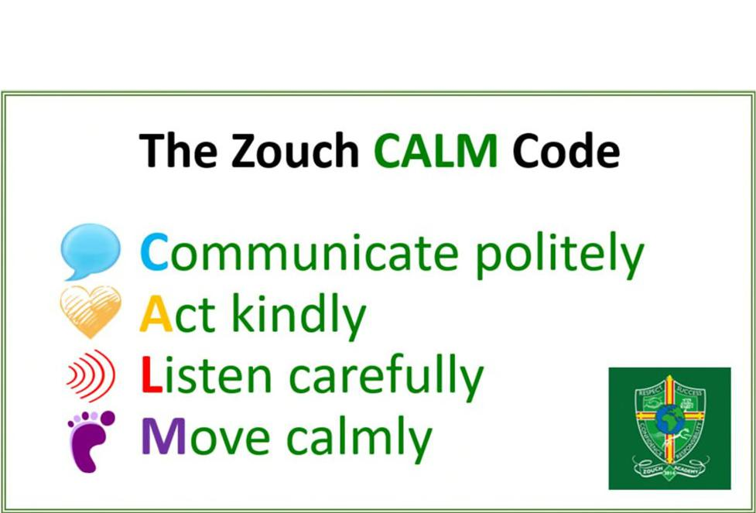

Throughout the school the use of the CALM school code supports our children in understanding acceptable behaviour during transition periods and is understood by all members of the school community and the language of the code is used when continually reinforcing expectations of behaviour and when dealing with any poor choices made. Like all of our communication with others it is led by our school values.

**Child on Child Abuse:** All concerns about child on child abuse will be taken seriously and never ignored. Pupils are encouraged to report anything which makes them feel uncomfortable. The school’s response will be proportionate, considered and supportive as outlined in the Behaviour and Discipline Policy which also details appropriate sanctions and reporting related to child on child[:](https://thewhitehorsefederation.org.uk/downloads/default/Behaviour-Policy-v5.pdf) <https://thewhitehorsefederation.org.uk/downloads/default/Behaviour-Policy-v5.pdf>

**Recording and Reporting**

**Racist and Homophobic Incidents**

Any racist or homophobic incidents must be reported to the Head teacher immediately. The adult who makes the report must complete the relevant form and pass this to Nina Johnson, who will follow up with the appropriate next steps. Nina Johnson will log in our Racist Homophobic Incidents Log.

**Bullying behaviours**

Please follow guidance in the Anti Bullying Policy

**Duty of Care - Outside the Classroom - our Strategy for Managing Out of Class Behaviour**

Leaving orderly classrooms to the relatively unstructured time of break/wet break and lunchtimes requires us to be extra vigilant and have absolute clarity around expectations/behaviours and how we manage incidents or accidents that happen. We have identified below our arrangements for managing our out of class behaviours.

|  |  |  |
| --- | --- | --- |
|  | **KS1 Arrangements** | **KS2 Arrangements** |
| **Play time** | EYFS - social time around snack and  outside play  KS1  Wash hands  Line up and collect snack  End of play whistle blown and children  freeze and then line up outside their  classroom.  Teachers/TAs come out and direct them  calmly into the classroom. | Orderly dismissal/stand behind  chairs.  End of play bell rung and children freeze.  Pupils line up outside their classrooms and their teacher/TA will welcome them back into class. |
| **Wet play** | EYFS - video then wake and shake  KS1 Golden Time in class supervised by  CT/TA | KS2 Pupils in classes supervised by CT/TA |
| **Lunchtime** | All pupils eat in KS1 Hall  supervised by MDSAs  Duty staff collect from classrooms  following end of meal  Pupils out to play  End of lunch routines same as those at  break | Pupils having hot lunch escorted over to KS1 Hall by adult.  Packed lunches eaten in the hall. Pupils to use Y5 cloakroom only. MDSAs/TA/Teachers will monitor use of the toilet to ensure minimal amounts of pupils are using them at once. End of lunch routine same |
| **Wet**  **lunchtime** | After lunch routine completed routine as for wet break | After lunch routine completed routine as for wet break |

**Appendix: Wider School interventions including ELSA work**

Continuing/Persistent poor behaviour in all likelihood will indicate that there is an underlying problem for the child. It is imperative that we stop poor behaviour becoming the expected behaviour and addressed only through sanctions and consequences. CT needs to raise the child's poor behaviour with either NJ/NM who will decide next steps following work with the child and their parent(s). At a school level we can offer a range of support/interventions for example provided through Primary Inclusion Lead and ELSA:

* Anger management
* Self-esteem groups
* Social skills
* 1:1
* Social stories
* Bespoke interventions dependent on child's needs
* Counselling
* Play therapy
* CAF/TAC (if appropriate)

However, if additional specialist support required the school will raise concerns through LA referrals for example behaviour Support/Ed Psychology. We will explore wider strategies dependent on need of the child. Our primary focus is to support the child and family however it might be agreed that rather than therapeutic support we need to pursue the disciplinary route of Individual Behaviour Plans and Pupil Support Plans (see appendices).

**Appendix 3 Reporting Forms**

Staff Incident Report Form Pupil Incident Report Form Racist/homophobic

**Zouch Academy**

**Staff Incident Report Form**

|  |  |
| --- | --- |
| Name of colleague  reporting incident: |  |
| Date: |  |
| Pupils involved: |  |
| Pupil Incident  forms completed  by: |  |
| Incident summary: |  |
| Actions taken: |  |

Circulation:

Please attach pupil incident forms to this form and pass to class teacher as a soon as possible to the event.

**Zouch Academy Pupil Incident Form**

|  |
| --- |
| **Important note for all staff**  The purpose of this form is to enable the pupil to reflect and think through their behaviour. Depending  on the age of the child an adult might want to read the questions and record the child's response. For those pupils able to write their own response the questions an adult will still need to go through each question and talk it through with the child so any misconceptions/misreporting can be corrected. The completed form needs to go to class teacher for next steps/actions. The class teacher should  make sure the event is recorded in the behaviour book. It's advised that the class teacher shares the incident with either NJ/NM. |

Pupil name Date

1. **What I did.**
2. **Why I think this happened (their right of reply).**
3. **What rule/right I broke or affected.**
4. **What I need to do to put things right.**

**Actions/next steps**





**Signed pupil: Signed adult:**

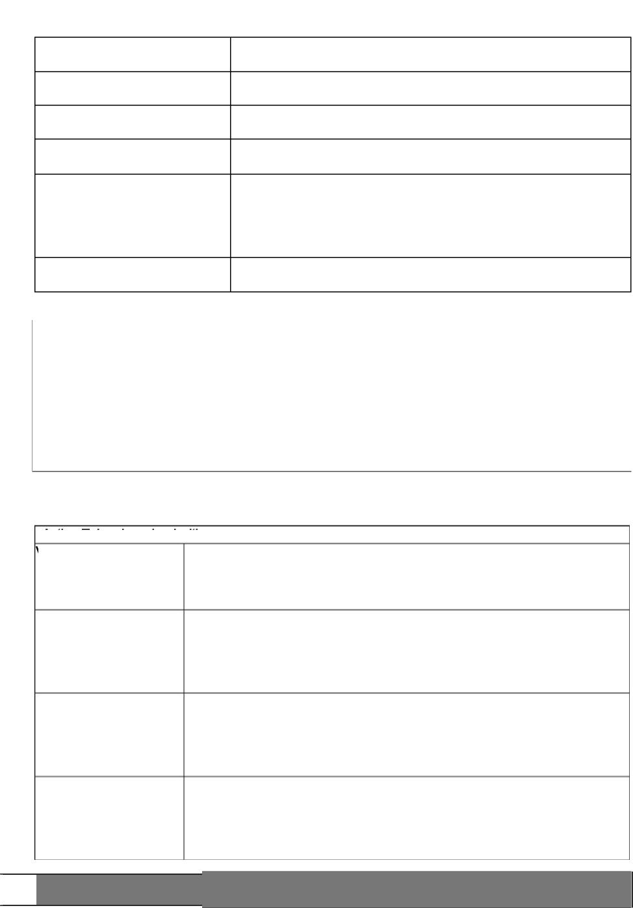

Date of Incident:

Date this form completed:

Name of victim:

Name of alleged   
perpetrator:

Names of witnesses:

Investigation completed by:

**Zouch Academy**

**Racist/Homophobic Incident Report**

|  |  |
| --- | --- |
| Action Taken by school with | |
| Victim: |  |
| Perpetrator: |  |
| With parents: |  |
| School actions  in response to  incident: |  |

Signature of investigator:

Investigation findings/outcome:

**Appendix 4**

**BLUE Pupil Behaviour Plan (PBP) Guidance**

Pupil Behaviour Plans detail the specific arrangements to support the development of appropriate behaviours for a particular pupil.

**1.** Triggers for a PBP

Continuing of persistently poor behaviour, the escalation of poor behaviour or a one off significant event for example deliberate harm of another child are all triggers for a PBP. The CT will have tried a wide range of interventions including meetings with parents and flagged their concern to NJ/NM. There will be a meeting of the CT, either NJ,NM/JU and SP to decide if a PBP is the required way forward or there are other options to be tried.

2, Setting up the PBP

Prior to the PBP meeting, the CT will meet with NJ/NM (dependent on age of

child) to discuss and formulate a positive plan, including:

1. Key challenging behaviours
2. Strategies already in place
3. What else we can provide internally and recommendations for external agency involvement
4. Recognition/reward strategy

The information is recorded on a PBP.

3. Communicating the PBP

A discussion about the plan will be had with parents.

4, Monitoring of the Plan

The plan will be reviewed regularly by the CT, SLT and/or FSW.

If there are no improvements then JU will make a referral to Behaviour Support

(BSS)/Educational Psychologist (if not already done so). The cycle continues regularly and a new plan will be agreed, if no improvements in this time a discussion will be had with NJ to determine if a child goes onto a formal Pastoral Support Programme if they are at risk of FTE/PEX.

**Appendix 5:**

**RED Pastoral Support Plan PSP Guidance**

A PBP will move to a PSP if the child's behaviour deteriorates over a period of time or there is a one of significant event that doesn't quite meet the threshold for PEX.

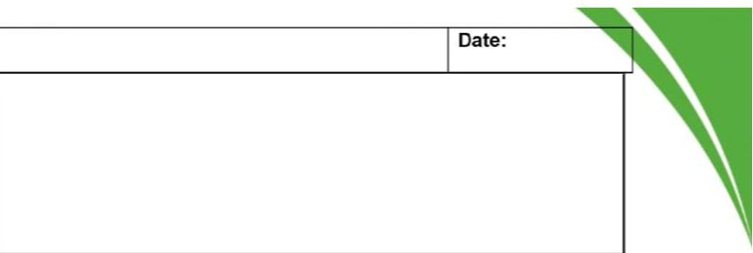

**Stage 4:** *Where will the child calm after the crisis - who will support them?*

**Zouch Academy Pupil Behaviour Plan**

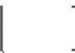

**Name:**

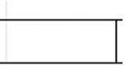



**Nature of the risk:**

**Stage 1:** *What anxieties/triggers need to be planned for?*



**Stage 2:** *What signs do you notice when things start to escalate? What are the best strategies for de-escalation?*

**Stage 5:** *What do they need for recovery (how do we re-enter them back to the classroom?)*

**Stage 3:** *In a moment of crisis, what is the 3 step plan?*

1

2

3,



**Stage 6:** *What script will be used to discuss the incident? How are Peers (witnesses) supported?*



|  |  |
| --- | --- |
| **Some responses to consider at each stage:** |  |

|  |  |  |
| --- | --- | --- |
| **Stage 1 (Anxiety/Trigger)**   * Read the body language |  | **Stage 4 (Recovery)** |
| * Read the behaviour |  | * Support and monitor |
| * Intervene early |  | * Be wary of the possibility for further escalation |
| * Communicate — `Talk and I'll listen' |  | * Give space and time |
| * Use appropriate humour |  | * Look for signs that they are ready to talk |
| * Display CALM body language |  | * Offer a glass of water (check physical signs and ability to |
| * Talk low, slow and quietly |  | breath/swallow) |
| * Offer reassurance — including positive physical prompts |  |  |
| * Assess the situation |  |  |
| * Divert and distract by introducing another activity or topic |  |  |
| **Stage 2 (Defensive/Escalation)** |  | **Stage 5 (Depression)** |
| * Continue to use stage 1 de-escalation responses |  | * Support, reassure and monitor |
| * State desired behaviours clearly |  | * Respond to any signs that they want to communicate |
| * Set clear enforceable limits |  | * Show concern and care (no consequences yet) |
| * Offer alternatives and options |  |  |
| * Offer clear choices |  |  |
| * Give a get out with dignity |  |  |
| * Assess the situation, making the environment safer and getting help |  |  |

**Stage 3 (Crisis)**

* Continue to use stage 1 and 2 de-escalation responses
* Make the environment safer
* Move furniture and possible weapons/missiles
* Consider physical handling if reasonable, appropriate and necessary
* Ensure face, voice and posture are supportive but not aggressive
* Use help script to `save face by changing face

**Stage 6 (Follow up)**

* Listen and learn (consider a Restorative Practice approach)
* Report, record, review and communicate
* Follow up any consequences
* Plan to avoid it happening again