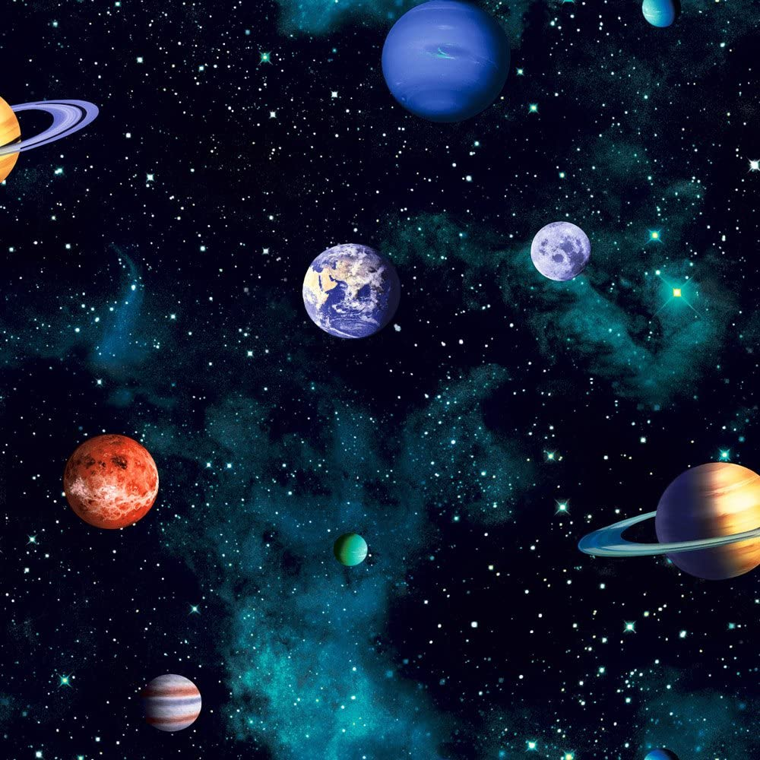
PSHE:
Being me in my world:
- learning how to feel special and safe in my class.
- knowing that I belong to my class.
- knowing how to make my class a safe place to learn, discussing achievements and consequences.

History
- To learn about a significant individual from the past - Neil Armstrong.
- To learn about a significant individual from the past – Tim Peake
- To learn about a significant individual from the past – Mae Jemison
- To observe changes in space travel.

Maths
- Place value to 20
- sorting and counting objects
- reading and writing numbers to 10,
- finding one more and one less
- ordering numbers up to 20.
- Addition and Subtraction
- Fact families
- Number bonds to 10
- Taking away and find how many is left
- Time: Days and Months
- To recognise and name days of the week
- To recognise and name months of the year.
Fabulous finish to the topic:
- A space art gallery
PE:
- Basic movement - Jumping, dodging and running.
- Ball skills – catching, throwing, rolling and bouncing.

ICT skills in Computing:
- E-safety
- Computing systems and networks – Technology around us.

English – Our texts for the term will be ‘Leaf’ by Sandra Dieckmann and ‘Stuck’ by Oliver Jeffers.
- Daily phonics sessions
- Revisiting phase 4 phonics and starting phase 5
- Role-play and storytelling through drama
- Writing labels
- Poetry (using the Sound Collector)
- Recount
- Setting description

Music:
- Pulse and Rhythm (My favourite things).
Science: Human body (Ourselves)

- Learning about our bodies by using drawing and labels.
- Explore our senses by asking simple questions and make simple observations.
Art
- Understand what a sketchbook is and how to use it.
- Begin to draw from observations.
- Explore a range of art mediums.
RE: Christianity
- Harvest
- Christianity and the story of creation.
Hook for Learning:
- Magic Box

Curriculum Web
Space Explorers
Year 1 – Term 1
Value of the term:
- Trust

