Playing & Exploring –Engagement
Exploring the learning environment,
Using their senses to explore a range of activities,
Playing and sustaining focus in an activity of their choice.
Creating & Thinking Critically – Thinking
Accessing the learning environment around them; using transporting and connection schemas.

Active Learning
Engaging in shared learning time,
Shared attention and listening skills development.

Communication and Language

- To develop an awareness of the rules and daily routine.
- To develop their use of visuals, verbal cues, and gestures to communicate their wants/needs.
- To develop their shared attention skills, such as shared gaze, gestures and vocalisation/verbalisation.

Personal, Social and Emotional Development

- Children to settle back into the school routine; familiarising themselves with routines and expectations.
- Children to develop their shared attention and listening skills, to engage in a range of child-led activities.
- Children to communicate in their preferred way, to get their needs/wants met by an adult.
- Children to explore the learning environment alongside their peers, or independently if preferred.

Physical Development

- To wash their hands, following a routine sequence with increased independence.
- To transport different materials/resources, from one area to another with increased control.
- To develop a preference in a dominant hand; when writing, eating or accessing an activity.
- To explore the garden equipment using their large muscle groups, such as climbing.
- Disco dough and Music and Movement, developing fine and gross motor skills.


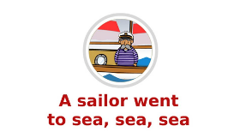
Goldfinch A
Term 1

Literacy
- To engage positively with the Rhyme of the Week.
- To begin to/ to recognise their name.
- To write some letters accurately, using a prompt and support, where required.
- Phase 2 phonics - Little Wandle (S, A, T)
- Rhyme Time Rhymes:
- A Sailor Went to Sea,
- Baa, Baa Black Sheep,
- Twinkle Twinkle Little Star.

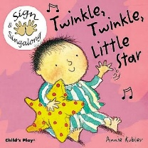
Expressive Arts and Design

- To engage in Music and Movement; moving their bodies to music and following actions, where required.
- To engage in Mark Making, both inside the classroom and in the outdoor area.
- To develop a preference in expressing themselves, creatively.
Understanding the World

- Exploration of the World Around Them; engaging in Forest School within a small group, with adult support.
- To explore the outdoor area, using a range of natural resources and materials within their play experiences.
- To develop an awareness of others, who make up the class; demonstrated in their interactions within the class.
Maths
- To engage in songs, relating to counting in a sequence to 5.
- 1,2,3,4,5 Once I Caught a Fish Alive;
- 5 Little Speckled Frogs;
- 10 in the Bed…

- To develop counting behaviours, such as pointing at each number, intonation in the sounds/words etc.
- To recognise the numbers 1 – 5, putting these into a sequence using the written numeral.

