Creating & Thinking Critically – Thinking
Having their own ideas
Making links
Choosing ways to do things

Playing & Exploring –Engagement
Finding out and exploring
Playing with what they know
Being willing to have a go
Motivation
Being involved and concentrating
Keep trying
Enjoying achieving what they set out to do

Physical Development

- Squiggle Whilst you Wiggle to develop gross motor movements
- To dress for outdoor wear e.g. putting on our coats
- To go to the toilet independently
- To wash and dry our hands
- To develop movement and balance skills
- To use one handed tools such as paintbrushes and pencils
Communication and Language
- To listen to simple stories
- To listen to other people’s talk with interest
- To understand simple sentences
- To talk to themselves when playing
- To communicate their basic needs to an adult
- Talk about Tapestry observations from home
Personal, Social and Emotional Development

- To develop friendships with other children
- To become familiar with our nursery routines
- To discuss nursey expectations and golden rules
- To learn how to tidy and take care of the resources in my classroom and outside areas
- Jigsaw – ‘Being me in my world’
- This term our value is ‘Trust’

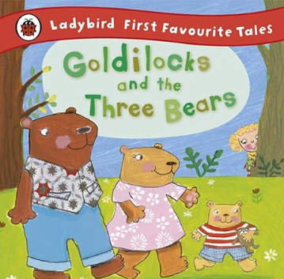
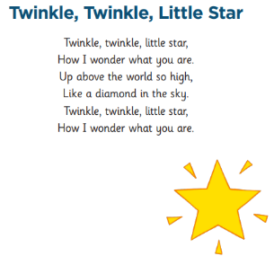
Duckling Class
Term 1
Literacy
- To look at books independently
- To make marks during play
- To ascribe meaning to marks
- To recite familiar nursery rhymes

Key nursery rhymes:
Twinkle, twinkle little star, Jack and Jill

Expressive Arts and Design

- To sing familiar nursery rhymes including adding actions
- Self-portraits
- To learn a song for Harvest
- Construction - simple models to express own ideas
Maths
- To learn simple counting up songs
- To talk about numbers in pictures
- To begin to count in 1’s 1-5
- To begin to count small sets of objects that can be moved
- To talk about designs e.g. spotty/stripy
- To begin to learn the language of size ‘big’ and ‘small/little’

Understanding the World

- To talk about who is in my family
- To become familiar with the nursery environment
- To use senses to explore natural materials
- To notice signs of Harvest
- Forest school



