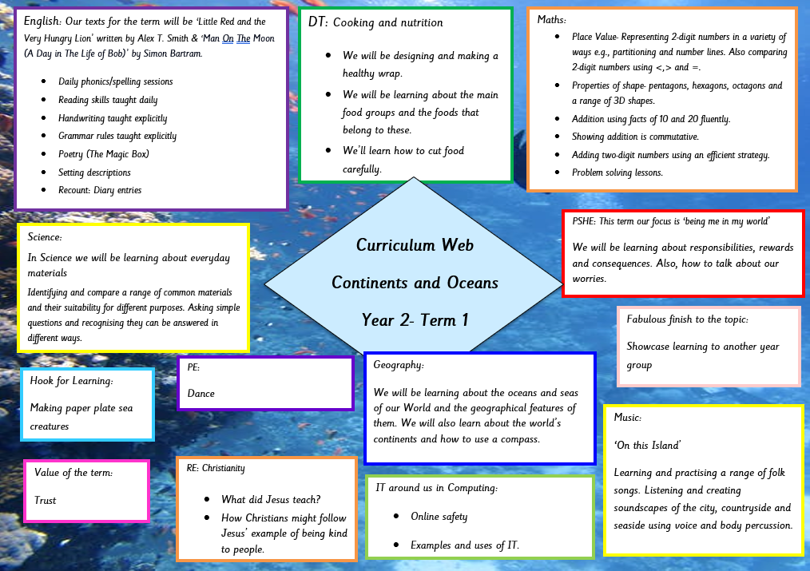
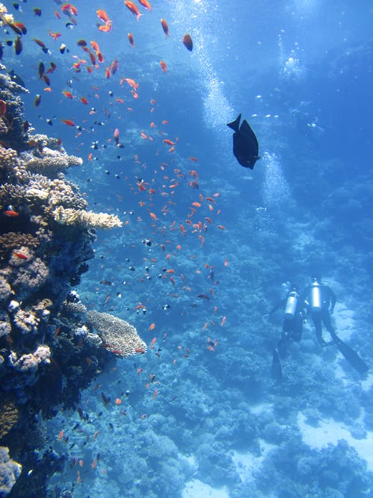
Curriculum Web
Continents and Oceans
Year 2- Term 1
PE:
Dance
IT around us in Computing:
- Online safety
- Examples and uses of IT.
Maths:
- Place Value- Representing 2-digit numbers in a variety of ways e.g., partitioning and number lines. Also comparing 2-digit numbers using <,> and =.
- Properties of shape- pentagons, hexagons, octagons and a range of 3D shapes.
- Addition using facts of 10 and 20 fluently.
- Showing addition is commutative.
- Adding two-digit numbers using an efficient strategy.
- Problem solving lessons.

Fabulous finish to the topic:
Showcase learning to another year group
Value of the term:
Trust
Hook for Learning:
Making paper plate sea creatures
Science:
In Science we will be learning about everyday materials
Identifying and compare a range of common materials and their suitability for different purposes. Asking simple questions and recognising they can be answered in different ways.

DT: Cooking and nutrition
- We will be designing and making a healthy wrap.
- We will be learning about the main food groups and the foods that belong to these.
- We’ll learn how to cut food carefully.

RE: Christianity

- What did Jesus teach?
- How Christians might follow Jesus’ example of being kind to people.
Geography:
We will be learning about the oceans and seas of our World and the geographical features of them. We will also learn about the world’s continents and how to use a compass.
Music:
‘On this Island’
Learning and practising a range of folk songs. Listening and creating soundscapes of the city, countryside and seaside using voice and body percussion.
PSHE: This term our focus is ‘being me in my world’
We will be learning about responsibilities, rewards and consequences. Also, how to talk about our worries.

English: Our texts for the term will be ‘Little Red and the Very Hungry Lion’ written by Alex T. Smith & ‘Man On The Moon (A Day in The Life of Bob)’ by Simon Bartram.
- Daily phonics/spelling sessions
- Reading skills taught daily
- Handwriting taught explicitly
- Grammar rules taught explicitly
- Poetry (The Magic Box)
- Setting descriptions
- Recount: Diary entries

