[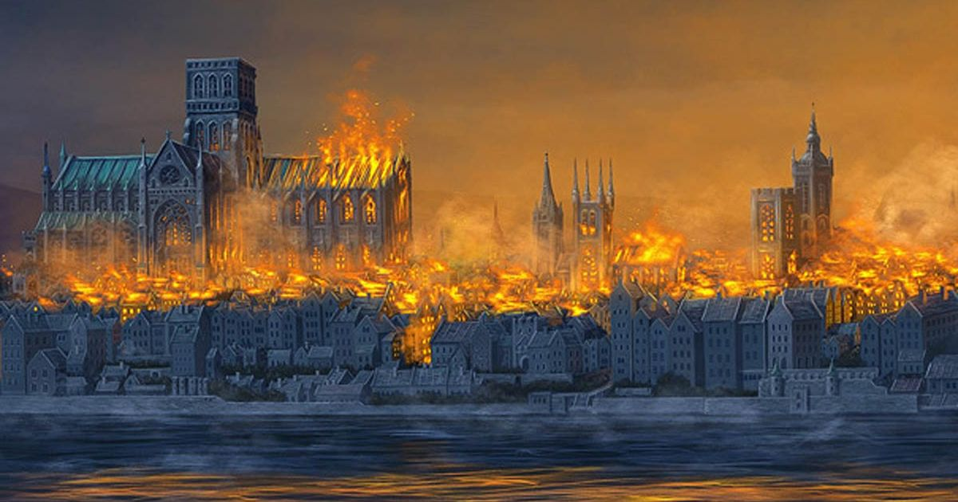](http://www.google.co.uk/url?sa=i&rct=j&q=&esrc=s&source=images&cd=&cad=rja&uact=8&ved=0ahUKEwjy4uXsiObWAhVMthoKHa2qCHwQjRwIBw&url=http://www.mirror.co.uk/news/uk-news/great-fire-london-anniversary-explained-8741830&psig=AOvVaw1OQAGByYX5LVRoSa_MqCr2&ust=1507725326657735)

Maths:

* Properties of 3D shapes
* Symmetry- finding a line of symmetry
* Subtraction- ranging from subtracting two single digits to subtracting two double digit numbers
* Multiplication (involving the 2, 5 and 10-times table)

Music:

Orchestral instruments (Traditional Western stories)

Science:

Exploring the properties of materials (including elasticity, bounciness, rigidity and exploring strength).

History:

We will be learning about the impact that the Great Fire had on London. We will also be learning about Samuel Pepys and Christopher Wren and the significance these individuals.

RE:

Christianity- Why do Christians believe that God gave Jesus to the world?

PSHE- Celebrating difference

We will be learning to celebrate differences, stereotypes and bullying. We will also be learning good ways to make new friends.

Art:

We will be exploring different artists through learning about the environment. We will be developing our drawing skills through observations.

PE:

Balance and movement and indoor equipment

English: Our text for the term will be Toby and the Great Fire of London by Margaret Nash

* Daily phonics sessions
* Reading skills taught three times a week
* Grammar rules taught explicitly
* Newspaper report
* Letter writing
* Character description
* Character and setting descriptions
* Fact file about Samuel Pepys
* Diary entry from the perspective of Samuel Pepys

Hook for Learning:

Active learning experience

**Curriculum Web**

**Great Fire of London**

**Year 2- Term 2**

Value of the term:

Friendship

ICT skills in Computing:

* E-safety
* Digital Photography

Fabulous finish to the theme:

Christmas celebrations