**Motivation**

Being involved and concentrating

Keep trying

Enjoying achieving what they set out to do

**Playing & Exploring –Engagement**

Finding out and exploring

Playing with what they know

Being willing to have a go

**Creating & Thinking Critically – Thinking**

Having their own ideas

Making links

Choosing ways to do things

**Personal, Social and Emotional Development**

* Jigsaw – ‘Celebrating difference’

1. What I am good at
2. I’m special, I’m me
3. Families
4. Houses and homes
5. Making friends
6. Stand up for yourself

* This term our value is ‘Friendship’

**Communication and Language**

* To talk using a complete sentence when answering a who, what, when and question
* To sit still and listen during celebration assembly
* To understand and follow 2-part instructions
* To introduce storylines during role play
* Talk in whole sentences when telling an oral story (Helicopter stories)

**Physical Development**

* To hold a pencil using the correct pencil grip
* To form the letters in my name correctly and other letters I have learnt
* To use scissors in one hand with increasing control to follow a simple outline
* Putting on coats and boots independently for outdoor learning
* Handle and use woodwork tools safely
* P.E. balance and movement skills



[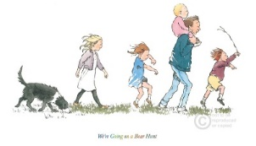](https://www.google.co.uk/url?sa=i&rct=j&q=&esrc=s&source=images&cd=&cad=rja&uact=8&ved=2ahUKEwjyj8rlkqfdAhUKWBoKHX3cAckQjRx6BAgBEAU&url=https://www.blossomstreet.co.uk/shop-items/were-going-on-a-bear-hunt&psig=AOvVaw2vw4vh-o3dVZJ2D7Qb1w7G&ust=1536349677941259)

**Robin and Wren Class**

**Term 2**

**’Wonderful Woods & Christmas’**

***’***

**Literacy**

* To write my name from memory
* To hear and use inial and final sounds when writing lists and labels.
* Phase 2 phonics
* To read common exception words (tricky words) by sight
* Reading practise sessions.
* To answer questions about what I have read or stories I have listened to

Key texts:

**We’re going on a Bear Hunt, The Leaf Thief, The Helpful Hedgehog, The Gruffalo, Dear Santa, A Very Corgi Christmas, We’re going on an Elf Chase, Father Christmas, The Nativity Story**

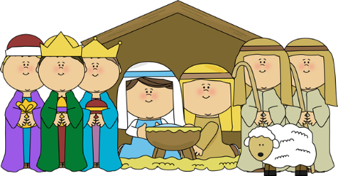

[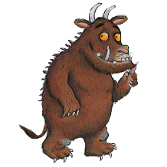](https://www.google.co.uk/url?sa=i&rct=j&q=&esrc=s&source=images&cd=&cad=rja&uact=8&ved=2ahUKEwjChaSkkafdAhVG4YUKHdK0CGEQjRx6BAgBEAU&url=https://www.briersltd.co.uk/products/the-gruffalo-pop-up-bag&psig=AOvVaw2xsVGYQmHoDpWleVnQqn90&ust=1536349296811967)

**Expressive Arts and Design**

* Woodland small world play using characters from the stories we have been reading
* Fire work pictures
* Create a remembrance poppy picture
* Learn Christmas songs
* Create a Christmas card
* Christmas role play

**Understanding the World**

* Learn about nocturnal animals and animals that hibernate
* Learning about Autumn/Winter festivals and celebrations
* Forest school sessions
* Exploration of magnets
* To interact with beebots
* Walk to the Church
* Visit from the Police

**Maths**

* Careful counting, saying one number name for each object
* Representing numbers to 10 in different ways on a ‘tens frame’
* Recognising non-standard dice patterns without needing to count the spots
* Count forwards and backwards from 10.
* 2D and 3D shape