Creating & Thinking Critically – Thinking
Having their own ideas
Making links
Choosing ways to do things

Motivation
Being involved and concentrating
Keep trying
Enjoying achieving what they set out to do
Playing & Exploring –Engagement
Finding out and exploring
Playing with what they know
Being willing to have a go

Personal, Social and Emotional Development
- To control my emotions using a range of techniques
- Jigsaw – Relationships
  - My family and me
  - Make friends, make friends never, never break friends (Part 1 and 2)
  - Falling out and disagreements (part 1and 2)
  - Being the best friend, we can be
This term our value is ‘Patience’
Physical Development
- To write letters using the correct letter formation and begin to control the size of letters.
- To hold scissors correctly and cut out small shapes.
- Manage all personal needs independently.
- To ride balance bikes and 2 wheeled bikes with control.
- P.E. tennis skills.
Communication and Language
- To understand questions such as Who? What? Where? When? Why? and How?
- To ask their own questions to find out more information.
- To continue to use sentence stems when talking about learning.
- To listen and respond to ideas during class discussions.
- To talk to different adults around school.
- To orally compose a simple story using first, next, after that and finally.
- To learn and recite a poem.

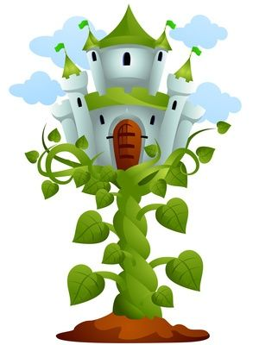
Literacy
- To write a sequence of 4 or more sentences which can be read by myself and others.
- To write longer words that are spelt using their phonics
- Phase 4 phonics – read and write cvcc and ccvc words.
- Reading groups.
- To use vocabulary that is influenced by their experinces of books
- To predict what may happen in a story and how it might end based on the sequence of the story.
Key texts: Jack and the Beanstalk and The Extraordinary Gardener Nourish Texts: Supertato, Olivers Vegetables, The Runaway Pea, The Secret Sky Garden.
Poetry Basket: A little Seed, 5 Little Peas
Robin and Wren Class
Term 5
’What a wonderful world!’

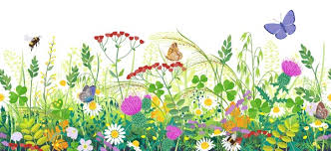

Expressive Arts and Design
- To use colour for a purpose.
- Dandelion observational art.
- To use lines for different effects.
- To mix and match colours.
- Music - using voices, bodies and instruments to explore different types of transport. Identify and mimic different transport sounds and interpret and perform a simple score.
Understanding the World
- Planting bean seeds
- To create imaginary small world settings using drawn elements.
- Forest school sessions
- Name a range of common plants found in the school grounds
- Explore contrasting environments
- Month of the Military child

Maths
- Oral counting to 20
- Recognise numbers to 10 out of sequence and order a set of numbers to 10
- Adding and subtracting single digit numbers
- Estimating how many objects can be seen
- Subitising - non-standard picture patterns.
- Instantly recognise 5 wise and 2 (pair) wise quantities to 10.
- To understand odd and even numbers to 10
- Make or draw numicon shapes from memory
- Spot mistakes in number collections and give the reason why it’s incorrect.
- To understand the concept of doubling and halving numbers to 10
- Order 3 objects by height and length

