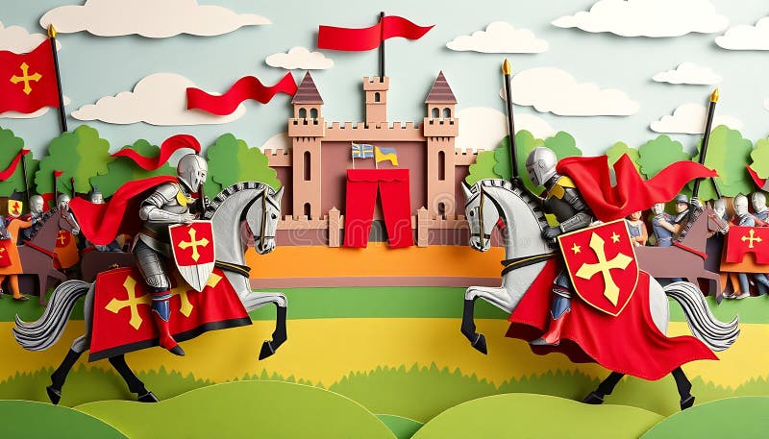
the crowds on Palm Sunday
Maths:
Geometry: Direction and Position
- Use mathematical language to describe whole, half, one quarter and three quarter turns.
- Use mathematical language including up, down, left and right.
Addition and Subtraction:
- Add two single digit numbers within 10
- Bridging ten
- Add a single digit number to 10.
- Add 9 to a single digit number
- Subtract a single digit from a single digit number
Time: tell the time to the hour, half the hour.
Music: Under the sea.
- Move and create sounds to reflect a character.
- Sing and play high and low sounds.
- Read symbols representing high and low sounds.
PSHE: Relationships
- Understand that there are lots of different types of families
- Identify what being a good friend means
- Discuss different ways of greeting people
- Identify people who can help us
- Recognise my qualities and recognise qualities in people who are special to me
English: Our text for the term will be ‘Lost in the toy museum’ and ‘Tidy’.
- Daily phonics sessions
- Active learning
- Grammar rules taught explicitly
- Use the suffix ‘est’.
- Use a range of conjunctions.
- Use exclamation marks to punctuate a sentence.
- Write a retell of the ending of a story.
Hook for Learning:
Find the characters from the book in hide and seek.
History:
- Know what castles are and name some famous British castles.
- Know basic events in the Norman conquest
- Know some of the different people who lived in castles and their jobs.
- To describe features of castles and identify similarities and differences.
- To use parts of stories to understand key events (Norman conquest).

PE:
Tennis
Art: Explore printing
- Hold a wide range of art resources accurately
- Draw lines of different sizes and thicknesses
- Explore a range of art mediums
- Begin to draw from observations.
ICT skills in Computing:
- Online safety
- Creating media
RE: Judaism – Shabbat
Key Question of the term: Is Shabbat important to Jewish children?

Science: Animals including humans - Pets
- Identify and name a variety of common animals including fish, amphibians, mammals, reptiles and birds.
- Name animals that are carnivores, herbivores and omnivores.
- Describe and compare the structure of different animals.
- Identify and classify. Use appropriate scientific language to communicate ideas.
Curriculum Web
Castles and Knights
Year 1 - Term 5
Value of the term:
Patience

