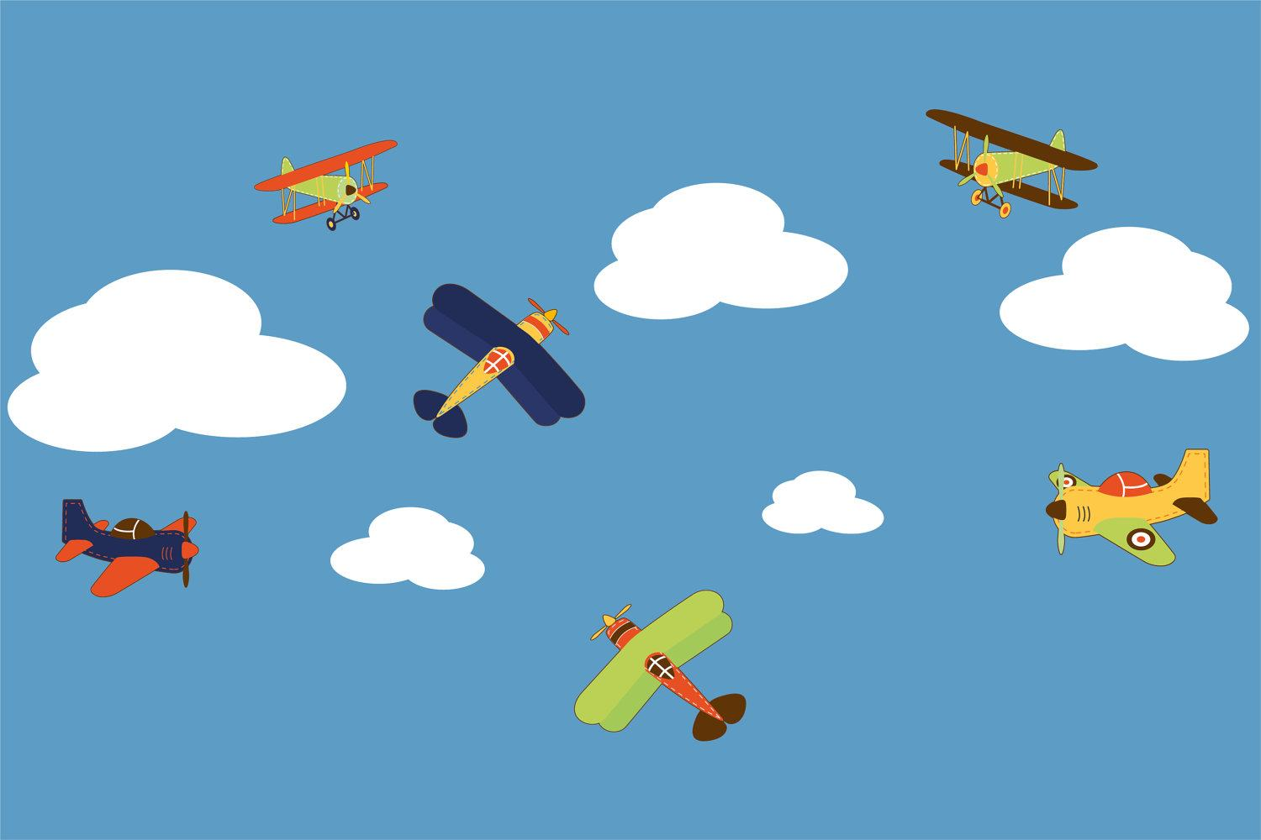
Music:
This term we will be developing our knowledge and understanding of dynamics using instruments, vocals and our bodies to make sounds. We will learn to compose and play rhythms to represent planets.
Art: Expressive painting
We will be learning about artists who use expressive painting. We will also be exploring a variety of mark making techniques.

Maths:
- Position and direction- describing positions, turns and the use of right angles.

The remainder of the term will be revision of the Year 2 Maths curriculum to ensure it’s embedded before the children move up to Year 3.

We will also be learning about different problem-solving skills and exploring these in different contexts.
English: Our texts for the term will be ‘The Bear and the Piano’ by David Litchfield and ‘The Wonder’ by Faye Hanson.
- Daily phonics sessions
- Reading skills taught daily
- Handwriting taught explicitly
- Grammar rules taught explicitly
- Poetry
- Innovated narrative
- Setting description
- Recount
RE:
Sikhi- We will be learning about the Sikh festival of Baisakhi (or Vaisakhi) and how the Khalsa began.
PE:
Athletics
Hook for Learning:
Exploration of how flight has changed over time
Science:
In Science we will be continuing our Plants focus. This term we will be exploring:
- What plants need to grow
- The lifecycle of plants
- The different ways to grow our own plants
Fabulous finish to the topic:
End of year party
History:
We will be learning about the development of flight (within and beyond living memory), famous pilots, such as: The Wright Brothers and Amy Johnson and we will be learning about the history of flights in Larkhill.

Multimedia skills in Computing:
- Online safety
- Programming
PSHE: This term our focus is ‘Changing me’.
We will be understanding the changes that are taking place around us, learning about the parts of the body and learning about privacy.
We will be doing lots of work on the transition to Year 3 in our PSHE lessons too.

Curriculum Web
Famous Flights!
Year 2- Term 6
Value of the term:
Happiness

