Playing & Exploring –Engagement
Finding out and exploring
Playing with what they know
Being willing to have a go
Motivation
Being involved and concentrating
Keep trying
Enjoying achieving what they set out to do
Creating & Thinking Critically – Thinking
Having their own ideas
Making links
Choosing ways to do things

Personal, Social and Emotional Development
- Jigsaw – Changing me
  - My body
  - Respecting my body
  - Growing up
  - Fun and fears x2
  - Celebration
Transition activities
This term our value is ‘Happiness’
Communication and Language
- To concentrate and sit quietly during assembly and carpet sessions
- To continue to use sentence stems when talking about mathematical understanding and learning
- To listen and respond to ideas during class discussions
- To talk in a complete sentence when sharing thinking and learning
- To retell familiar stories using a ‘Talk for writing’ story map
- To orally innovate a well-known story using ‘Talk for writing’
Physical Development
- Continue to form letters correctly
- To continue to understand how to be healthy (Healthy Eating Week)
- Balancing, holding body weight and swinging
- Riding two wheeled bikes and scooters
- P.E. – Athletics - linked to Sports day

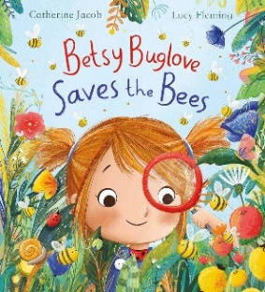
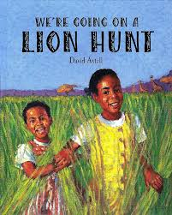
Literacy
- To write a sequence of sentences which can be read by myself and others.
- Find out bee facts from non-fiction texts
- Phase 4 phonics – read and write cvcc and ccvc words
- Phase 3 phonics intervention.
- Reading pracise lessons to develop fluency and comprehension by answering questions about what I have read.
- Reading with expression
Key texts: We’re going on a lion hunt, Betsy Buglove saves the Bees
Nourish Texts: Jungle Jamboree, The Giant Jam Sandwich, Superworm, What the Ladybird Heard
Nursery rhymes: The Grand Old Duke of York, Humpty Dumpty
Poetry Basket: Monkey babies, A little shell, Under a stone

Robin and Wren Class
Term 6
What a wonderful World!

Maths
- Counting beyond 20
- Representing numbers 11-20
- Correctly forming numbers 1-9
- Comparing numbers using a range of comparative words
- Order numbers to 20
- Adding and subtracting single digit numbers
- Doubling, halving and sharing
- Estimating how many objects can be seen
- Subitising - recognising non-standard picture patterns without needing to count
- Solving simple mathematical problems.
- Count groups of 10 objects to 100

Understanding the World
- Jungle Jonathan Roadshow visit
- Forest school sessions
- Contrasting environments – Tidworth and Africa
- 2paint on ipads
- Use and create maps

Expressive Arts and Design
- Joining clay using slip
- Child initiated role-play
- To create detailed paintings
- To paint from imagination
- Making music instruments from recyclable materials

